## Dj4e101x – MichiganX –

## Web Application Technologies and Django

Django (Version 1.5) [Computer Software]. (2013). Retrieved **from** **https**://djangoproject.com.

1. Introduction to Dynamic Web Content
   1. [Welcome](https://learning.edx.org/course/course-v1:MichiganX+dj4e101x+2T2021/block-v1:MichiganX+dj4e101x+2T2021+type@sequential+block@48867828f1624b0898f8dae7e38bd439), 10 min
   2. [Lectures](https://learning.edx.org/course/course-v1:MichiganX+dj4e101x+2T2021/block-v1:MichiganX+dj4e101x+2T2021+type@sequential+block@1a8127e837ff4432b5600bdae960f97e), 64 min
   3. [Assignments](https://learning.edx.org/course/course-v1:MichiganX+dj4e101x+2T2021/block-v1:MichiganX+dj4e101x+2T2021+type@sequential+block@81750e5d1f59466681b7f7b764af0318), 1 min + 1 activity
   4. [Bonus Materials](https://learning.edx.org/course/course-v1:MichiganX+dj4e101x+2T2021/block-v1:MichiganX+dj4e101x+2T2021+type@sequential+block@b7504413295c48a3a04692ad4a87bdcf), 20 min
2. Install Django on PythonAnywhere
   1. [Lectures](https://learning.edx.org/course/course-v1:MichiganX+dj4e101x+2T2021/block-v1:MichiganX+dj4e101x+2T2021+type@sequential+block@e9bc54ffcb794ed3816bd23a94dd2a92), 18 min
   2. [Assignments](https://learning.edx.org/course/course-v1:MichiganX+dj4e101x+2T2021/block-v1:MichiganX+dj4e101x+2T2021+type@sequential+block@2e7d835a81c54961a977a8c06755d5b8), 10 min + 1 activity
   3. [Bonus Materials](https://learning.edx.org/course/course-v1:MichiganX+dj4e101x+2T2021/block-v1:MichiganX+dj4e101x+2T2021+type@sequential+block@e169153652f441a9a82636f549657984), 16 min
3. Hypertext Markup Language
   1. [Lectures](https://learning.edx.org/course/course-v1:MichiganX+dj4e101x+2T2021/block-v1:MichiganX+dj4e101x+2T2021+type@sequential+block@64b4bfccd4084009a2114e566f1ed89d), 35 min
   2. [Assignments](https://learning.edx.org/course/course-v1:MichiganX+dj4e101x+2T2021/block-v1:MichiganX+dj4e101x+2T2021+type@sequential+block@dc9f2eb6497d437dadd4e4efc9bba576), 1 min + 1 activity
   3. [Bonus Materials](https://learning.edx.org/course/course-v1:MichiganX+dj4e101x+2T2021/block-v1:MichiganX+dj4e101x+2T2021+type@sequential+block@6cc3d2e57711473b9365185e12b969f5), 4 min
4. Cascading Style Sheets
5. [Lectures](https://learning.edx.org/course/course-v1:MichiganX+dj4e101x+2T2021/block-v1:MichiganX+dj4e101x+2T2021+type@sequential+block@ffaeeb3ee0c0468097bb33604dd126d2), 82 min
6. [Assignments](https://learning.edx.org/course/course-v1:MichiganX+dj4e101x+2T2021/block-v1:MichiganX+dj4e101x+2T2021+type@sequential+block@3b3ff72fdbe648f1811f1da4575a3a45), 1 min + 1 activity
7. [Bonus Materials](https://learning.edx.org/course/course-v1:MichiganX+dj4e101x+2T2021/block-v1:MichiganX+dj4e101x+2T2021+type@sequential+block@4b4d98f17e6942a0a62e5c6b40c0518f), 6 min
8. Introducing Structured Query Language (SQL)
   1. [Lectures](https://learning.edx.org/course/course-v1:MichiganX+dj4e101x+2T2021/block-v1:MichiganX+dj4e101x+2T2021+type@sequential+block@dfadc7c7a55946e493f2bccf80d391ae), 32 min
   2. [Assignments](https://learning.edx.org/course/course-v1:MichiganX+dj4e101x+2T2021/block-v1:MichiganX+dj4e101x+2T2021+type@sequential+block@6a110d888efa494eb15b90f7e91d7764), 7 min + 1 activity
   3. [Bonus Materials](https://learning.edx.org/course/course-v1:MichiganX+dj4e101x+2T2021/block-v1:MichiganX+dj4e101x+2T2021+type@sequential+block@2ede6b72a6d94cdf88a58081a4038b37), 10 min

### Introduction to Dynamic Web Content

### Why Django?

Hello and welcome to Django for Everybody.

One of the things that I like to do at the beginning of each class is sort of say, why?

Why should you take this class?

Why did I make this class? And in particular, why Django?

There are some questions like, why not Flask?

And I'll get to that. So, I just want to take you back in time a little bit.

Three years ago, I was a happy professor.

We were teaching Python for our beginning users in our data mining and then I thought it was really important to learn a second language and so I

taught PHP for our web dev. I like PHP.

It teaches you like how the web really works.

I taught SQL and I love that, and taught about all the good stuff.

Then we taught JavaScript, jQuery, and JSON as well.

And I had been building that class literally for five years.

I had been building the graders for it, the stuff.

And one of my metrics as a teacher is how far do my students get at the end of the class?

I look at 15 weeks and what was the last assignment.

And then that to me is the way I judge whether or not I've done well or not.

And over the years, I try to get the students farther and farther, and I adjust the first part of the class to be more efficient so that I can be more effective at the end and so I can put more useful stuff, because there's so much in the beginning classes that is just like all the mechanics of it. And you've got

to learn the mechanics, and then you can apply those mechanics.

But you just can't start off and say here, cut and paste these 4,000 lines of code, it does you no good whatsoever.

So, three years ago, I had a very well-developed PHP class and in not too many words, I was told that they didn't want me to teach PHP for

web dev anymore because everybody wanted to do Python.

And a lot of people were actually doing Flask in some of the more advanced classes like our mobile application classes.

I was told to switch to Python, sort of told to switch to Flask.

I've done Ruby on Rails, I've done PHP, which is pretty raw.

I've done CakePHP, which is a framework.

I've done a lot of programming with and without frameworks.

Another teacher taught a class using Flask and I didn't like how that class turned out.

I looked at the end of what they were doing at the very end and I thought,

whoa, that's not very much stuff.

But I started with an open mind and so I actually had a whole year when I was teaching PHP for one whole year.

They let me teach it for the last year.

That's also when I developed Web Applications for Everybody and that's also become a MOOC as well, and which I love and I think a lot of people use it.

It's really a great MOOC.

And I'm still convinced that learning more than one language is a good idea.

So, you might want to take Web Applications for Everybody after you take Django for Everybody.

So everywhere I would go, I would ask everyone that I would meet

do you use Flask or Django?

I mean, luckily, five years earlier there was like 25 choices in Python.

But five to three years ago it really narrowed down to Flask and Django.

There are other cool ones like Sanic that are specialized, but Flask and Django are kind of like the big ones that everybody, not Web2py.

There were so many of them that I'm like, "Oh man, which one am I going to pick?"

And that's a problem with PHP frameworks is there's so many of them,

although Symfony and PHP are kind of winning.

So, I would ask people, Django or Flask?

And people would give me very passionate responses.

They would say, "Django is the greatest thing ever and Flask is absolute trash."

I would go onto the next person and they would say, "Django is trash and Flask is awesome."

Fifty percent of the time they would love one thing and hate the other one.

It was amazing. I really got no trend whatsoever.

But halfway through that, I'm like I'm getting no data.

I mean, I'm getting half the people love one thing and hate the other thing,

and so, I changed the question.

I stopped asking whether it was Django or Flask because they were saying, "What do you like?"

I was really asking what do you like better, not what should I teach?

And I said, "Look, I can only teach one, Django and Flask, and which would you teach first and then which would you teach second, what order?"

And then universally, everybody just had to accept the fact that Django was way better, way, way better to teach as the first class.

And I felt I got really strong data on that.

I picked Django. I wanted to use Django, and in retrospect, it's brilliant, right?

I've been working on this Django class for two, two-and-a-half years now, and each semester I make it better.

Each semester I improve the slides. And I do that thing where I try to like

compress the beginning and get efficiently done with the beginning part

so that I can do better stuff at the end, and I'm really pleased.

And what you're seeing in this Django for Everybody MOOC is that two years of careful engineering of the class. And I'm really proud.

You can go to projects.dj4e.com and see some of the things that the students have built.

I'm amazed at how much they can actually build on their own and literally couldn't have done it with PHP and couldn't have done it with Flask.

Django is the only way that students would be able to produce complete functioning websites with a real user interface at the end of the 15 weeks.

And so that to me made Django a great success.

And I'll close with, I just got done looking at the most recent Python programmer community survey and I was surprised to see that the number one use that they had of Python was web applications and the number two

use that they had was data applications, which like floored me because I know that Python is great for data applications and it's just super dominant.

Part of the reason that it worked out that way is it wasn't like web was twice as much.

Python is used for so many things and so there was a lot of things on

the list and then web just edged out data analysis by a little tiny bit.

You can be critical of Python web development and my answer is,

if it's not perfect, it's going to be perfect because people like to write in Python and they don't want to write in Rust or Elixir or Scala.

Those are harder to learn and honestly, whatever the shortcoming of Python web development, it's going to get fixed.

So welcome to Django for Everybody.

I really enjoyed and I've been looking forward to the moment where this was mature enough and well enough developed to become a MOOC and so, here we are and I'm glad to make your acquaintance. Cheers.

### Course Prerequisite

This course lays the ground work for the rest of the Django for Everybody (DJ4E) Program.

The only pre-requisite for this course is to have a basic understanding of Python.  For example, you should be reasonably well prepared for this specialization after you have taken the first two courses from PY4E:

* [Programming for Everybody (Getting Started)](https://www.edx.org/course/programming-for-everybody-getting-started-with-pyt)
* [Python Data Structures](https://www.edx.org/course/python-data-structures)

### Welcome to the Course

Hello, and welcome to the first course in the Django for Everybody specialization.

The purpose of this course is to in effect make it so that the only prerequisite you need are Python skills.

Like you might have taken the Python for Everybody specialization and finished that,

and then you can come here.

And so, I don't want to put a bunch of prerequisites, like HTML, and CSS, and SQL.

And so what I've done is I've just covered all the foundational knowledge that sort of supports the rest of the specialization in this class.

We're going to use PythonAnywhere.

In this first class, we're going to install Django.

We're going to use it for some HTML, CSS, and SQL assignments.

And so, the idea is to get everybody on the same page when we finish this course so that we can sort of at that point start digging into learning how Python and Django work together.

### The Django Community and Django Girls

One of the best parts of Django is that it is a 100% free and open source project. By learning Django, you are joining a large, wonderful, and caring worldwide community. There are Django meetings and meetups all around the world. Be sure to take some time to learn more about [Django and its community](https://www.djangoproject.com/).

One of the coolest aspects of the Django community is [Django Girls](https://djangogirls.org/). Django Girls holds face-to-face meetups and workshops around the world to teach beginners about programming in Python and developing Django applications. You can work with them to organize a Django Girls event near you. Django Girls also has an [online tutorial](https://tutorial.djangogirls.org/) for Django beginners.

This course walks through the [Django Project tutorial](https://docs.djangoproject.com/en/3.0/intro/) as part of its instruction, in part so you can also enjoy the Django Girls tutorial either [in person](https://djangogirls.org/events/map/) or online. We did not want to ruin the fun of you doing their tutorial later. Or perhaps after finishing these courses, you will want to lead a Django Girls workshop! :)

### Django Girls impact (from their web site Summer 2020)

*Since 2014, an army of 2160 volunteers in the Django Girls community organized 936 events. We've been to 526 cities in 98 countries (*[*see them all on a map*](https://djangogirls.org/events/map/)*). A total of 21253 incredible women attended events organized by members of our community.*

### Lecture Resources

**Introduction to Dynamic Web Content**

The following materials may be helpful to you as you review this week's lectures and content.

* [Downloadable slides for this week's lectures](https://courses.edx.org/assets/courseware/v1/22b8e13fd81ad1a62f0e23337a952eb9/asset-v1:MichiganX+dj4e101x+2T2021+type@asset+block/C1-Week1.pptx) can be found in the here.

Resources you might find useful / interesting

* [Hypertext Transfer Protocol Wikipedia Page](https://en.wikipedia.org/wiki/Hypertext_Transfer_Protocol)
* [What Happens When You Click a Link? - Computerphile](https://www.youtube.com/watch?v=keo0dglCj7I) explains the Request / Response Cycle.

### Introduction to Dynamic Web Content (ch 1)

Hello, and welcome to our lecture on dynamic web content.

It may seem kind of weird to be talking about building web applications and to,

when we start out talking about building web applications, that we're going to talk about protocols and stuff.

But in a way, when you are building a web application, if you don't understand the protocol and you just sort of say, I changed this little bit of code, and hit refresh, and some magic happened, you really are cheating yourself in terms of becoming a really

good web application developer.

Because ultimately, these protocols are what enable web applications.

And as you go forward and use frameworks, you don't need to know all these things in detail.

But when you debug your applications, you absolutely do.

And I don't know if you've had your Firefox console or looked at things and watched, but there's so much complexity going on.

And when you're using a web application, hopefully everything works and that complexity is hidden from you.

If you have some interest in this and want to go even lower to sort of more the network protocols, not just the HTTP protocols,

I've written a free book on networking called Introduction to Networking, How the Internet Works that you are welcome. You can buy a print, if you want.

But it's also completely free, like every book that I write these days.

And if we take a look at what we're going to really be talking about in this lecture and in this web application course is the technologies, the different technologies that are used to, in effect, produce a web page, right?

We have a web page over here, you go to URL dub-dub-dub data, I mean, data.pr4e.org/page1.htm, and here comes a page.

And this is like a super simple page.

But there are so many technologies, like how browsers work with JavaScript, and jQuery, and CSS, and eventually Vue, and things like that.

That's a whole set of front-end technologies.

And then there's sort of back-end technologies, like Django or Flask and databases.

And we're going to learn in this, my focus in this class is less about how to make it all look beautiful, although that's important, and more about how to deal with the back end.

So, what we're going to see is these technologies that define the look and feel and the interactivity of your web pages.

But then how data and HTML, CSS, and JavaScript are served up by the remote server.

And the Internet here is in the middle.

The browser is sitting on your laptop, or your phone, or whatever, and it has all these technologies built into it.

It makes requests, and then the server comes back with responses.

And so the simplest version of this protocol is that you click on a tag.

And when you click on that tag, you get a new web page.

Now, if you watch your debugger console, you will see that sometimes it's 120 different request-response cycles used to construct the page.

But in a sense, they're all the same.

Now, as we move to things like HTTP 2, there are ways to pull down multiple documents in a single connection, but we'll stick with the old HTTP 1 way of thinking about it.

In the simplest form, the browser asks for a document, and then retrieves the document, and then shows the document.

And that is the basic request-response cycle.

If you look at how this works, that browser is an application running inside your computer, on your laptop or your phone, that is a piece of code.

And in that, it's got a connection to the screen, or the keyboard, or the mouse, or whatever, and it's watching for events.

Meaning that you're going to go and you're going to click somewhere, and then this application is going to respond to the events.

In a web page, in the simplest case, you've got stuff that you can click on and stuff that you can't.

And you go find your way through whatever to click on part of that web page.

And that click is intercepted by the application, whether it's Chrome, or Firefox, or Safari, running on your piece of equipment.

And then that application then opens what's called a network socket, a socket across the network to a web server, and sends a request.

And that request, as we'll see in a bit, is a specially formatted request.

It has a GET command, and then it has the URL that it wants to get from the web server.

And then the web server does a bunch of work inside itself, a bunch of work inside itself, maybe reading disks, files, and running programs, generating what it is that you want.

And then it sends the response back on that same socket connection.

There's like this socket connection through which all of this stuff is viewed.

And the HTML is kind of the basic thing that comes back.

As we go further, we'll see that it's not just HTML that comes back, but other things as well come back.

And when the browser receives that HTML, then it says, oh, I know what HTML is. I've got this header 1 tag.

Let me change the color of this thing so you can see it a little better, yellow is way better.

Okay, so when the browser receives this page, it sort of sees it and it looks at it, and then it looks at all the HTML.

And so part of this course is to understand the syntax of HTML.

That itself is how to build good HTML and CSS and how to make it look beautiful.

But ultimately, something in that HTML, plus its CSS, plus its JavaScript, leads to a visual display of the page.

And then that's the thing that you see.

And this is the request-response cycle.

Up next, we're going to talk about what these network sockets are or the things that fundamentally underlie this request-response cycle.

### Network Sockets and Connections

Network sockets are like phone calls for computers, and literally, in the 1960s when they were designing the concept for network software, that is the concept that they came up with.

And that is that in a sense we make a call, we talk on the call, and hang the phone up.

And as computers were going to share data and some computers were going to have data and other computers are going to want data, they thought, oh, the way to do this is not necessarily have a permanent connection to that data, because there's going to be so many computers and so many sources of data, and so many computers that want to consume those data.

And, of course in 1960, they had no imagination that there will be billions, they just thought there would be 10,000, and they thought that was a lot.

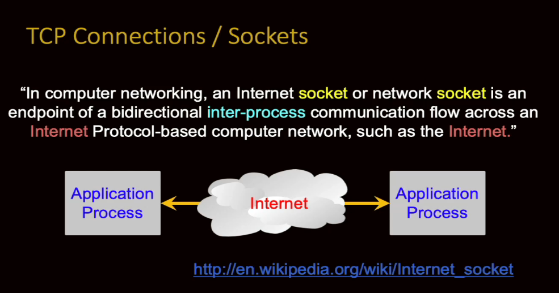

But they came up with a protocol that basically said when you don't have continuous,

permanent access to data, you actually make a phone call.

You know where the data's at, you kind of say, you dial up, you grab the stuff, you get it back, and then you let the connection go.

And it means that with billions of computers each talking to each other, the network isn't so complex.

And there's this…connect, talk, disconnect. Connect, talk, disconnect.

And it's the way the phone system in our world scales to all the people, and it's the way the Internet scales to all the people that want to use that Internet.

So this is made inside of software using an abstraction, or a library, called sockets,

and sockets really are computer phone calls.

You know where you're going to call, you can start the call, wait for them to answer,

once they answer, there is a two-way communication.

It's kind of like a file, except that you can simultaneously read from the file and write from the file.

Although it's important for the two cooperating pieces of software to know who's going to read first, and who's going to write first, because it's like if when you pick the phone up after it rings, we all know to say, "Hello." And that's kind of a protocol.

Who talks first is a protocol.

And then the person goes, like, "Who is this?"

And then eventually conversations happen pretty naturally.

Somebody talks, listens, someone else talks, listens, and that works, but there's complicated protocols.

And you can think of this not necessarily as the browser on your laptop or phone as talking to data on the server, it actually is talking to another program.

So even when it's just retrieving a file, it's talking to an application on that server, and that application is reading the file and sending it out.

And we'll see that eventually, how we have to do that, when we're doing things like uploading pictures.

We upload pictures and then we have to actually serve them back out.

We can't just say, "Oh, the pictures are there, you can grab them," because sometimes not everyone can see every picture.

And so, part of the software application decides if you are allowed to see this picture, I will send it.

If you're not allowed to see the picture, I will not send it.

And so that's where it's a piece of software that you're talking even if you're looking at a picture.

Sometimes that software's really simple and you barely notice it, but there is software in the loop, it's not like you just go straight to data.

It is really two pieces of computer software talking to each other, and we use the Internet as that intermediary to allow that conversation to happen.

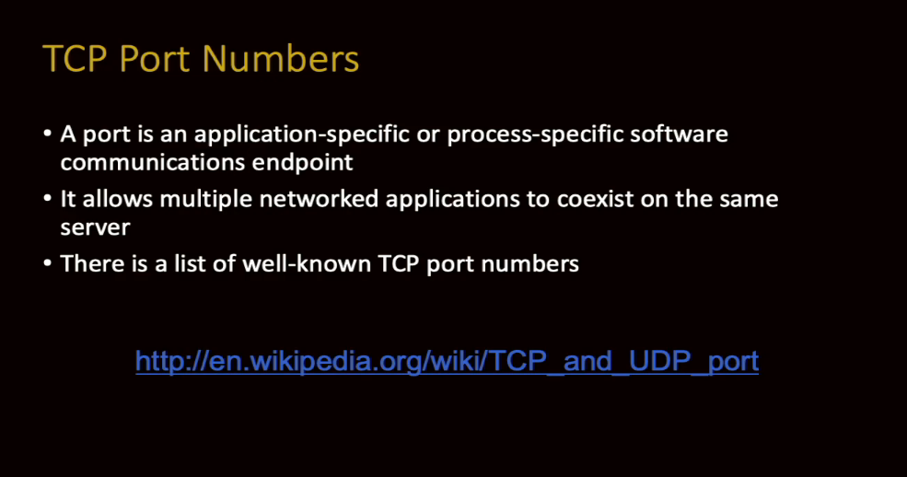

If you read my book about the TCP/IP, you'll learn this in super great detail, but every computer has an IP address.

It is a number.

There are two kinds of addresses, there's IPv4 and IPv6.

IPv4, version 4, is the one that's got four dotted numbers, like 142.16.42.114,

but within each of those they have what's called a TCP port number.

And because this whole Internet thing is applications talking to applications, we need to have a good way to know which application we're talking to, and that's where TCP port numbers come in.

And you can think of this as like a phone extension.

You have a phone number, and then you have extension 1436. TCP port numbers are like that.

We cannot have a specific address for every application, but an application has an address and a port within that address, or a phone number and an extension within that phone number.

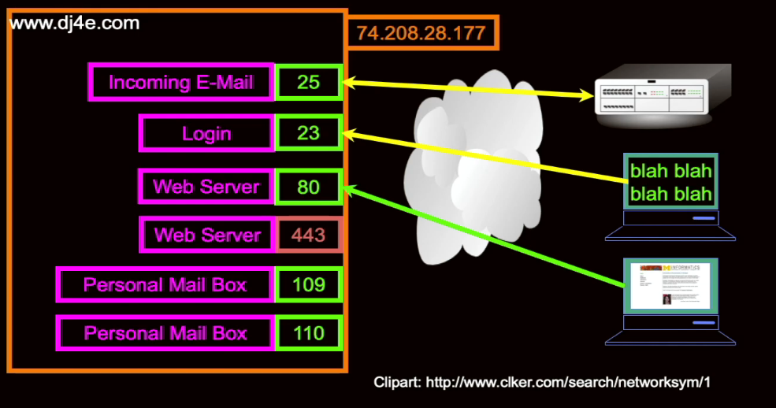

And so, you can look these things up.

Port 25 is used for email server-to-server communication.

In the old days, we used this thing called telnet, we'll talk about that, on port 23.

And so the client is on the right-hand side, and it might be a computer where you've got a keyboard and it's you, or it might be a server that's got some mail that's being forwarded from somewhere, and they all talk and they connect to an IP address.

In this case, 74.208.28.177 is the IP address of this computer, and then port 25 is the extension where one computer sends email to another computer.

And each of the arrows in between them is a separate protocol.

If you're talking to an email server, you expect to talk to in email protocol, and if you're talking to a login server, you get a login protocol, that's kind of the simplest one.

A web server can be on port 80 if it's unsecure.

Preferred, of course is HTTPS, which is on port 443.

If you have a mail application like, say, Thunderbird, that's reading Gmail, it talks to ports 109, or 110, or a couple of other ones.

There are ways for a mailbox application to talk a protocol to a server-based mailbox

to retrieve the new messages, or delete a message, or view a message, or whatever.

There are these ports on servers that have protocols, and then we can build software on

our clients that talk to these protocols.

The one we're going to be playing with the most in development mode is port 80, and in production mode, port 443 for the HTTP, for web documents, basically, and web application documents.

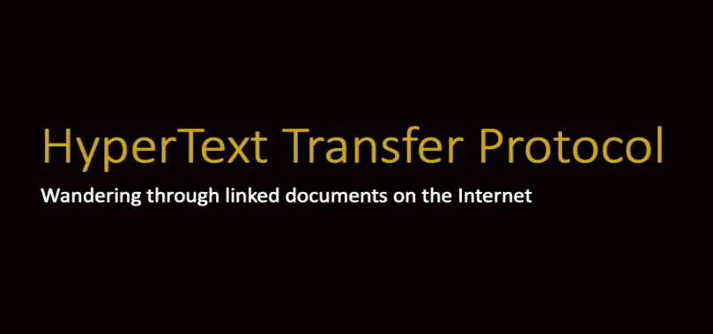

So up next, we're going to take a quick look at the HyperText Transfer Protocol, I also want to call it HyperText Transport Protocol, HTTP, and that is the protocol that we talk to port 80 or port 443.

### HyperText Transfer Protocol

HyperText Transfer Protocol is the protocol that browsers use to talk to servers.

Now, we've used it for all kinds of other things because it turns out that it's a super-simple and super-elegant protocol.

But this goes to a long time ago.

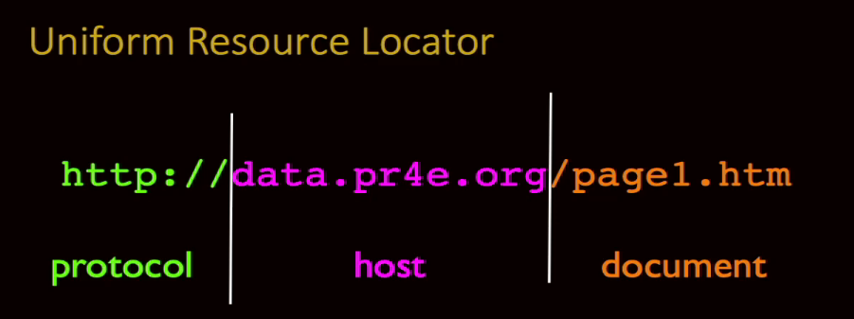

This protocol was invented in 1990, which is going on 30 years ago now or more.

And there were many protocols.

You would have one piece of software and there was server software and client software, you had to match them up, and then you talk to the right port with this server software.

And one of the inventions of Tim Berners-Lee and Robert Cailliau at CERN was that we came up with this notion of instead of lots of pieces of software, we would have one piece of software called the web browser, and it would be multiprotocol.

And we have this thing called the URL or Uniform Resource Locator, and we just sling these around, we just use them.

But this was itself an amazing innovation in 1990, because in the old days you'd be like,

"Use this piece of software and talk to this address."

So, the URL captured three really important very separate things.

First thing it did is it allowed for multiple protocols, and the one that you mostly have seen is **HTTP** or **HTTPS**, that's a protocol, **ftp**: or mailto: might be the other ones that you've seen, and then a host, and then a document.

And that host is a domain name, which is a nice symbolic way to get a server address.

And that eventually resolves to an IP address like 141.206.14.22 or something, and then a document within that server and that /page1.htm is the document in the server.

And I'm just saying before 1990, there were many protocols and we did many things.

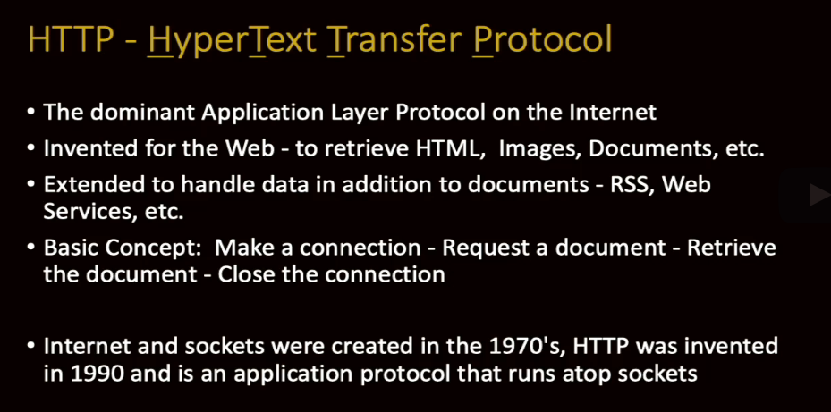

But after 1990, this one protocol, HTTP, found its way into so many awesome solutions that it's by far, other than email, the dominant protocol that we use on the Internet.

Like I said, it was invented at CERN by Tim Berners-Lee and Robert Cailliau to retrieve documents and images.

And as soon as they built it, because most of the other protocols were kind of complex,

because we're computer scientists and we make complex things and we love complex things, and we're very, very good at complex things.

But this was, when the web was being built, Tim and Robert we're not like, "We're going to make the greatest thing ever. We're just going to make a simple thing."

So, they made a simple thing, but it turned out to be the greatest thing ever because different engineers would be like, "Oh wow, I can use that in a little different way."

And the grounding of it was super simple.

And the basic concept was you connect to a server, you figure out where it is, you send

a single command with a bit of extra data, and then you get back something, a document, it could be an image, it could be data, it could be HTML.

And it was really amazing, right?

And so, the underlying sockets are the things that make the phone call, HTTP is what we do once this phone call has been established.

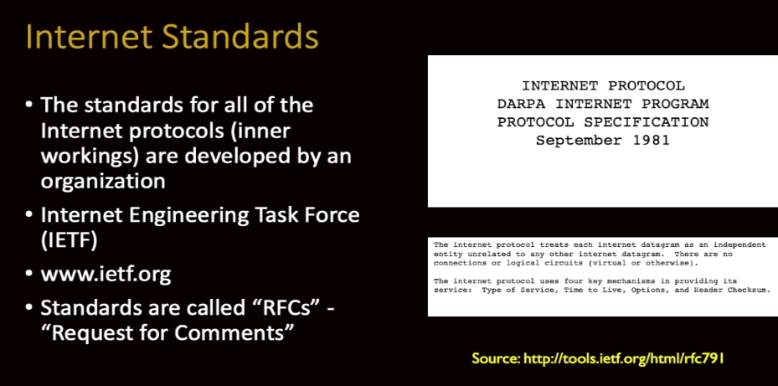

One of the things that made the Internet so successful, starting in the 1960s, was a radical openness.

A very we're all around the same campfire feeling, very friendly, respectful, that still allowed criticism.

And there wasn't like one super genius that designed this or one company that designed this, this was a collaboration.

And the collaboration was around a set of open standards and meetings to help build these standards, and they are called RFCs, they are called Request for Comments.

And there was a group that built these called the Internet Engineering Task Force, the IETF.

And the Request for Comments is a fun notion.

We're looking here at a September 1981 document, which is 40 years old about now,

and it's called a Request for Comments.

And the idea is, as engineers, we might have a design that everyone thinks is the greatest thing ever, but we should always question.

No design is perfect.

No design is beyond question.

No design is beyond commentary.

And so even when they're 40 years old and used worldwide and dang amazing, we still say there is room for improvement.

And so, this talks about, I think this one is IP. And there's an IPv6.

There's another one, if you look for this RFC that we're looking at here, there'd be IPv6.

And you'd start reading it and it's pretty dense reading, but as an engineer, it gives you all the details to build a router or build a piece of software or build whatever.

And these are 100 percent public documents.

The idea was that no company, because literally the companies that were around in 1960, if they had said Burroughs or Sperry owns the Internet, or Digital Equipment owns the Internet, they're all out of of business, because they didn't make good choices.

But the market was able to make good choices, and because the commons were these open standards and open specifications, new companies like Sun Microsystems and new operating systems like Linux could come in, and even Windows could come in and participate as full participants because they just read these specs and all of a sudden,

they're inter-operating with everybody else.

This is fundamental and foundational to how the Internet works.

And I'm not saying you're supposed to go read them, but it's just fascinating to understand that the entire technological infrastructure upon which the Internet is built is license-free, royalty-free, and you could build a brand new gadget and you could hook it to the Internet by reading these specifications.

You don't have to pay a developer's license or nothing.

Dang, it's cool.

Sorry, I'm just a little bit too excited about that.

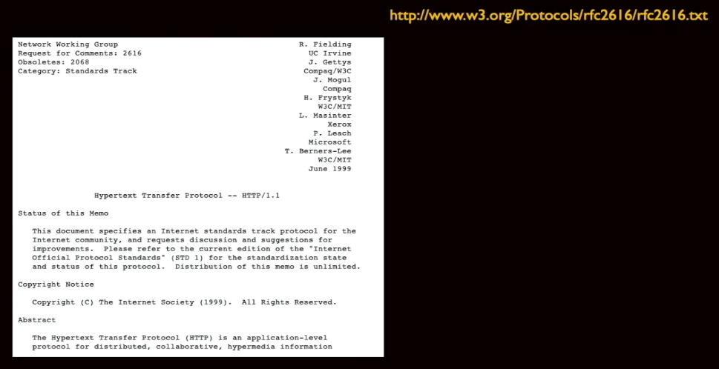

So, let's take a look at one of these in particular.

Now this is probably supplanted, but we'll look at RFC 2616, and they go up in numbers.

This is HTTP, HyperText Transfer Protocol.

And if you wanted to build a web browser or a web server, you could read this document.

Go ahead, read the document.

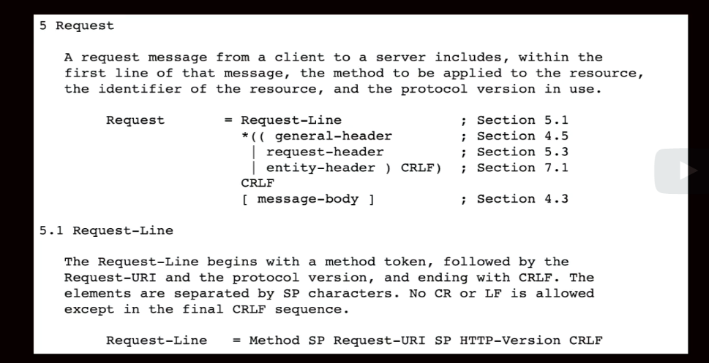

And if you read down far enough, you'll say, "Oh, this is how you make a request." Blah blah blah, it's got a header, and it's got like a carriage return line feed, and then a message body, and you got to do this, and this is what it looks like, this is how it works, right?

And at some point, you're deep in this document and you're finding out, in this page right here of this document, how your browser is supposed to format it.

And this tells both the client and the server what the rules of the protocol are.

Now, it's lot easier to just for me to tell you.

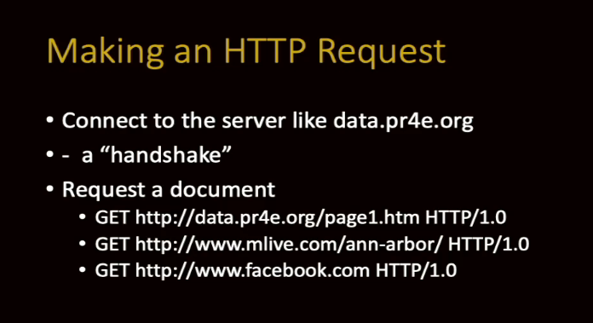

So, you connect to the server on a socket, usually port 80 or port 443, and then the client is supposed to make the first it makes first request. It sends a line, with a carriage return line feed at the end that has the characters, there's other ones, but GET, G-E-T, space, a URL, space, and then a protocol.

And now, I'm using this HTTP 1.0 because I can do it by hand, right?

And you ask for a document and then you can optionally send some header information.

Things like, what language this a person at this browser prefers, what are the capabilities of this browser, what version browser we have.

So, there's a series of things. You say, give me this document and here's something about the browser that's requesting the document, including information like cookies that are being said.

Now so this in case you want to know who is doing this request because you've logged somebody in and set a cookie to indicate that they're logged in, that's all sent on this GET request.

But we'll not send the headers.

There's actually incoming headers and then outgoing headers.

We'll see these when we start looking at Firefox's debugging console.

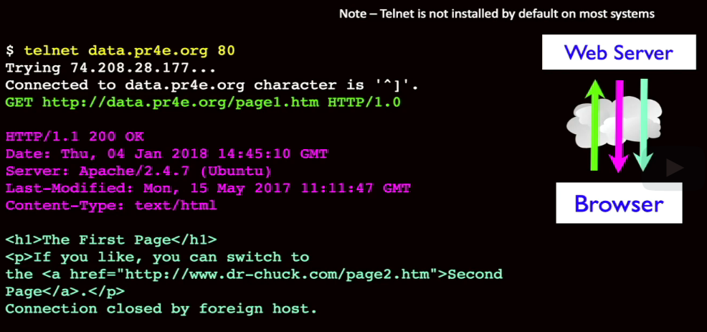

And so, this is an entire interaction that you can do on your laptop.

Now, I'm not going to do it for you, but I would note that the program telnet that this uses has been removed from most computers.

It makes me sad.

They think of it as a security hole because it doesn't use encrypted connections, like port 80 is not an encrypted connection.

Ultimately you can install go search on your favorite search engine and find out how to install telnet.

But if you get in a command line, whether it's a Windows command line or Mac command line or a Linux command line, and you get telnet properly installed,

you can type the following command.

**telnet data.pr4e.org 80,**

and then hit Enter. And at that point.

Telnet originally was used to log in to computers but if the server we're talking to and the protocol we're talking to is simple enough, and in this case HTTP 1 is simple enough for us to be able to do this, we're actually talking to the server because I remember

I said that these are applications.

Your browser is not talking to files, your browser is talking to an application on

a server and the server might give you back a file.

So, it's really talking to a piece of software and we'll see this in more detail in next section.

And what'll happen is because the HTTP protocol requires that the client speak first,

we have to type.

Now if you can get this working and type wrong things, and type a couple enters, newlines, you will see that you're talking to a piece of software and it will say,

"You have violated my protocol."

You're not talking to a thing that has any online help or user interface or anything like that, you're talking to a server and your job is to request some data using the proper format because you read the specifications about the proper format, right?

So, in this particular one, it's easier to cut and paste this because some of these servers if you don't type fast enough, they'll be like, "You're not a software, you're a human.

Quit playing with me."

Like if we talked to Facebook or something.

And you can talk to Facebook and see what happens on port 80, and it will time you out really fast.

So, it's good to have a cut and paste buffer.

You paste this GET command in.

And the other thing that's important is you've got to put an extra blank line.

And this extra blank line is to indicate that you're not going to send any of those headers if we were going to send things like what language we would prefer or what formats we would prefer as a browser.

The browser has certain languages and other configuration and login information and that can get sent up to the web server along with the request for the document,

and we would be able to type them in here.

But we're not going to do that in this very simple, we're just going to say "Enter"

which means no more headers.

If you were putting in headers, you'd type header, header, header, header, and then Enter on a blank line.

And then the server would know that our request was finished.

But we can just ask for a page.

And then what the server does is it sends us back two pieces of information.

First, it sends us headers.

The first header is HTTP 1.1 200 OK.

That's actually a status line.

Now you'd have to go read the documentation on how what that works.

But, for example, 200 means that you got a document.

Another one that you might have seen is 404. It might say, 404 Not Found.

If you go to a web page and it doesn't exist, something will say 404 in your browser usually, unless it says, here's a search box, go find it.

But there's a status and so you might the thing that you're typing, page1.htm, may or may not be on this server.

If it is, then you'll get a 200 OK and the data, or you'll get a 404 and Not Found.

And then we get some response data, some header response.

and this header response looks pretty much like the same format of the data we would've sent into the browser if we were sending things like that in there.

Here it's what the date is, what the server we're using, last modified.

And one of the important things is, what kind of content are you about to see?

Content type in this case is text/html, which means the thing coming next.

And then there's a blank line.

And the blank line is our indication as we're reading this data that we have finished the header, which is really metadata about the page we're retrieving, and the actual page itself.

And the rest of this page is the actual data.

And we know the format of it because we were told before the page starts.

This could be image/png, this could be XML, the application slash XML, and it could be JSON, it could be like anything.

And then the browser is supposed to, and if this was an image, it would be garble, garble, garble. garble, garble, right?

It would be all garbled stuff that we can't really see.

But the browser knows what a PNG or JPEG looks like and it shows it to you.

And it basically uses this text/html to tell you what's going on.

And so this then your browser has read all this information and has both the metadata and the data about the retrieved page, and then its job is to sort of produce a pretty rendered version of the page and show it to you.

And that is the request-response cycle.

Again, you don't have to do this.

You can just sort of believe that it's done here.

But if you want to install telnet on your system, it's not a bad thing to install telnet.

It's a classic fun thing.

It's far less useful than it was in the early days because we used to use telnet to test everything.

Now we've got like browser developer consoles that are way easier than telnet.

But it's kind of a cool thing, feel free to do this and you'll be like, I know what's really going on.

So, I'm a big fan of using the console, of using the terminal, of using text-based interfaces.

I think they're actually way more accessible.

I think it's awesome.

And in a way, all these fancy graphical user interfaces distract us from the simplicity of what's going on inside of computers because you think, well, where's the button?

The answers is, so there's probably some command inside this computer that does what the button does.

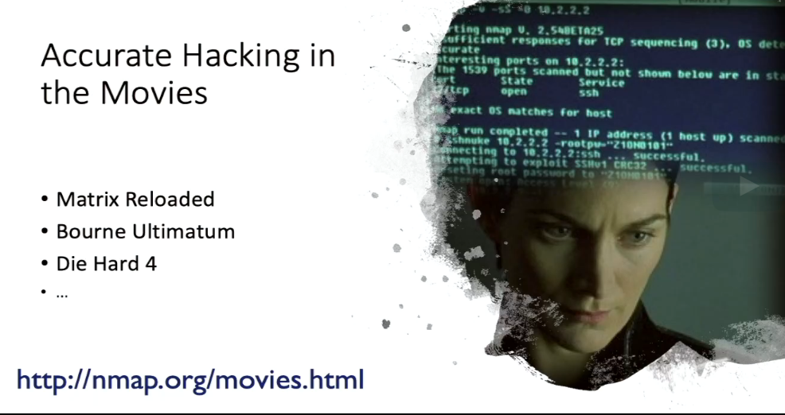

I have a former student of mine who actually wrote the scene in I think maybe this was Matrix 2, I think this was Matrix 2, yeah, Matrix Reloaded, this scene where Trinity is breaking into the power grid and she is using the console.

And it turned out that the way this scene was written is it was written exactly as a hacker, whether that's a hacker with bad intent or good intent, because there are hackers with good intent who are trying to break into your system so they can tell you or you pay them to break into your system so that they can tell your vulnerabilities.

But you can take a look at the analysis of this little scene and just this sort of is just one of the cool things about me teaching people about how to use the command line,

and increasingly me teaching people about how to use Linux.

I really think that it's okay to know your Mac and Windows command line, but really increasingly the world is in a server world, and we are starting to work on web servers

in this class and you might as well start learning some Linux because also that's an important skill.

Just writing some Java code or Ruby code or Django code, that's a skill, but knowing how to start the server, debug your application, find log files, etc. in the command line is really important in real production systems because we're going to play in some simplified environments to make it a little easier.

But those simplified environments go away once you go into real production in a real job.

And so, I'm really into teaching you Linux command line, etc., etc.

So up next, we're going to show you in Python, in effect as few lines as I can possibly show you, how a browser works, how browser sends the HTTP protocol, how a server reacts to the HTTP protocol and returns documents.

So that's what's coming up next.

### Building a Simple Web Browser in Python

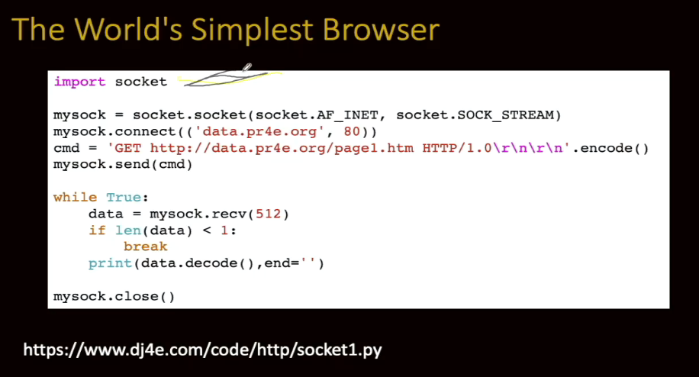

So now, we're going to build a very simple browser and server in Python.

Okay, so import a library, import socket.

And that, just like import math or import whatever, that pulls in a library into Python.

Sockets are built into Python.

It's very cool and it's very simple.

So, sockets kind of function like files, but they're files that we can send data to and receive data to.

But when you're using a file in Python, you've got to first open it.

And so, the opening of a socket is really a two-step process.

First, you create the socket, and that socket sort of lives in your computer as an endpoint that's not yet finished.

It's the endpoint that you're going to send and receive data to inside your computer.

But then we have to actually make the phone call.

So socket.socket, and don't worry too much about this syntax, we don't change it,

socket.socket basically says, "Make a phone." That's what we're making.

And then mysock.connect, that second line, is dial the phone.

And we're dialing the phone to a domain name, data.pr4e.org, and a port in that domain name.

So that is the call.

Now, if we made a mistake, right, if we were dialing and not talking to the right server, therefore that server didn't exist, this connect would blow up, meaning we'd make a data phone call to a server that doesn't exist.

That line is what's going to blow up.

But as you continue down to the next line, if it gets that far, now you put try and excepts around this, if there was blah blah blah, I want to keep this really short, so I'm not putting in all that stuff, all that error checking.

Connect might blow up, socket.socket won't blow up unless you don't have networking at all in your computer, but it's unlikely these days.

But mysock.connect is like dial the phone, dial the data phone to this endpoint.

And it includes the port, the port 80 that we talked about before.

And now, we need to send a command.

And in this command, it's exactly what we talked about before.

It's exactly what we sent via telnet.

It's a GET, followed by a space, followed by our URL, followed by a space, followed by a protocol HTTP/1.0, and then we hit the Enter.

Now, it turns out in network world you actually hit two things.

It's the \r\n as a return in a newline, and you have to hit it twice, the enter at the beginning of the first line, then remember we had to put that blank line in because to say no headers.

Now we would put, in between here, we would put all our headers in there if we were going to do that, but we're not going to do that.

And then you have to use encode.

And encode means that the data sent across the Internet is generally sent in what's called UTF-8.

Inside of Python, the data is in Unicode, so that you can put literally any character in

a Python string. And then preparing it to send it out across the Internet, we encode it into the more dense, more compressed UTF-8 format, rather than we don't send strings across the Internet in Unicode in general.

I mean, it's very rare, you'd have to control both ends.

We want to send them in UTF-8.

And so the string GET, blah, blah, blah, that's in a Unicode string in Python and .encode says, "Convert this into a UTF-8 string."

So, command, cmd, is a variable that has a UTF-8 string in it. And then we say, "send."

Now remember I said that you can simultaneously send and receive on these sockets.

But the protocol tells us whether the first thing we're supposed to do is listen or talk.

And we're the browser in this case, and so we're supposed to talk first.

We send the request out, and that's just like you typed it in telnet, because in effect you're scripting telnet.

We liked telnet in the old days because it was kind of like a socket.

I could connect to any host, any port, and type things and see if it's broken or not.

And the protocol says, once the server has received the first line, any headers, and then the blank line, then it's to return it.

Then the next part of this is we're going to have a little loop.

The protocol tells us we're supposed to receive data until the socket's closed.

And at the bottom of that telnet, you saw that it sent a bunch of lines, like four, I think,

and then it closed it.

That's what's going on here.

We are retrieving data and then this receive, this actually waits.

If the server is coming slower, the network is slow, this piece of Python will be sit, sit, sit, sit. Oh, got a little bit, got a little bit, up to 512 characters.

It will wait until it's gotten 512 or it's done and it's got 100 or so.

But the receive is a blocking, waiting operation in Python, says give me up to the next 512 characters.

Now, usually the network is so fast that the Python doesn't even wait because this operating system already has it, but we get it.

And if we get no data whatsoever, that is our indication that the network connection,

the socket, has been hung up on, closed, by the remote server, and away you go.

So that's why we're going to break if the length of the data is less than one.

And if not, we're going to simply print out the data, but we're decoding it.

And that's because the data that comes in is in UTF-8, but the print statement wants to print Unicode.

And decode says, "Here's a variable that has UTF-8 in it, convert it to Unicode for printing inside of Python."

Because this data is externalized to us, we encode it before we send it, and we decode it when we receive it before we use it, because Python inside itself doesn't use UTF-8.

Python inside itself uses Unicode, which is awesome and a whole separate conversation.

I'm just kind of bringing that up to remind you how important it is because we're not going to write much of this in Python really, and all this stuff is taken care of

for us in web servers, when we get to that point.

But it's just a good time to review Python's strings and Unicode and encode and decode because it's really important.

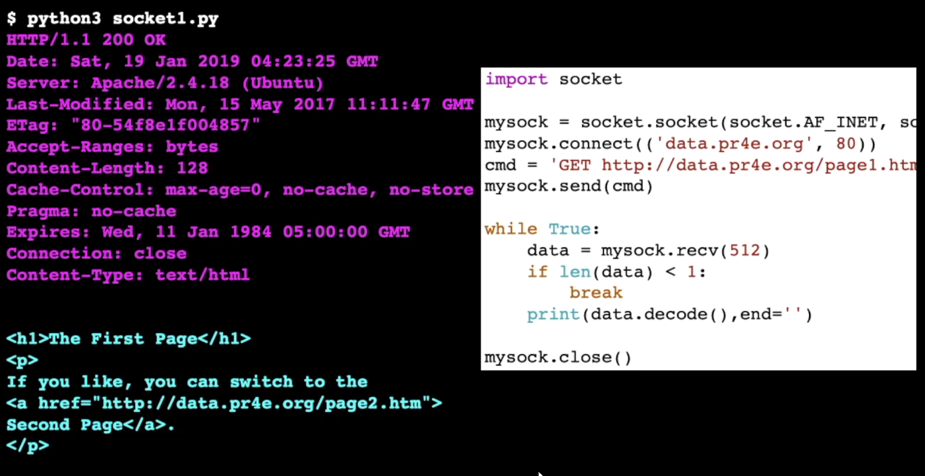

If you run this, and you've got it right, it runs pretty simply.

Let's get the color back, get it back to yellow here.

If you run it in your system, python socket1.py, all the work is done up here before you see your first output.

And then all of this output that you see is just this loop running.

And what you see is really the exact headers that are coming from this server.

And then you see a blank line and then you see the actual page that's coming out.

And you don't see it, but at the end here, the connection gets closed and you break out and you're done.

And then we close our end of the socket.

The far end was already closed, that's how we know to stop reading data.

And then we hang ourself up so that our local system does not end up with a bunch of half hung up phone calls.

And so that's basically how we talk to a socket in Python.

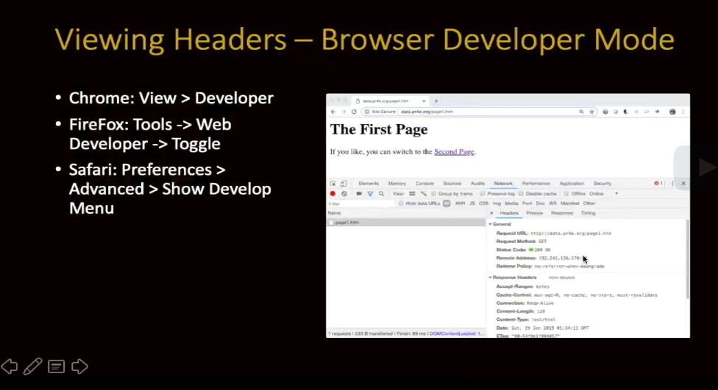

Now, that was literally, ten years ago, how I would debug applications.

I would like telnet or write a little thing like that and dump all the headers.

And that got really tiring, really boring, really tiring.

And browser developer mode is going to be your friend.

In a way, browser developer mode, and I'm going to have a separate video on this,

browser developer mode lets you look at the sent headers, the received headers, the received data, the sent data, what URL it went to.

And it's super awesome, especially because a lot of web pages have like 40 to 150 request-response cycles.

You don't want to debug them all by hand.

You just let the browser do its thing and say, "What was that second one and what went wrong in the second one?"

I spend a lot of time when I'm debugging web applications using the developer mode.

And that's why I have a special little video that gets you familiar with it.

And I'll tell you by the time you've done web stuff for a little while, you're going to know your browser developer mode.

Next, we're going to talk about writing code in the server to respond to these requests.

### Building a Simple HTTP Server in Python

We built a browser in Python.

It's time to build a web server in Python.

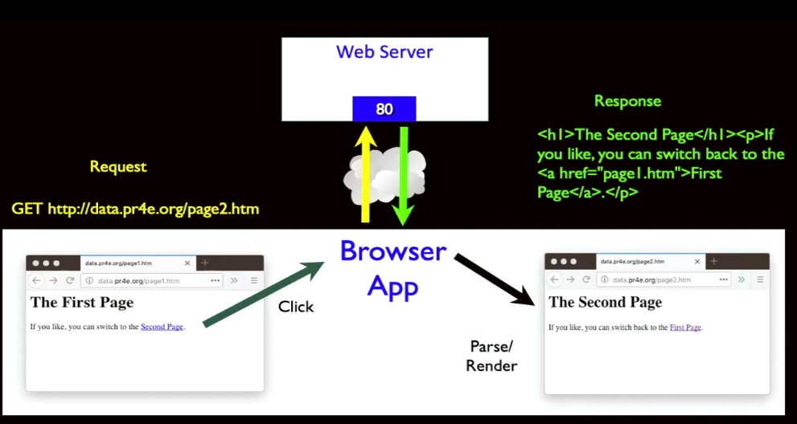

Remember that what we've got here is we've got the browser is an application, and we've made this a Python application now, that sends this GET request.

We have effectively, like I said, built the world's simplest browser and that sends a GET request.

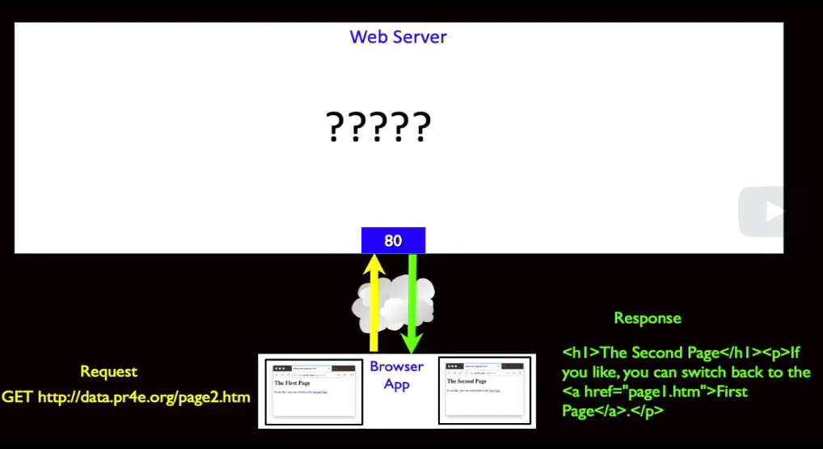

The server does something and then it sends the response back.

And now, we're going to kind of change this, right?

We're going to assume the browser exists and it's like okay, because we're going to be the server folks, right?

Now we're going to look in greater detail at what goes on in the server.

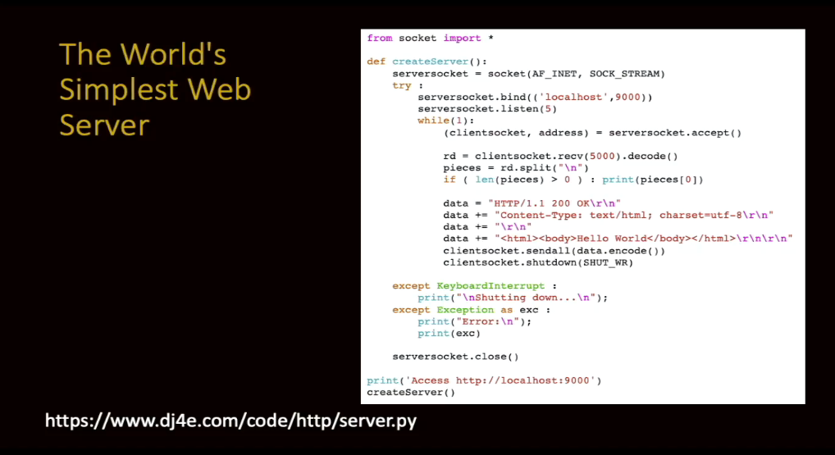

And so here is a very, very simple web server.

It's a few more lines than the simplest web browser because we have to put a little bit of error checking in with some tries and excepts, okay?

Let's walk through what this code does, okay?

Let me change the color again to black.

If you're from Microsoft and you can tell them to make a key to change the color on the scribbler, I'd greatly appreciate it.

Oh, and then I went down a page too.

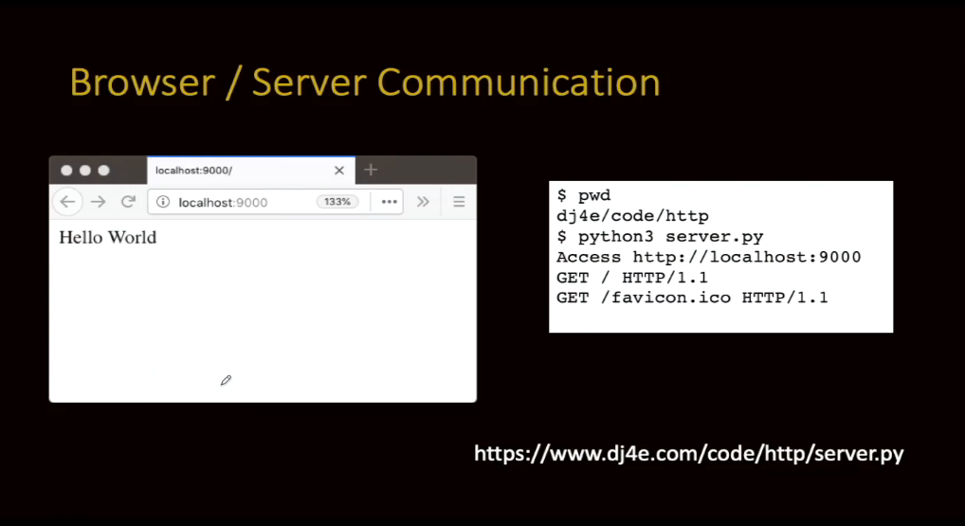

Okay, so we're going to pull in some more stuff from the socket.

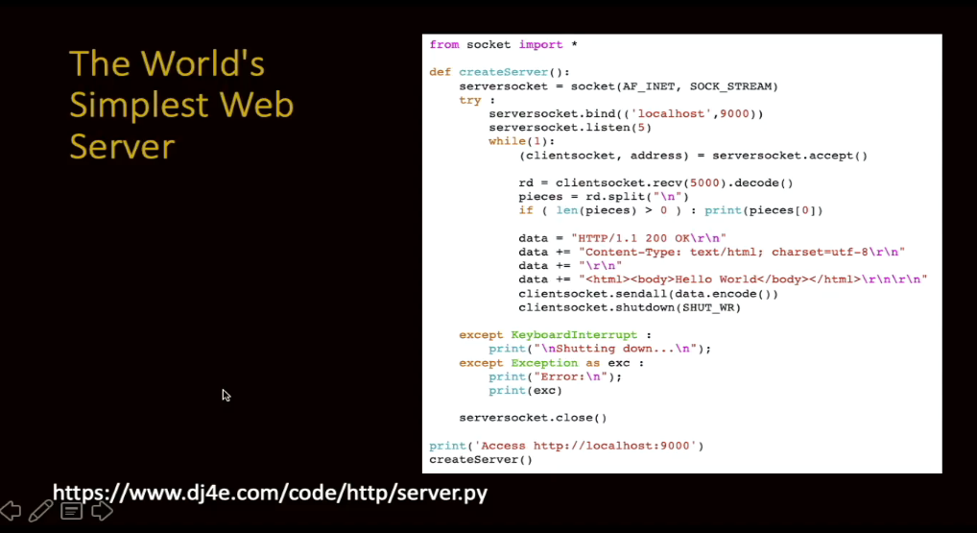

We're going to pull in some stuff from the socket right here.

We're going to make a function called createServer that we're going to call right down here, and it's going to print out how you're suppose to access it and then start the server.

Now the whole idea of the server is that the server is woke up to wait for incoming connections.

So, the server already exists.

When you start talking to a web server, that server is in that computer already.

The server software is already running, registering its interest in incoming requests.

That's what we do.

When this Python program starts, it's going to sit there and wait in an infinite loop for incoming requests.

The first thing we do is we're going to make a socket.

This looks very much like the time we made.

It's an endpoint. It's not actually making the phone call.

Remember, I said this socket call is making the phone.

We're saying, we're going to make a phone and it's up to us later to decide if we're

going to make a phone call or receive phone calls.

And then this next thing is like the connect, except this is, "I am willing on port 90 to receive the phone calls."

Now it turns out there's only one program on port 90 that can receive phone calls.

This might blow up.

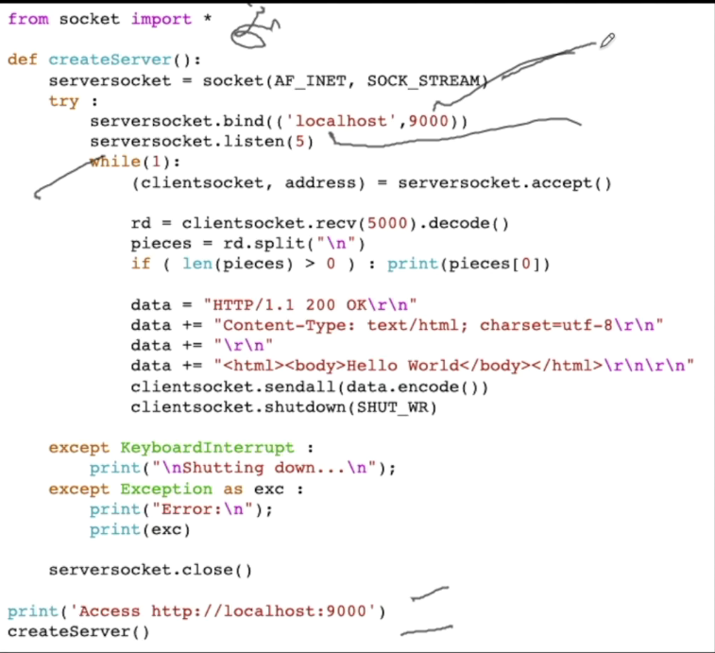

You might try to do this, I mean port 9000, and if you run this twice, and you can do it in two windows on your computer, the second one will blow up and say, you can't have port 9000 because another piece of software has it.

But as long as there's only one running, away you go.

And that's part of this whole try/except thing, because if you run this twice, it's going to blow up the second time because you cannot receive phone calls on this server on port 9000 with two applications.

One application gets the phone calls.

That's what socket listen says.

The 5 on there says, "Dear operating system, if I'm busy handling one phone call, you can hold on to four more and queue them and then I'll come back and get them for you."

That you're asking the operating system to queue incoming calls.

Don't just say you're busy, shut down.

If you didn't say this listen(5), if you're busy writing the data for phone call 1 and phone call 2 came in and you weren't ready for it right that instant, it would just deny the phone call.

That's what listen says is, "Dear operating system hold those temporarily. I'll get back to you." Which is how it works.

And then what happens is we go into this accept.

Now this accept is, "I'm at the phone, I've registered what my number is and what my extension is, and I'm ready to pick the phone up. Let me know."

So, this accept is blocking.

It stops and it just sits there.

And it can sit there forever, just literally forever.

And if nobody calls it, nothing happens.

The next line never runs until you blow it up or the server goes down.

So, that accept is a blocking.

And the reason we do this accept, well, we have to establish the phone call first, right?

Then this next line runs only when a phone call is received.

That means that we on the browser side, we already connected.

We made the phone call.

Now we haven't sent any data yet, right?

Now at this point, somewhere out there there's a piece of client software that has done a socket.connect,

and we have done accept and our accept has succeeded in the server, the connect has succeeded, and we are ready to talk.

The phone call has been made.

Now the question is, who is going to say hello?

And this is where the HTTP protocol solves our problem.

The server knows that the client must speak first, so it just does a receive.

Now you'll notice the receive and the send are the same function calls because it's a two-way thing.

Whatever the browser is sending, the server is receiving, and whatever the server sends, the browser receives, and they can do it simultaneously if they can figure it out.

But you usually kind of like say, it's your turn to listen and my turn to send and then I'll listen, and usually they kind of go back and forth.

In this, there is only one step.

The server listens, gets the GET request, sends the data back.

Then we're going to read some data and we're going to get 5,000 characters. We going to get the whole thing.

Remember it's one line, it has a GET request in it, and it has the optional parameters in it.

And we're going to split it.

Now again, we've received it as UTF-8.

We've got to decode it for Unicode inside of Python, and then we split it based on Newlines because the GET request is on one line, then header, header, header, header,

header, and then the blank line to tell us that we're ended the headers.

In this, we're just going to look at that first line.

We're not going to do anything with it.

Most servers actually like look at the line to figure out what document to send.

This a very simple server, it sends the same document no matter what the URL is.

All we do with the URL is we print it out to prove that we got it, and then we construct a response.

And in this response, again, go back to RFC 2616, and it will tell you what this response is supposed to look like.

It sends back a 200 OK.

Remember, this is all the stuff we saw.

Probably I cut and pasted it from a working thing.

We tell it that we're sending it back in content type text/html, the character set UTF-8,

remember I was telling you that, a blank line, and then some HTML.

HTML body, Hello World body.

And I'm throwing in these \r\n's, which is the network's version of newlines.

And then you will notice that I encode it before I send it, because it's Unicode inside of Python, and it needs to be sent as UTF-8.

Because when you're in a socket, that thing that's going across the socket almost always is supposed to be UTF-8. So, we encode it.

And then, because the protocol says so, as soon as we send the data, we close the connection.

And remember that the client had to close the connection too.

So, we close it, it's half closed, and then the client gets all of its data, gets the indication that it closed, knows it's finished all the data, and then the client shuts its side down.

And there are two hang-ups.

It's kind of like a phone call.

The person hangs up, and then click, you hang up.

Now you can't really keep talking, but you do want to have both sides hang up and that shutdown is what's going on.

And then the rest of this is all try/except for various things so we clean up our socket, so we don't have to restart our server when our software blows up, and so the rest of it is pretty simple.

So this while(1), the first browser will talk and then it'll send some data and it'll go back and wait for the next phone call, and that's what's going on.

The next phone call comes in, it receives a GET request.

It sends the data back, then waits for another phone call.

This is an infinite loop that sits and waits for incoming phone calls and it answers the same thing.

It's like you call this phone number and it goes and you go, "I would like a pizza," and it says, "Hello World," and then click. And then you call it up and say, "I would like a car."

And it says "Hello World."

Click. And then you say, "I would like to register for this class."

And it says, "Hello World."

Click. So this is not a very flexible server, you will build far more flexible servers, but it's the one that I could build and fit on a single page in a slide deck.

So to run this, if you download this code, and it's a tiny bit of code, and you run it, so you go somewhere, maybe your laptop, maybe PythonAnywhere, I don't know if it works on Python, it probably doesn't work on PythonAnywhere because you can't actually talk to ports.

But let's just run this on your laptop and you start the server up, somewhere get ahold of my sample code or download from here, server.py, and it's telling you this is just output from the server.

And this is the moment at which it's waiting, right?

It's waiting. The server could wait for hours at this point.

But I just give you this in a print statement so you can copy that and put it into your browser, you paste localhost:9000 into your browser, and then the server is printing that it got a GET request for the slash document from this browser.

That's what the browser sent. I mean, we're talking from Firefox browser to the little web server that we just built.

Now there's another a second GET request that you don't even know because you didn't ask for it, and that's because the browser is built in to ask for a URL called favicon.ico so that it can make an icon, and that icon ends up in the tab or wherever in your browser and so that's like an icon for the website.

So you didn't ask the browser to do this, but it's a thing browsers do.

And you'll see when you're looking at your debug logs when you're building stuff that it's a favicon.

And this happens like blink blink and now it's waiting again, right?

And you can hit refresh or you can go start a different browser, and you would see the GET requests.

Every GET request you're going to see in your browser and your server.

It's working, and it works really well and you're welcome to go ahead and play with it and try it all out.

From: https://dj4e.com/code/http/client1.py

import socket

mysock = socket.socket(socket.AF_INET, socket.SOCK_STREAM)

mysock.connect(('127.0.0.1', 9000))

cmd = 'GET http://127.0.0.1/romeo.txt HTTP/1.0\r\n\r\n'.encode()

mysock.send(cmd)

while True:

data = mysock.recv(512)

if len(data) < 1:

break

print(data.decode(),end='')

mysock.close()

Now what we're going to do is build a simple web client and it'll talk to our server.

The other web client we made talked to data.pr4e.org.

This one is going to talk to yourself.

So, it's this. It almost looks identical, right?

We're making a phone.

We're going to connect to localhost.

127.0.0.1 is the IPv4 connection, what's called loopback, right to the same host.

We're talking to port 9000 because that's where we've got our web server running,

that little web server we just wrote.

And then we're going to send a GET request, a valid GET request, to this thing HTTP/1.0,

and then two newlines and we're going to encode it into UTF-8 before we send it.

Then we send it, and then we just have a loop that prints it all out, and then when the socket gets closed, we hit a break and then we close our end of the socket.

The server clicks the phone and then we know we're done with our data but we've already printed it out, and then we hang up the phone on our end to kind of clean everything up all the way in between everything else.

This is a very simple web client.

And so now you can run the web server, right, just like we did before, and instead of talking in a browser, we run this client.

And this client gets a header of HTTP 1 OK, its content type HTML, it gets a newline, and then the body, and we're done.

Now, I mean, it's not a browser, but it is client that's talking HTTP, and so now you'll notice that this server sort of sits and waits for incoming calls.

You could run this over and over on the client, run the client over and over again, right?

And then you would see more requests, but in general the server is destined to just

sit and wait for hours potentially until a client connects to it.

Then at some point you'll just abort this server, and then if you Control C or blow this

up somehow, this will fail.

The client will fail, and it will fail in this connect code.

If you want to play with it, try to run this client without running the server, and you'll see that the connect, which is the part of actually making the phone call.

This will continue to work, which is make me a phone on my current computer. And then connect is make a call to the remote computer, that will blow up.

And then if you wanted to play with this you could put some try and excepts around it, say remote computer is not responding on port 9000, that's if you blew up you could put a try and except around that.

But I'm not doing it because it doesn't fit on my slides.

Here is an even simpler web client that we can use, and again you can get this code from my sample code.

We don't talk this week there's a higher-level thing.

The previous client talked to sockets, so I could show you the low level.

But because we spend so much time talking to URLs, we then have a urllib.

I'm just going to use urllib, and this could be a localhost or it could be whatever.

I'm just going to make a four-line urllib call.

And so I just do a urlopen of that same URL.

Now we're operating at the HTTP level because the concept of URL is not a socket concept, the concept of URL is a HTTP concept.

Then we just get in effect what looks like a file handle to us and we loop through it and print it all out.

We run our server, and the server says this and waits.

And then we run our client.

It basically hits our server and we can see in the server window, you've got to do these two things in two windows, right?

You've got to do these things in two separate windows.

So, in the server window it'll sit and wait, and then in the client window, when it runs you'll see the client will make the request to the server or blow up if the server's not running.

And the server will see the GET request and then the data will come back to the client.

You do this in two things and you can run the client over and over and over again, and you'll see every time you run the client, the server sees it, responds, and away you go.

And again, our server always says,

"Hello World" no matter what, which is delightful and classic. It's a classic.

You can actually watch when you're running Django, there will be a way for you to see when you're running Django locally and you start the server up.

We'll do this later, manage .py runserver and then you talk to it, and you will see all the GET requests.

And Django when you run it locally you can debug a lot of what's going on.

You can see like the favicon that it's asking for, and that is five or six HTTP requests to produce that little Django web page.

And so that will be something that you will learn how to do.

And so that sums up what we're doing in this.

At the beginning you look at it very simply.

Pretty soon you'll just be looking at the developer console and it will all make sense to you.

I want you to be able to know that you can dig as deep as you want to and understand all of these protocols that are going back and forth, okay? Cheers.

### Walkthrough: Browser Developer Mode

Hello and welcome to another walkthrough for Django for Everybody.

In this walkthrough, we're going to talk about the browser debugger console.

And this is something that in the old days was only in Firefox, but eventually everybody built it in and you used to have to build a plug-in.

And it shows up at different places.

And in Firefox, it's here under Tools.

It turns out that you can kind of go to any of these things because they're just different tabs here.

In Chrome, we do View, Developer, JavaScript Console, and then you see a similar kind of thing here, right?

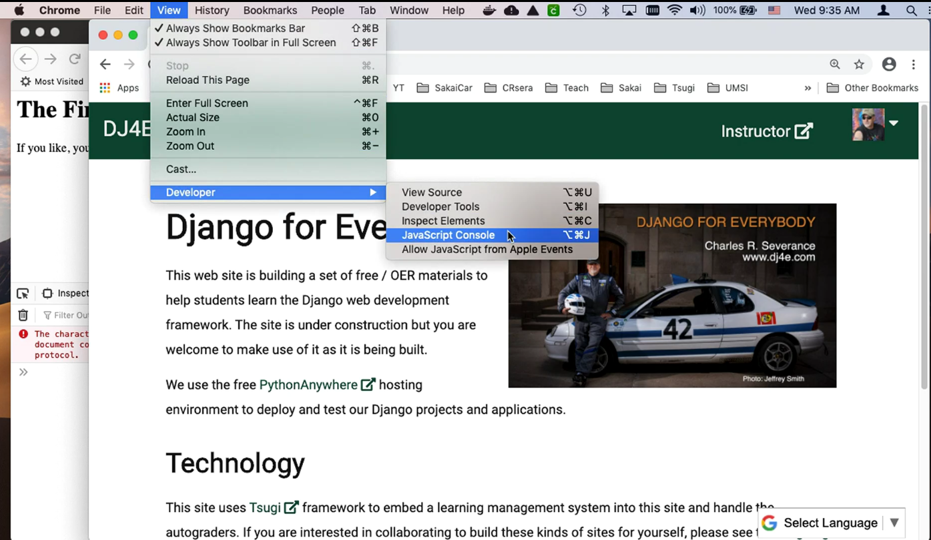

I'm going to do it in Firefox here.

And you can see the Document Object Model, you can see the JavaScript console.

This is little error hardly matters, it's because it's such a simple page.

You can actually debug JavaScript code.

You can watch the network.

You can play with CSS, etc.

Performance, cookies are in here.

There's a lot of things that you can do.

Right now, we're at the very beginning class, so I'm just going to show you some of the most basic things here.

I'm going to clear this out and then refresh the page.

And what you see here is you see each request-response cycle, right?

And I came up here as if I typed this.

Let me clear it again, so you see it.

I'm going to type this, I'm going to press Enter.

And that tells the browser to go retrieve this page.

It connects to the server, www.dr-chuck.com, and gets the document page1.htm.

This favicon.ico, that's basically getting this little favicon right here.

That's the little thing that shows up in the tab bar.

And websites can have a file and later we will actually make a favicon.

But what I want to show you from a request-response cycle, is you can see some detail here.

Let's go up here, and you can see detail.

You can see that this was the URL.

We sent a request, a GET request.

We got back a status code.

Status is the first thing, 200 is an OK, 404 is Not Found, and we used HTTP version 1.1.

They always show you the response headers first.

These request headers are actually part of the HTTP protocol where we are telling things like what my preferred language is, what kind of documents we can handle, and cookies that we're sending back in.

We'll learn more about all of this stuff.

The browser makes the connection to port 80, sends the GET request to the URL it's interested in.

**GET http://www.dr-chuck.com/page1.htm HTTP/1.1.**

And this is pretty much the format, accept colon, blah, blah, blah.

And then it sends an empty line and then it's done, and then the browser sends back first a set of headers. You know what?

The content type is very important.

The size is sometimes in here.

gzip means that it compressed it on the way.

And these are the response headers.

If I go to an error page, notapage.htm, I'm going to clear this, and what's happening here is it's putting up a page from my hosting system.

But the most important one here is this, and that is the 404 error.

And so, it was going, and it sent a GET request to <http://dr-chuck.com/notapage.htm>, and it got back a 404 Not Found.

That 404 Not Found is a different status code that said this is a thing that's not there, 500 means the server had an error, and we'll talk about all these codes.

But the point is that you can debug all this stuff quite nicely.

Let me go back to page1.htm.

Let's clear this and refresh it to make sure we got it all right.

Okay, so we grab the page.

And now another thing that you probably by now have figured out to be able to do is inspect element.

Now you're actually looking at this Document Object Model, right?

This Document Object Model is not necessarily the code that came back from the server.

But here in Network if I click here on GET and I look at the response, this is the response down here.

This is what actually came back from the server.

And then the browser parses this and turns it into what's called the Document Object Model.

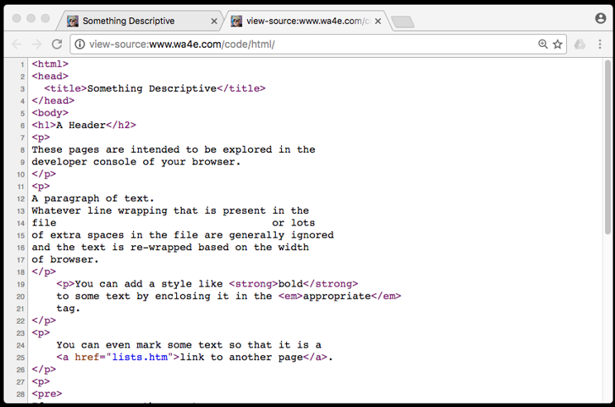

This is the source.

Now, just for fun here, you'll notice that I can change the Document Object Model here, right?

"If you are cool, you can switch to the second page."

Notice the Document Object Model changed and what I saw up here changed as well.

This is like inspect element.

I can do something like I can even add here, I can add some CSS, style="color:red;" and if all goes well, there you go.

You see I switched the color.

This is the Document Object Model.

Now the server was completely uninvolved in that.

And later, we're going to write a lot of code to mess with the Document Object Model.

The server, it doesn't have the red in here, it didn't change this to cool.

This is what we originally got from the server and this is what we've got in the browser.

And so once that page comes from the server, you or JavaScript can mess with that page.

Okay, so now I'm going to clear it, and I'm just going to click on this second page, which is an anchor.

Let's inspect it, well, it's an anchor tag.

So it's going to do another GET request.

And so this time it went and grabbed page 2 and there's the second page,

and you can go back to the first page.

And so there's a lot of things that you can see.

This Persist Logs is

an important feature. That

means that it keeps them across

more than one request and Disable Cache means that

sometimes the browser wants to keep a copy of something and you, while you're debugging, you want to say, "Hey, go get the original every time."

And so right now I am getting you starting you on very simple pages,

but if you take a more complex page and I can never remember where it is, View, Developer, Network, let's go here.

If you take a more complex page with a bunch of things in it, and you hit Refresh on this page, you will see that it does a GET request but then as it parses that GET request, it finds things like all kinds of stuff, right?

So here this took 44 request-response cycles, 1.6 megabytes, and it took almost one second to download all that stuff, right?

It took a second to download it.

And so if you go, you scroll all the way up to the top, the original GET request was to this URL which was /lessons/rrc, which is the URL.

But then if you were to look at the response, and I don't want to see that, I want to see the actual HTTP.

If you look at the response, you see all these URLs for more stuff, some CSS, some JavaScript, some who knows what?

And so then what you see is you see it then retrieving

all these other things that it needs to actually construct the page, some CSS, grabbed a font, it grabbed jQuery, it grabbed timeago, and it grabbed a bunch of JavaScript and

fonts and this and then the translate.

You see this little translate thing? It's doing that.

You'll see that's how it quickly builds up to about 44 request-response cycles to produce a page.

Now, so that's just my quick introduction to this.

You may not see these little drop-downs like this.

You might have to turn them on in Preferences.

You go into Preferences somewhere.

I turned them on a long time ago, I probably couldn't even find it, but you might see it.

The other thing that I would suggest is, don't use Safari, because Safari is trying to hide too much stuff, like it doesn't even show you the URL unless you click on it.

So Safari is kind of a pain in the neck, and so I would suggest that for this class you either use Firefox or you use Chrome in addition to using Safari.

Safari is fine for daily use, but I just find it as a debugger it's bad, which is really sad for Safari.

They made Safari unfriendly to software developers, which means we're not going to test our stuff on Safari, which means if it breaks, too bad.

Well, enough of that little Safari diatribe.

Again, I hope that you found this walkthrough for Django for Everybody, as usual, helpful. Cheers.

### Exploring the HyperText Transfer Protocol

### Welcome from Guido van Rossum

I am Guido van Rossum.

I created the Python language.

I've worked on Python for 25 years and I've worked with a large group of others, of course, in the Python community.

I'm very excited to see you all in this class.

And I'm very proud that you're using my language to learn.

Python is just the first step you are setting on the path to programming.

There are many exciting things to learn in programming, many that you can learn using Python, many that you can learn using other things and you won't be alone.

There will be millions of people who have gone before you or who are learning Python at the same time as you and you can help each other and you can learn together.

### Face to Face Office Hours - Bletchley Park

### Len Klienrock - The First Two Packets on the Internet

When you walk into the back entrance of Boelter Hall on the UCLA campus, you may notice a seemingly random pattern of floor tiles in the entrance.

If you spend a little time looking at the pattern, it might dawn on you that the tiles

represent zeros and ones, and then you might even figure out that the tiles represent ASCII characters.

The characters in the floor tiles spell out "lo and behold" to commemorate the building

where L and O were the first two packets ever sent on the ARPANET from UCLA to Stanford Research Institute on October 29th, 1969.

ARPA wanted a network so that they could share the large computing resources they

had given to their researchers across the country.

University of Utah had a terrific graphics operating system.

SRI had database, we had simulation.

University of Illinois had high-performance computing.

Every time ARPA brought on a new researcher, they'd offer to buy him a computer, fine,

but the researcher will say, "I want the same capability all those other guys have.

I want the graphics, the database, and all the rest."

ARPA said, "We can't afford that.

If you want to do graphics, you log onto the machine at Utah through a network that we think we're going to make."

The network was to do resource sharing and not to protect the United States against a nuclear holocaust.

When Bob Taylor came in as the next director and he recognized this need for sharing resources.

By the way, notice the phrase I'm using.

Sharing resources is exactly what I built into the network design.

Now they wanted to share the external resources.

Same idea.

You have it, you're not using it, somebody else should be able to.

So they brought in Larry Roberts, another classmate of mine, in fact, an office mate of mine at MIT, to manage this project.

He came to me because he knew my work.

He watched me do the simulation.

In fact, I used his compiler on the TX-2 computer and said, "Len, we need to know if this thing's going to work."

He knew that I had the theory so I could show it to him, it's going to work.

In fact, he even says he would never have decided to spend millions of dollars of

the US government's money if he wasn't sure this thing would work.

The design began to be laid out by a few of us in 1967.

In '68, they sent out a request for proposal.

The end of '68, Bolt Beranek and Newman, a Cambridge, Massachusetts firm won the contract to produce the first switch of the ARPANET.

We became the network measurement center early on so we could test it out.

During the design phase, some great people were there throwing their ideas out.

Herb Baskin was there, a time-sharing expert.

He said, "If this network can't deliver short messages within a half a second, I can't use it for time-sharing."

Specification, half a second.

By the way, we got 200 milliseconds.

Wes Clark said, "Swap your computer from communications."

I said, "Look, if this is going to be an experiment," and I was also interested in the research and experimentation.

"We have to build software so we can run experiments."

Artificial traffic generators, measurement hooks, a place where the measurements can be evaluated, put the software in.

Howard Frank began to talk about network reliability and said, "If anything fails, the network shouldn't collapse."

We didn't say this should be five nines of uptime.

We were much more pragmatic.

We said, "If any single thing fails, everybody else can still talk."

To do that, you need something called a two connected topology, two independent pairs between every pair of nodes built in it.

All those specs went to BBN, they built the darn thing.

They delivered the switch here at UCLA on schedule.

Eight months after they got the contract, they were to deliver this new technology, new applications, new device, they did it on time, on budget, it came here, we plugged it in and bits began to move back and forth between our time-shared machine and that switch on the day after Labor Day, September 2nd, 1969.

But that was just a one-node network.

The schedule was that another one of these switches would be delivered at Stanford Research Institute, 400 miles to the north and they would connect that to their machine and that happened in October.

In October, 1969, we had a two-node network.

My machine, my switch, another switch 400 miles away, and the SRI host.

It wasn't one single line, it was a gang of 4.8 kilobit per second lines.

So now what do you do? You have a two-node network.

Well, now you can do something.

Then we decided one night late in October, programmer Charley Klein and I went there and we say, "Look, let's communicate between these two machines."

We got a hold of Bill Duvall, their programmer up there, and we said, "Let's simply log in from a terminal connected to our host to that machine."

The idea is these are both time-sharing systems.

They expect terminals to connect in and use the services of the machine.

The big thing was, sit at a terminal here, log onto your machine here, and through this wonderful network, log on here as if you're a local user.

That's easy enough. So, we got all set, got Charley down at the terminal over here, and just to be sure this worked, we had a telephone handset.

In fact, here it is.

I just happen to have it. That was the telephone here.

That's the telephone.

That was the telephone. We plugged it in.

The radios in Skype?

Afraid not. Plugged it in, we used a piece of the high-speed line for the phone connection, but with the interesting thing is, we were using the defunct circuit switching technology to prove out the new packet switching technology, and it really helped us, until we see what's going on.

Charley typed the L, and said you get the L?

Bill said, "Yeah, got the L." You've got the O?

We're trying to do L-O-G for login.

Got the O? Got the O. Got the G?

Got the G, crash.

The first message ever on the network was "lo", as in "lo and behold".

Now, that's especially interesting because if you go outside this hallway here,

down into the alley, and come into another entrance to this building.

I just discovered this about a week ago.

You walk on a platform and there's a mosaic of tiles down there, and they're a strange pattern.

It turns out it's the ASCII code for "lo and behold".

I have no idea who did that, it's about a year and a half now.

Some very clever person put that in.

That was the first message, October 29th, 1969 at 10:30 at night.

You're entering 1969 right now, we reproduced this room to look as it did, and smell,

and feel like it did some 40-odd years ago.

If look over here,

you're looking at the first piece of

equipment ever on the Internet.

This is that first interface message processor,

IMP number 1 at UCLA,

a Honeywell minicomputer adapted

by Bolt Beranek and Newman,

BB and N. To

operate as a switch to channel [inaudible] functionality.

This is the same physical four square feet where it

served as the opening node of the Internet,

the first piece of equipment ever on the Internet.

That's the actual one?

That's it. I kept it for years,

they tried to throw it away many times.

Most of the people had [inaudible] have tossed them.

This is the one or two left around the world,

but this is number 1, it's the first piece.

If you open this machine, you'll

be privileged to smell it.

Yeah.

It's got an unusual odor and just brings you right back,

emotionally, that's great, can't smell it through there.

This is a military hardware machine.

This machine was

essentially state-of-the-art minicomputer,

which was adapted by BB and N,

and I first saw it in

1968 at one of the joint computer conference shows,

thousands of people in a big exhibit floor.

You see these sky hooks up here?

They had one of these machines hanging from the ceiling,

swinging in the air,

running and there was a guy,

a big guy, stripped to the waist,

oiled skin with a sledgehammer,

and he was going whack,

to show that it was military, and it was.

But the most important document of the Internet,

the most important document

of the entire Internet is right here.

You talked about who was working with me.

Well, one of my software programmers was Jon Postel.

In fact here's his picture, and he was not a hippie,

even though he appears to be.

He was the one who basically disciplined

my staff to do things properly and keep records.

He said we have to keep a record of what's going on,

so beginning in October,

basically a month after the IMP arrived,

we started keeping an IMP log.

You know it, this is an engineer's log.

This is not Madison Avenue piece

of document, just scribble,

we're using old STS log,

and in here we kept a record of what's going on.

The most important entry happens to be right

here on October 29th,

1969 at 10:30 at night, Charley Klein,

the programmer was in the room with me made this entry,

talked to SRI host-to-host.

This is the only record of

the very first message ever on the Internet, right here.

We had the technology,

we started making measurements,

we were the first experimental node,

so we saw things happening.

How come we have a 50 kilobit per second line,

the routing procedure either goes one way or the other,

one at a time, so how can you

get more than 50 kilobits per second between

two nodes if there's only one path at any time?

We said, it's obvious,

that pair design now when it gets backed up,

you change paths, to this guy's empty,

and it's packed backup while you're sending this way.

They got close to 100 kilobit per second too.

So we could break it [inaudible] as I said, and every time we did, we would call BB and N and say, "fix it, we did this, fix it," because they wouldn't give us the code.

They kept it proprietary until [inaudible] said, "We paid for that code, you have to open it," they did, we saw it.

It would take them six months to fix anything.

We discover a fault, this time we had the code, we'd show them how to fix it, still took six months.

One of the things I was very much interested in with design was, distributed control.

Why? When I was a student of Shannon, and Shannon's great work came when he had

a lot of things interact with long code words, for example, that's when these emerging properties arise.

I said, I want to design large networks.

If It's not a large network, you can't have a single point of control, you have to distribute it.

What does it mean to distribute control?

You're delegating authority to all the peers.

When [inaudible] started funding principal investigators, they had the same philosophy.

Look, you're a smart guy, here's some money.

Go do the thing you do best, we're not going to sit on top of you, make good things happen.

So here we are, I'm a recipient of that kind of money. What do I do with it?

I've got my graduate students, they're brilliant kids.

Look, we need a host-to-host protocol, here.

I'm not going to sit on top of you, I'm going to run with it.

That is not a product mentality.

That is a research and development to create at the time, and it worked so well.

### Lecture Resources

**Installing Django on PythonAnywhere**

The following materials may be helpful to you as you review this week's lectures and content.

* The [PythonAnywhere](https://www.pythonanywhere.com/) website will be used throughout the course to build out web sites and submit them for grading.
* You will use this [Writing Your First Django App, Part I tutorial](https://docs.djangoproject.com/en/3.0/intro/tutorial01/) from Django's documentation to complete the assignment and some quiz answers may also come from this site.

Resources you might find useful / interesting:

* [Following the official Django Tutorial on PythonAnywhere](https://help.pythonanywhere.com/pages/FollowingTheDjangoTutorial/) serves as a companion guide to the previous tutorial. This tutorial is for Django 2 and the course uses Django 3 - but the process to install is similar and there is some useful information on this page.

### Installing Django on PythonAnywhere

Hello, and welcome to a demonstration for Django for Everybody.

This is to install Django on PythonAnywhere.

In a sense, we're going to just be getting started.

This is a bit tricky because there's a tutorial on how to write your first Django application.

There's a tutorial on how to set up Django.org on PythonAnywhere.

And neither of these are exactly perfect.

What I've got is an assignment that sort of walks you through a series of things that lay down some necessary things for this class.

And so the first thing we're going to do is you should have a PythonAnywhere account.

And you should be able to log in on the PythonAnywhere account and you should be able to get somewhere.

So this is my Dr. Chuck, this is my account that I use to, I use to be a student on this.

There's other accounts that I have for the production stuff, but this is one of my student accounts.

And so the first thing you're going to do is you're going to use a console and you're going to start a Bash shell.

This is actually Linux.

And I love PythonAnywhere, I love the fact that we're learning Linux.

Hopefully you'll just get a little more comfort with Linux as we go.

But this is where you're going to do a lot of the command line of the system.

We're going to do mkdir virtual environment.

You might be able to make this Python 3.7 or Python 3.8.

The later that Python is, the better.

This is going to take a while because it's going to create what's called a virtual environment that allows you to have your own version of Python, your own set of installed Python libraries.

And virtual environments are a wonderful thing in Python.

Because then you don't have to ask the owner of this system,

which is PythonAnywhere, hey, could you upgrade the Python?

Turns out you can upgrade the Python all by yourself.

So we will sit and let this,

oh, there we go, it ran right away and

[SOUND], it ran right away.

So let's go do the next thing.

The next thing I know takes a long time.

So the next step is to install Django.

Now, this is pip, it is installing software.

So it's going to download a bunch of software, and

then it's going to install that software.

And it's installing it in our django3 environment, right?

And so this is not installing it for the whole system,

it's just installing it for us.

And so you'll get used to the idea that you've got to work on the Django,

in the appropriate Django environment.

We're using Django 3.0 in this situation.

As of the recording of this, Django 3.0.2 is out.

Django 3 is quite nice.

So we'll just sit and watch this for a while.

So it's finished, and now we have it installed.

Now, there's a command that gets us into,

This is redundant right now because we're already in it.

But work on Django 3 and make sure that you're in it.

Then the next thing to do is grab this command and

make sure your Django version is right.

If that says 3.0.2 or later, then life is good and you have your Django working.

Now, I want to also have you install some of the sample code in the class.

I'll get this started, and I'll explain what's going on.

So this is GitHub, and this is code that I maintain, and I can update this code and

I can send it to you.

And so this is a lot of sample code.

So if you go to dj4e, tab I hit the Tab key to do completion there,

there is a bunch of files in here.

And this is the kind of sample code that we're going to go through in the class.

And so we need to add the requirements.

pip, again, is the dependency manager.

There's a file requirements.txt that says hey, we need a whole bunch of libraries.

And so let's install those libraries.

Now, in your first Python applications, you're not going to need all of these libraries.

But I want to get them installed into your virtual environment early on so that as we go along, you're not going to add a feature like social authentication, which is this little application right there, like social authentication, and then, oops, we had to install a thing.

I want to get all that stuff installed at the beginning.

And this will take a little while, so we'll just pause for a bit.

Okay, so that finished.

And now what we want to do is run a command, manage.py check.

You're going to run this command a lot.

And we're in actually a Django application.

And this Python manage.py check reads through your files and these files that point to other files, looks for syntax errors.

And it's a good way to check the sanity of your application.

Because if it won't pass this manage.py check, it's not going to start.

We haven't even tried to start this application yet and put it up on the web.

For now, that's what we're doing.

So don't worry about this message, we'll get to that later.

We can say python3 manage makemigrations.

And in this one, it's going to say no change detected.

And then we're going to do some,

we're going to run migrate, and that will create a bunch of database tables.

Don't worry too much about that.

So we've finished there.

Now we're going to actually pick up in the Django application.

We're going to basically make a new Django, we're going to make a folder.

So we're going to go back to our home directory, cd ~ says go back to home directory.

And we're going to make a directory called django_projects.

This is so you can have more than one of them.

We're going to go into that directory, cd django_projects.

And then we're going to start a project my test site.

Now what this does is this actually created

a whole bunch of files in my test site, okay?

Now, we do have to edit one file. I'm going to edit this file.

Now, I have a whole thing on how to edit files on PythonAnywhere.

I'll do it the hard way, I'll do it the way you probably will do it, and that is use this Files screen.

Oops, I have to go back and get my shell, dang it, Console > Open Link in New Tab.

You'll find that you'll want to have, go back to that console.

Here I am, I want to edit some files, so I can go into django_projects > mysite, mysite.

And then settings.py is the file that it's telling me to edit.

It says mysite/mysite, it's a little weird that the name is doubled.

You've got to go down to around line 28 and say add quote, star, quote.

And that has to do with protecting what systems can talk to this web server, and we're just going to say anybody can do it.

Do not set this to false, forget this warning, it's a lie.

We are not in production, we are in development.

Then we have to say Save, so that will save our file, okay?

So let's go back, we had to do that.

Here's different ways of editing the file.

You can use nano on the command line, and that's cool.

I just used this number one way to do that.

vi is really cool, but we won't do that.

Okay, so now we need to convince PythonAnywhere to run the application, okay?

And so that is under another tab, that is under, I'm going to open this in a new tab.

Now I have these files, actually I don't need this tab anymore, I should, oops,

I should say python3 manage.py check here just to kind of be creative.

Yeah, that's good.

You always want to do python3.

I'm in the site, the actual website that has manage.py in it, python.

Actually, you don't have to say python3 any more, it's after the year 2020.

You can say python, python manage.py check.

You'll see me type python3 all the time because old habits die hard during

the transition from Python 2 to Python 3.

That's good, that suggests that this application in django_projects is in good shape.

So now I have to go look at this web app setup.

And what's going on here is this is PythonAnywhere's way of taking the code in that folder and running it and giving you a web address for that.

And so the first thing you've got to do is you've got to set this up.

And this is correctly set up.

You've got to point to the folder that has that manage.py in it.

And if I go to the console and type pwd, print working directory,

you see home, Django, Dr. Chuck's mysite.

And this is the file that has, the folder that has manage.py in it.

These two things have got to be right.

This code here has also got to be right.

When you see this, it's going to start out really big.

Throw it all away, throw the sample away.

I give you the entire code to put in there.

And again, it's all setting up which site.

And then, we also have to set the virtual environment in this Web tab, got to go back to the Web tab.

We've got to set this virtual environment.

And I want that to be, you've got to go and change the name of it.

Don't do the same as me, this is for my virtual environment.

It checks, yep, there's a good virtual environment.

You have this source code, working directory, WSGI configuration file, and virtual environment set properly.

We'll come back to this.

These are error logs.

And if all goes well at this point, let's double-check the assignment.

Hit the Reload, it's what it says.

Every time you change your code, you have to tell PythonAnywhere, so this takes a little bit.

And if all goes well, I will open this URL in a new tab.

And it worked, debug is true.

Please leave debug true, or else this course is going to be really tiresome for you, okay?

So that's the first step, but then we have a little bit more work to do.

We're going to add a polls application.

So we're going to go back into that,

I'm already in that folder, I'm in that folder.

And then I'm going to start an application, oops, come back,

I'm going to build an application.

This is a way to create a bunch of source code.

So one of the things about Django is that it comes with batteries included.

And so in this particular case,

it's writing a bunch of code in a folder named polls, okay?

And so that's now in polls.

And then we go continue on our, now we're going to pick up in this Django tutorial.

We said startapp polls, we did that.

And we're going to edit a file polls/views.py.

And we're going to copy this code here,

Open a new tab, and django_projects

> mysite > polls > views.py.

That code is in a tutorial, going back to the tutorial.

It says create a file called urls.py in that same folder and put in this code, so I'll copy this.

I'm going to create a new file here, urls.py, New file.

Let's put that stuff in there and save that file.

Then we go back and then we are going to go into mysite.

So polls/urls.py is an application, mysite is for the entire site.

And I'll grab this code also.

This file already exists, so we go mysite > mysite > settings.

This is the only folder that has settings.py in it.

I wasn't supposed to edit settings, I was supposed to edit urls.

And this looks pretty good, we'll just add the line.

Well, actually we've got to do all of it because we have to import the include.

This little import include, this little part here was there.

So, I copied this.

These are all, of course, comments.

All these files are just some Python.

This is setting a variable called urlpatterns to an array, and

path is a thing that returns an object.

And you can go read all the documentation.

And then I will save this, and then let's go back.

Now, every time you see here when it says python3 manage runserver, you want to go do python3 manage check.

That's like do everything but run the server, except run the server.

And again, you could get errors here, and read those errors.

They're tracebacks. They'll say, oh, no comma found.

Let me just make a mistake so you see what happens.

I'm not making mistakes.

Come back, and let's go into this file.

Let's forget a parenthesis, okay? Let's save it.

Shocking. See?

Now when I did a python3 manage.py check, it blows up.

And it tells me something's kind of funky around line 22 of urls.py, looky-look.

I mean, my editor even told me that, so there we go.

I fix that back up and I say save.

And now I go back and I type, by the way, you can hit up arrow and you can run a command again.

python3 manage.py finds no issues.

Then what do we do to test our application?

We go to the web app.

Now, we've got these guys set up, we don't have to change those, they're all set up again.

We hit the Reload button, take a little bit of moment.

Let me go over to our actual application.

Now, this looks like a failure, but it's not, because it turns out that that little bit of code you run is sitting at polls.

And so that's a code that you ran.

At this point, you have completed the assignment.

I got a little bit of odd errors down there.

We walked through that. It wasn't too bad.

Getting things set up is often the hardest bit, but hopefully in a little bit of time you'll have it all working.

And then we'll start adding things to our application.

Hope this was helpful.

Cheers!

### Understanding the DJ4E Autograder

### Guido van Rossum: The Early Years of Python

I worked at this place, CWI and for my damn current project, which was the Amoeba Operating System, which I was working under Sape Mullender.

One of our projects was to write application-level utilities for this new Amoeba operating system.

There was an operating system kernel, and it was very good at talking to the network and it was very good at managing processes, but there wasn't much user-level software

that was barely a shell.

I think there was a ported very old Unix shell, something like the original Unix version 6 shell, but because the file system model on Amoeba was so very different, we couldn't take an existing suite of Unix utilities.

We wanted it to be self-hosting and in order to do that, we realized we needed a large amount of user-level applications, utilities, tools, whatever you call it, from an editor to

a mail program to a login utility and a backup tool.

One of the things I realized as we had a small team of people working on those things,

that it was very slow-going writing all that stuff in C and it wasn't particularly

interesting or novel or difficult and often we also didn't really care how fast the code ran.

All the reasons why you would write a piece of software in C didn't really apply.

The only reason left was that C was the only language that for which we had a compiler.

There was this ABC language that I had in the back of my mind that would be a much better language to write a whole bunch of utility application tools for Amoeba.

Except that ABC was so high and abstract that it wasn't a good language to talk to servers and file systems and processes.

The whole operating system thing was abstracted away from ABC.

In an alternate universe,

ABC could have become the language of spreadsheets.

It was very good for talking about

a user's data and doing all clever stuff with that data.

It did that using very general, all-purpose data structures like lists and dictionaries.

Of course, it had very nice code structuring devices like a small number of simple statements that could be combined in any way you wanted to create other constructs,

the usual function and procedure abstractions.

It was not at all an object-oriented language, although the implementation had some objects shining through.

Anyway, ABC as it existed, still wasn't usable.

But I somehow since I had worked on the ABC project, I knew exactly how it was built and I had this idea in my head that, given how much time we had available for our project, I could actually build a whole new language, design and implement it from scratch, given what I learned about both the design and the implementation of ABC, and start using it to implement our suite of tools and still be ahead of the game compared to a situation where we will just clinch on writing the things we wanted to write in C. For three months, I did my day job and at night and whenever I got a chance, I kept working on Python.

I believed that within three months, I was to the point where I could tell people, "Look here, this is what I built." It had an interactive interpreter loop.

the first demos were all, let's assign an expression to a variable and print it back and let's define a small function and call it and let's put some things in an array and iterate over the array.

All those things worked.

Somehow, and I don't exactly know how fast this happened, but certainly my two office-mates were almost instantly taken with it and started helping out.

They and the few others within the institute were very excited about this thing that I built.

Of course, we didn't instantly use it on Amoeba because it wasn't mature enough to actually write the Amoeba utilities that we wanted, but it was already instantly useful enough to run on our Unix system.

People within CWI, even outside my own department, started using it and recognizing that it was fun and productive to use.

They used it for small scripts.

People started contributing things like bug fixes.

Somehow things went very quickly during that first year because I think by the end of 1990, a year after I started, we developed a plan to do an open source release of this language.

This was before the word open source had even been coined.

We didn't call it that, but we did have some models.

We had X11, the Windows system at the time.

It had a distribution that was one of the open source examples.

With two colleagues, I worked on building a distribution.

It turned out to be very simple to get management to sign off on this release.

That was an incredibly lucky stroke.

I asked my managers. "

Manager, What shall we do about this?"

He said you got to talk to this and this person in

the administrative branch of the institute.

I talked to this woman and she

was in charge of all legal affairs, I believe.

I said, "Well, I have written

this source code and I would like to release that

and I have made up a license

that's identical to the MIT license.

MIT releases software under exactly this license."

We just put the formal name of our institute in there

instead of the regions of the Institute.

She asked me some questions like,

"Did someone pay for this to be developed?"

My answer was "No,

I started this all on my own time,

and it was for this research project.

My Manager is fine with it."

So she said, "Sure,

go head, " and we did it.

So in February '91,

we did the first Python release and

it felt at the time like an incredible milestone.

We needed to post it to Usenet.

There was this Usenet newsgroup that would

receive source code for random free projects.

I got immediately started getting

useful positive feedback initially just

from random people who picked up

free software from Usenet,

and we quickly got

into a routine of doing new Python releases.

There were the obvious improvements to the language,

and the library, and bug fixes.

A very important category of

things that were often contributed were

ports or porting fixes where

people had different architectures, different compilers.

The Unix world was much less homogeneous at the time.

There were lots of small Unix vendors that had

their own compilers or their own hardware,

all things.

So the big things that happened during, say,

the first half of the '90's was a community

of Python users and developers self-organized.

Then came the invitation to come

to the United States for a couple months.

From whom?

From NIST,

the National Institute for Standards and Technology.

So I spent two months there.

We organized the first Python workshop,

which was hosted by NIST.

Through that Python workshop,

I met people who offered me a job.

I went back to the Netherlands for

a few months and then from '95 to

2001 US in Northern Virginia at CNRI.

There we worked through

a lot of growth of the community and the infrastructure.

We created the Python website.

I got in touch with a bunch of people who are

still active in the Python community, like Barry Warsaw.

I think when I started there,

Python 1.3 was about to be released.

While I was there, we released

several subsequent versions leading up to 1.5.2,

which for some reason 1.5.0 was nothing but 1.5.2

remained the gold standard

of Python for a very long time afterwards.

### Paper: [Gordon Bell: Building Blocks of Computing](https://courses.edx.org/assets/courseware/v1/381eecc5e01392d530e45c0c4b05d5d0/asset-v1:MichiganX+dj4e101x+2T2021+type@asset+block/2015-05-Guido-Early-Years-Python-IEEE.pdf)

### Lectures Resources

**HyperText Markup Language (HTML)**

The following materials may be helpful to you as you review this week's lectures and content.

* [Downloadable slides for this week's lectures.](https://courses.edx.org/assets/courseware/v1/75db75f74f98a95c9ee55eae47291a3d/asset-v1:MichiganX+dj4e101x+2T2021+type@asset+block/C1-Week3.pptx)
* [HTML Sample Code (Browse)](https://www.dj4e.com/code/html/index.htm) is the source for the example code used in the lecture. You can walk view the code in the browser with this link.
* [HTML Sample Code (Download ZIP)](https://www.dj4e.com/code/html.zip) allows you to download the sample code to your computer.

### HTML - HyperText Markup Language (Part 1)

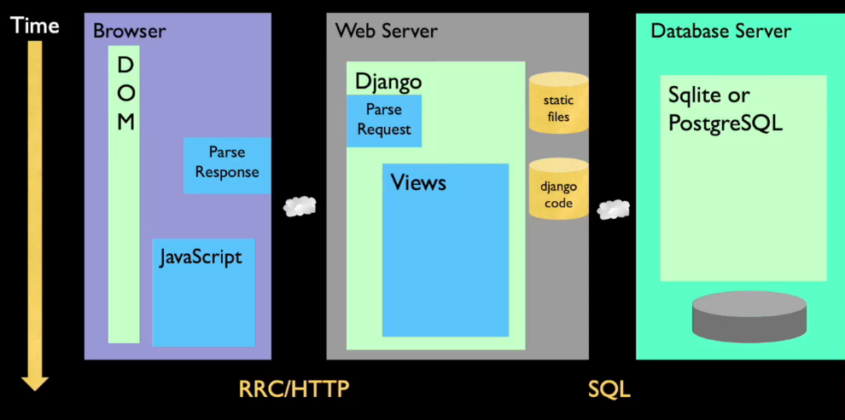

Hello and welcome to our lecture on HTML, the Hypertext Markup Language.

I'm going to place this in the context of our request-response cycle, and sort of here's us in the request-response cycle in our browser and what we're seeing.

We make a click, it goes across the network to the web server, runs some code, maybe talks to a database, formats up some new stuff, and we get the response.

Then HTML comes out, and then that's parsed to make the DOM and what we see is the Document Object Model.

And we're going to ignore most of that in this lecture.

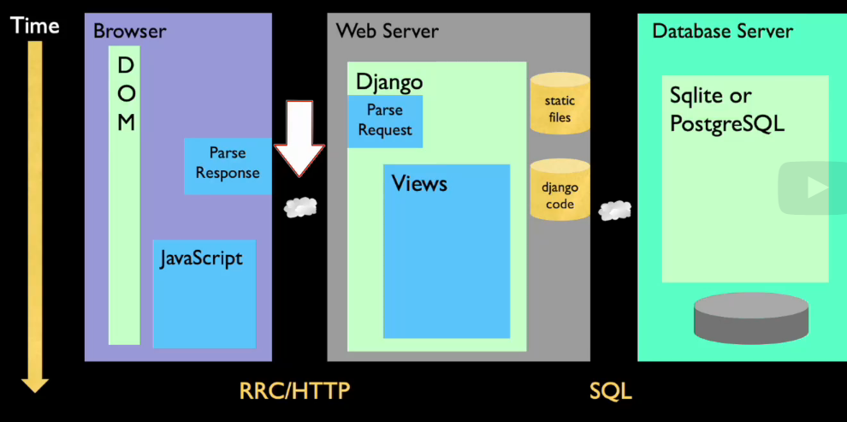

We are really only going to talk about this part here and that is what this response is.

It's HTML and it is parsed and it's read through and it's used to construct the Document Object Model, which then shows what we see.

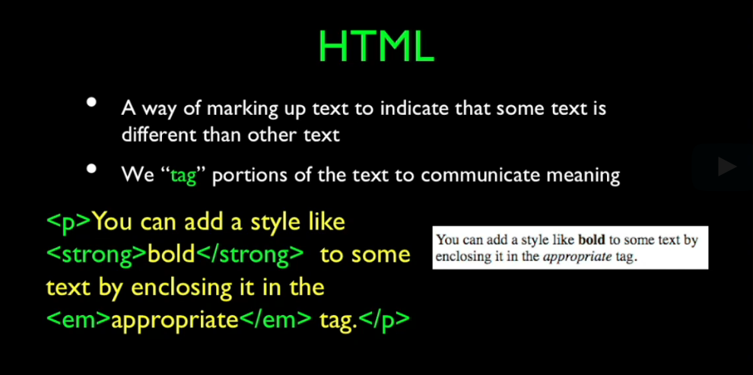

And so, HTML is just a technique of using some special characters, less than and greater than, to add tags to indicate what we want to see, like the paragraph tag.

The paragraph tag, that's a paragraph tag, strong tag makes things bold, emphasize tag, and a paragraph tag.

And we have these tags and we just mark up, we're communicating meaning.

If you're old enough to remember, old word processors used to have ways to look at the actual codes that were being stored in the word processor file.

The web is, the HTML and Hypertext Transport Protocol and all that stuff is a relatively recent invention and we're doing so many cool things with it.

It's continuously evolving and it’s really less than 20 years old, but we're doing so much with it, it's continuously evolving.

HTML and CSS are really kind of at the edge.

Looking back in the early days, if we take a look at what HTML was really intended to do,

it worked on a NeXT computer in the early 1990s.

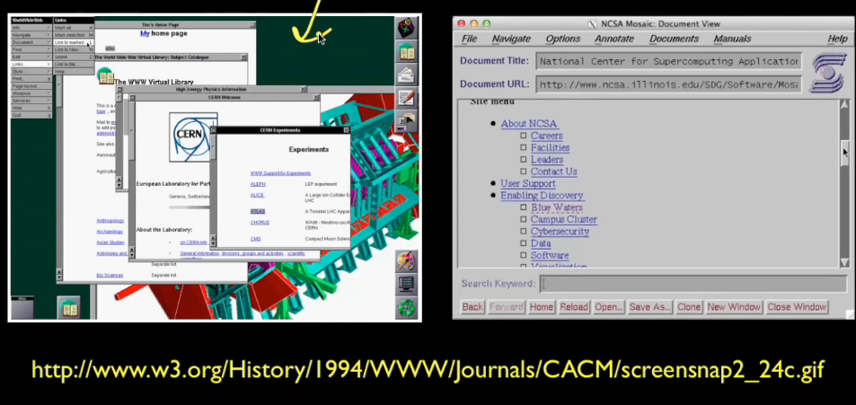

And this is the NeXT browser which came from CERN.

And it had everything in a new window, images were not shown inline.

And then there was the NCSA Mosaic browser, which was the first browser that was universally available on Unix, Windows, and Macintosh.

And you see things like a gray background and blue links and highlighted links that you visited in purple.

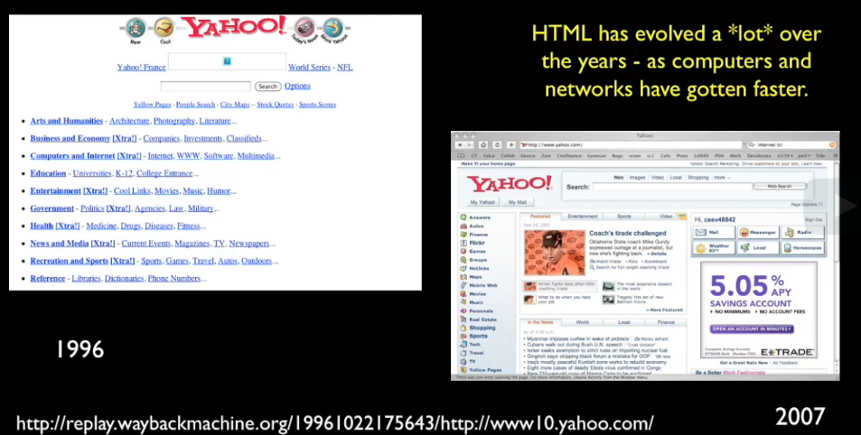

In the early days, it was nothing like what we see today.

In the early days, we were just amazed and happy that we could see a link and you'd

click the link and something would happen.

But today, money has is be made based on making stuff super beautiful and the number of pixels and how things line up and how things are shoved over and how navigation looks.

And so today we need to create beautiful web pages, whereas in the old days, we were just amazed to have web pages that worked in the first place.

And of course, computers have gotten much faster, are capable of handling video and images.

Back in the old days, images were costly, both for network bandwidth and for the time it took your computer to display them, and so that just affected how we did it.

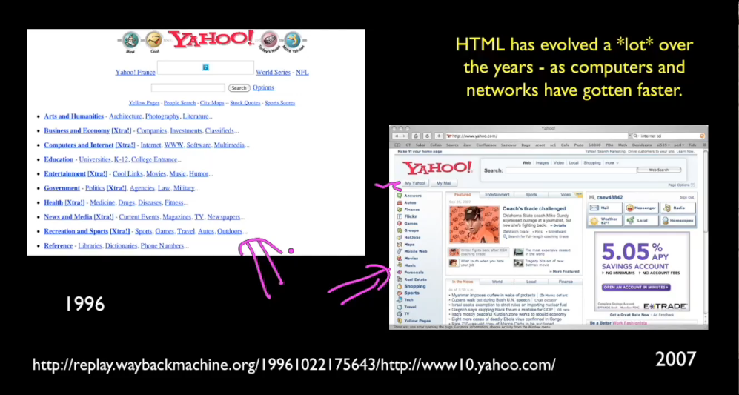

And it's kind of fun to use the Wayback Machine, otherwise known as the Internet Archive, to go back and look at some of these older web pages and realize that it's still

amazing that a lot of them pretty much work.

And in the good old days, HTML was kind of a wild west.

The browsers did not want to show broken HTML as broken HTML and so they compensated for it.

And in the old days we had things like tags that could be uppercase, we would have a paragraph tag that didn't finish, we would have li tags that didn't finish, we would have attributes that didn't even have double quotes in them.

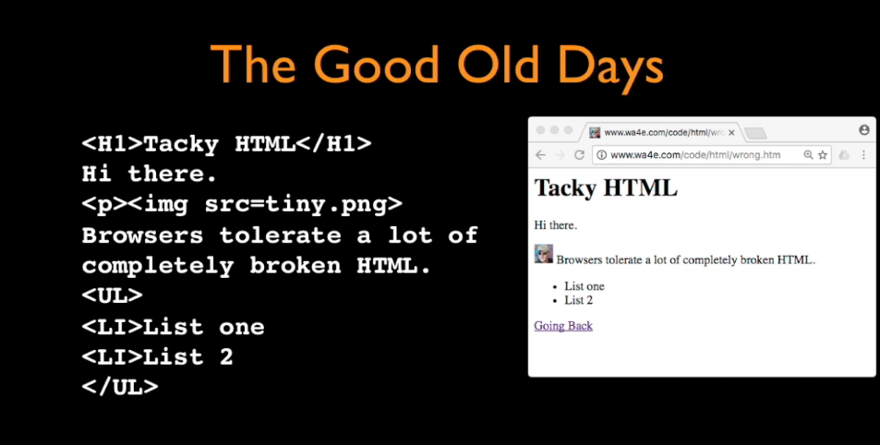

There were all kinds of stuff and literally you could take this bad page and you could put it into a web browser and it will still display.

HTML, while it technically is a very precise language and you can make syntax errors,

browsers are extremely flexible in terms of parsing it.

Now, you're not going to get predictable results, the browsers can go into what's called quirks mode.

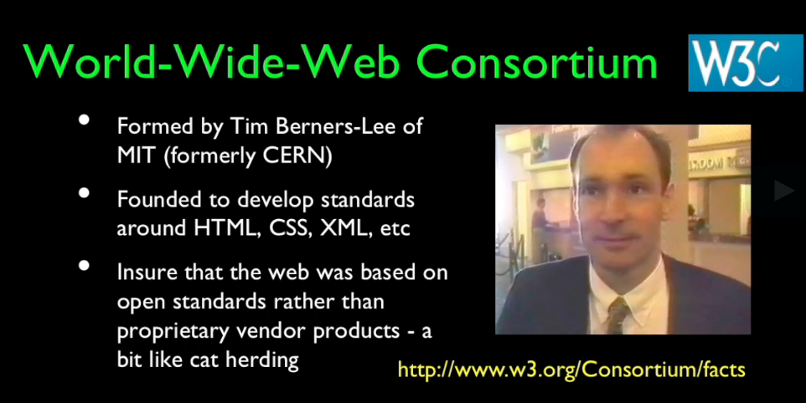

In order to create the standards environment that we have today, Tim Berners-Lee, one of the original founders of the World Wide Web, helped found an organization called

the World Wide Web Consortium or the W3C and it really decided that instead of just letting people write a browser and having HTML be defined by the browser, instead they would write a spec for what HTML was and then multiple vendors could produce the browsers.

And it took a while for this to become successful but there was a need for every vendor to build a web browser and so they worked with the World Wide Web Consortium.

And like the mid and late 90s, '95, well '94 through '98, '99, the World Wide Web Consortium created a lot of wonderful standards around the World Wide Web.

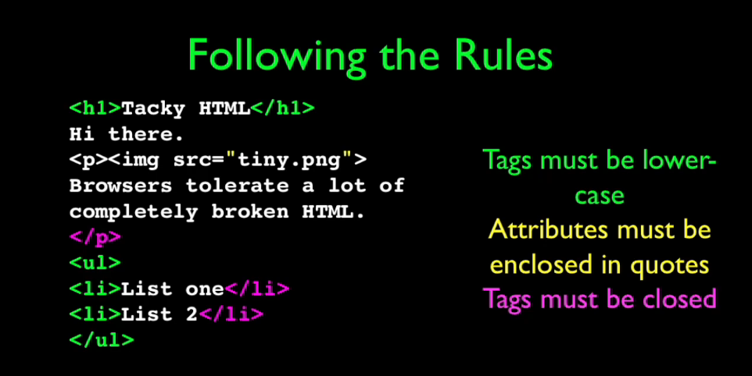

Now, once we started having rules, then we tend to want to follow those rules.

And tags need to be lowercase, attributes like this image source equals have to have double quotes around them, you have to have open tags and close tags.

And there's a set of rules and now we are much more precise about our HTML.

We try to write it as precise as we can so that we get the best performance and the

best sort of rendering out of the browsers that we can possibly get.

Because if you don't write precise HTML, then the browsers are going to make decisions as to how to render things, whereas if you write precise HTML, then you really are in control of how the browser lays things out.

So, up next, we're going to talk about HTML itself, look at some HTML documents, and take a look at the syntax of HTML.

### HTML - HyperText Markup Language (Part 2)

Welcome back. Let's talk about some of the basic syntax of HTML.

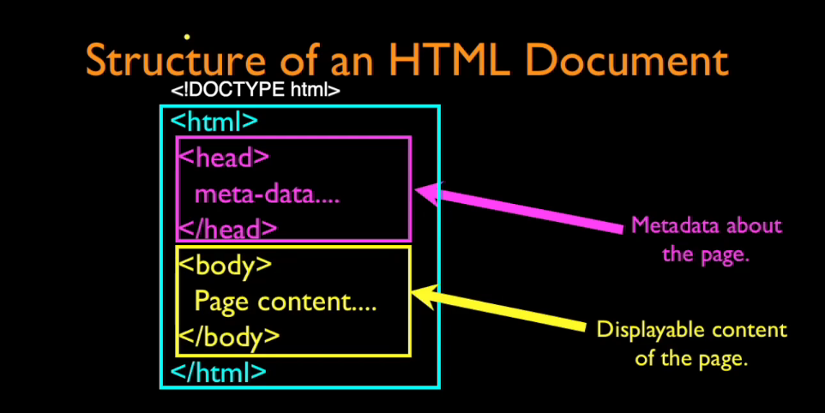

And the first thing is to look at the overall document layout.

They start with an HTML tag.

You might have a thing called a doctype up here, and we can put in one if we like,

but HTML is the outer tag and then there is a head tag and an end head tag, and this is sort of non-printing information.

And we set styling up, we declare the title of a page, perhaps load some JavaScript, and then the printable page of the content is in between a body tag, and mostly what we're going to talk about is the stuff that we put in as page content.

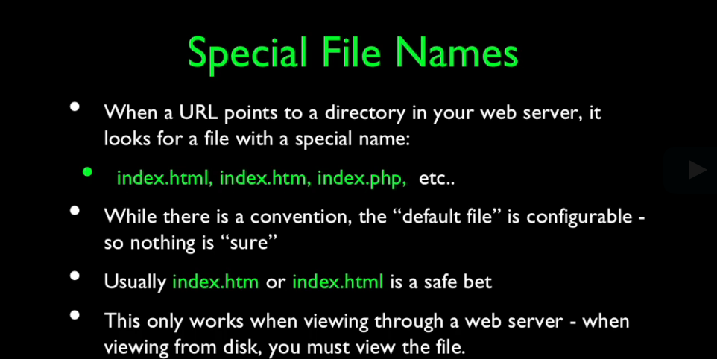

You'll find that there are special file names that we use.

It really has to do with the fact that what we do is we make a directory within the web server, and when we go visit the directory, the web server looks through a series of files that it's configured to look to, things like index.html, index.htm, or index.php, and each one has a slightly different order and a slightly different set of things.

It might even be called default.htm or default.asp if you're on a Windows box.

It is configurable, so different systems do things differently, but usually index.htm is

probably the safest thing unless you're doing PHP, which we will be doing later in index.php.

And so, those are usually the safe bet.

Now when you're viewing things off of disk, which we can do if you download all the code that I've got in html.zip, then you'll have to open index.html by hand.

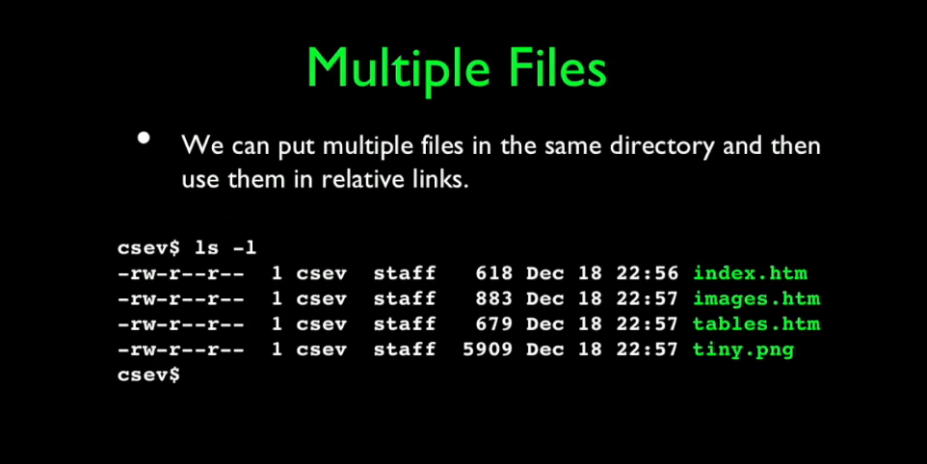

We can put multiple files in the same directory and then we can use them in what are called relative links.

And we can easily create links between one file and another and you'll tend to see if you look at the zip file that you've got a whole bunch of files in the same directory, and with little anchor tags, they point back and forth between each one.

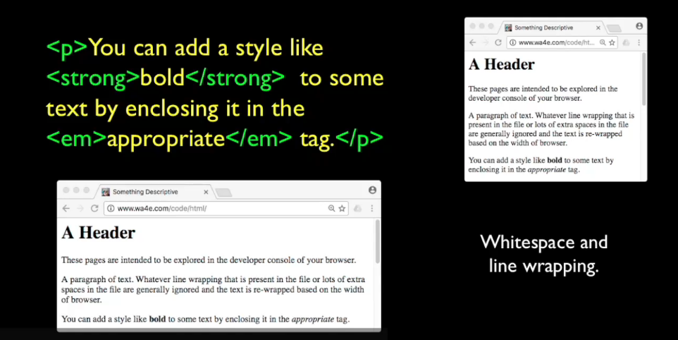

And like I said, you got tags like the paragraph tag, the strong tag, and the emphasize tag.

They have to start. They have to stop.

But another thing that's really important about HTML is the fact that most of the time we are logically marking up the text.

And we're saying we want this stuff right here to be a paragraph, but the end of the lines that we put in the HTML that we write are not really that important.

What happens is depending on the width of the browser, if you change the width of the browser, the text will be rewrapped.

And that's because there's still a paragraph, but we don't want to hard-code it because we're not working on paper.

Sometimes browsers are really large, sometimes browsers are really small, sometimes you're on a phone, right?

And on a phone, browser is really small.

And you don't want to tell exactly how many pixels it is wide, except when you start doing really fancy layout.

But in things like paragraphs, you just say, "Hey, make it a paragraph and rewrap it."

And the rewrapping then also changes how tall the pages are, because the narrower the page is, it kind of extends the page down.

But the whitespace inside of the HTML is really generally ignored, and the lines are generally ignored.

There are some tags, like the pre tag, that changes that, so whitespace is respected and newlines are respected, but most of the time we just let the browser rewrap things, and it's good.

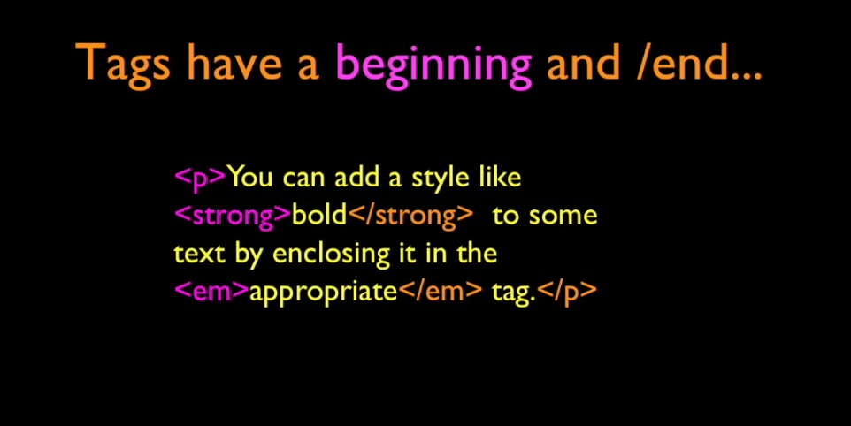

You have beginning tags and ending tags.

There is a beginning tag and then there's the ending tag.

The slash is our indication of an ending.

And they're paired, and they're also nested.

This p tag has a strong tag within it and an em tag within it and that's totally okay because this whole thing is a paragraph and this is a piece of bold text.

They have a beginning and end, and slash is the end.

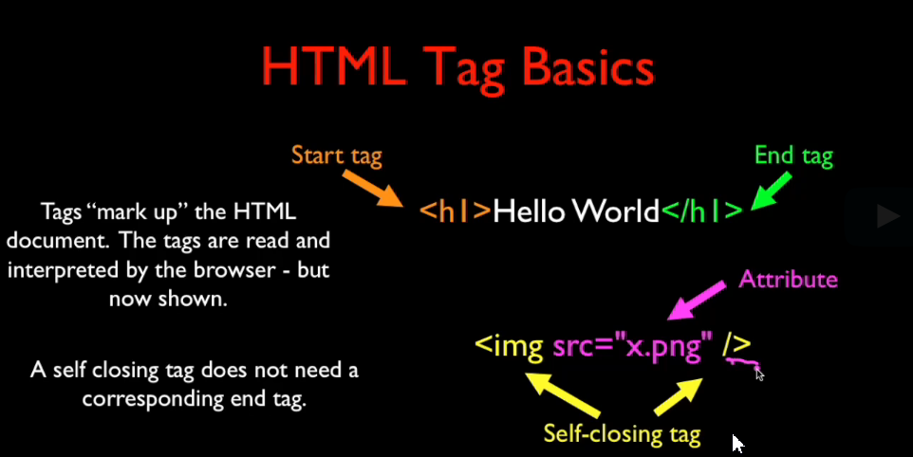

You can also have self-closing tags like an image tag that has like a slash and that means that you don't have to have like a slash image over here.

That's the same, you just put a slash here and it self-closes.

Another thing that you will get used to is the fact that you can put on the opening tag attributes, so key-value pairs.

You go read the documentation on the image tag and it'll say, "Oh, put a source attribute on to say what picture, what file we want to display as the picture."

And the image tag is to show pictures, basically.

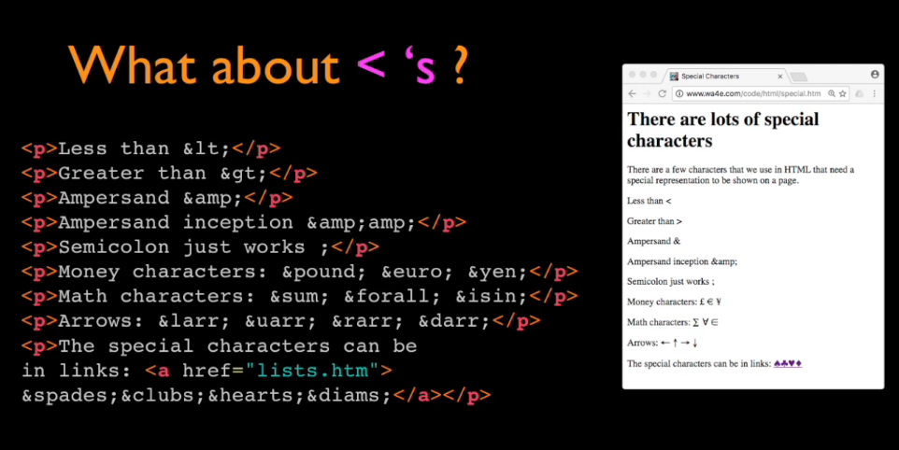

Given that less than and greater than and other things are special characters, we have to have a way to print the special characters.

how do we print a special character?

Well, we use ampersand lt semicolon &lt; , and there's a whole list of these things, HTML special characters, and you can look them up.

There's some that are kind of fun, like the special characters for the deck of cards, there's mathematical special characters, and you go look these up and you can find them.

They're cute and you'll see that I'll use some of these arrows in the things that I'm doing.

But the key ones that you really need to know about are less than, greater than, and ampersand, because ampersand becomes a special character. Less than, greater than, or ampersand are really the special characters in HTML.

To represent less than you do ampersand lt, ampersand gt, and ampersand amp semicolon to get those things right.

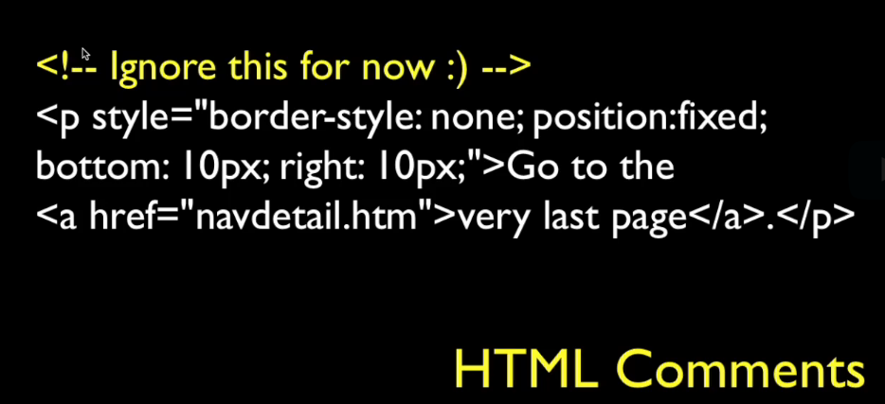

HTML comments, like in any programming language, any situation, the start of an HTML comment is less than exclamation dash dash.

It's a little clunky, but we just want to make sure it's really clear, and so dash, dash, less than. Comments can go across many lines if that's what you want to do.

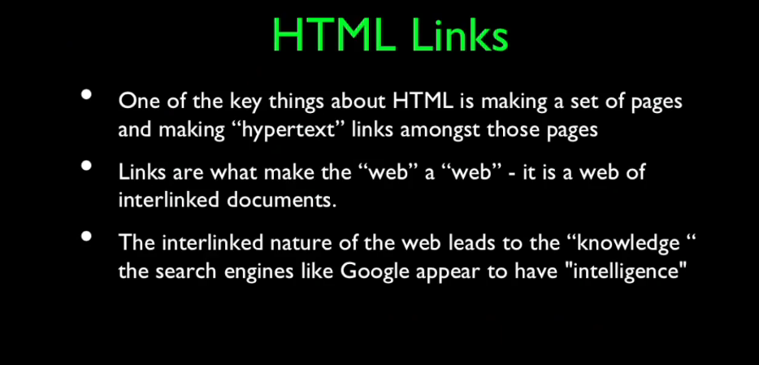

Links is a critical element of HTML.

It's why search engines work.

It's why when I first saw it, I'm like I click on a thing and there's a new page, isn't that amazing, right?

And hyperlinks is the H in HTML, it's the H in HTTP.

And it is how we in effect use this thing that we're sort of just scribbling on to create

knowledge that Google then can extract.

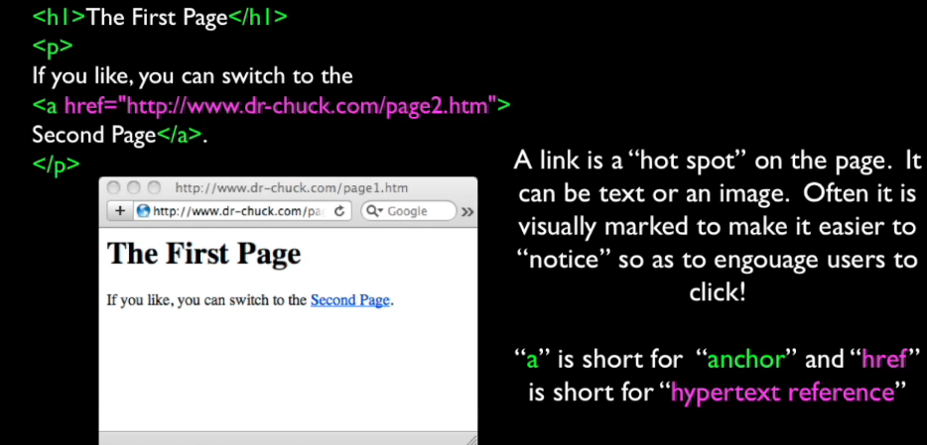

And the anchor tag, the ‘a’ tag, is the tag that we use to do these things.

And there's a header 1, a paragraph, and the anchor tag has, this is the start tag and this is the end tag.

And the text that's clickable is Second Page.

And you can see that it's clickable right there.

It is styled with a underline in blue to indicate that it's a link and so there's the href, which stands for hypertext reference, and then its attributes, so its key-value with double quotes, and this is another URL. And so that's like in effect putting that URL up and going into that next page.

It's a hot spot.

In the early days, and I'll show you a few of these, these links were like the coolest thing ever and so we made them pretty colors like the blue with the dash.

People didn't sort of when they first saw the web, they didn't know to click places.

We sort of styled them quite brightly.

And then, because you were often scanning and searching the whole web, because the web wasn't so big in the beginning, we would mark them as purple after you'd been to it.

You could sort of slowly but surely work your way through the whole Internet as it existed back in the old days and keep track of the ones so you didn't have to go back to the ones that you'd seen before.

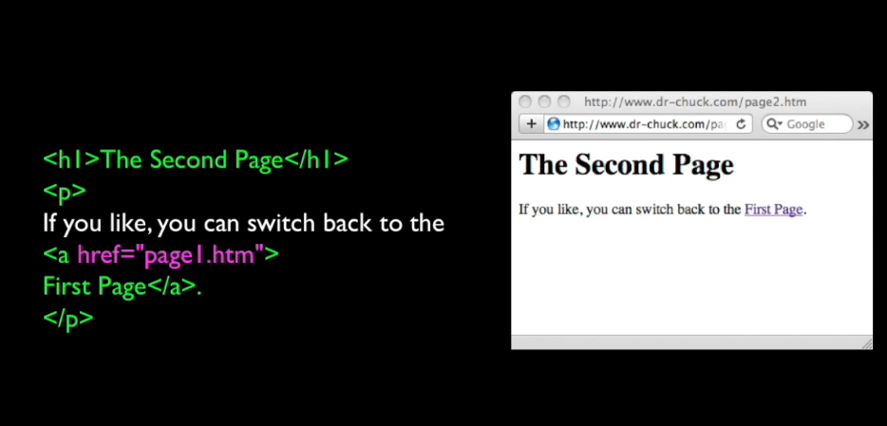

And that was a absolute link and here's one with a relative link and that assumes that we are now in the same folder, same directory on the server, where we have a href.

And here's the start tag, here's the end tag, and then First Page is the clickable stuff.

And you'll note that that is a purple link because I have already been there because page1.htm was exactly where I just came from.

And you click on that and you can go back and forth.

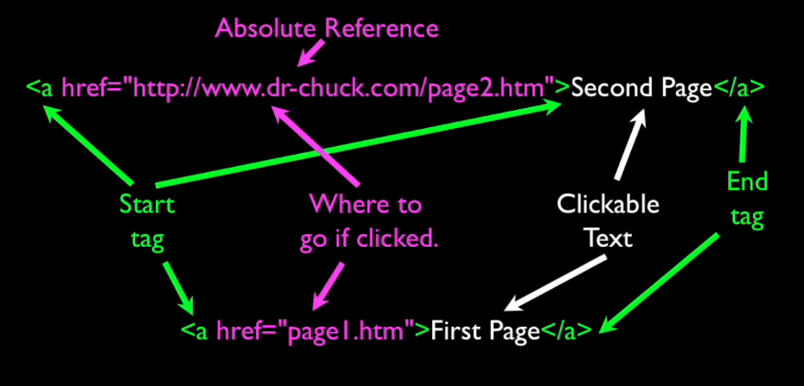

And these absolute references are references that start with http or https or whatever, and relative references don't and so that basically means that this page1.htm

file has to be in the same folder as whatever file we happen to be viewing right now on the same server.

If you want to switch folders or switch servers, you have to use absolute references.

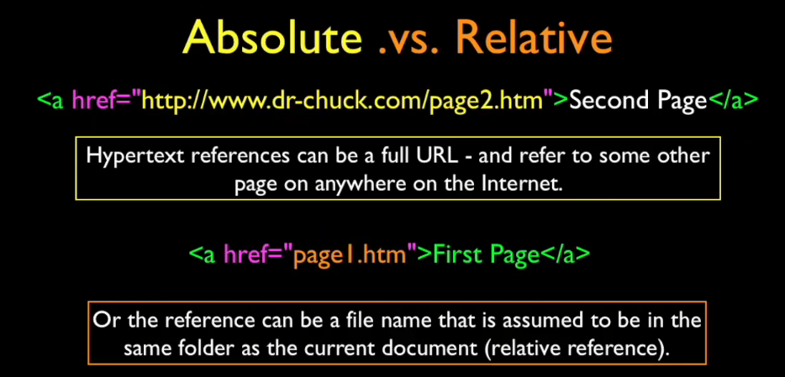

And if you are just moving between files on the same server, you can use relative references.

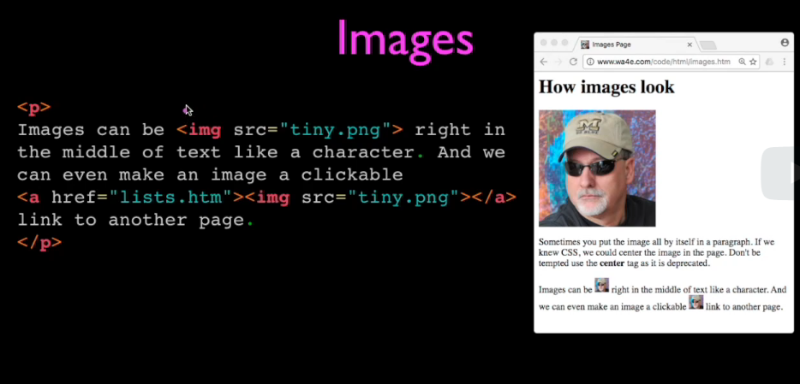

Images are a lot of fun. The clickable “anchor tag” <a href=…></a>

Try by doing.

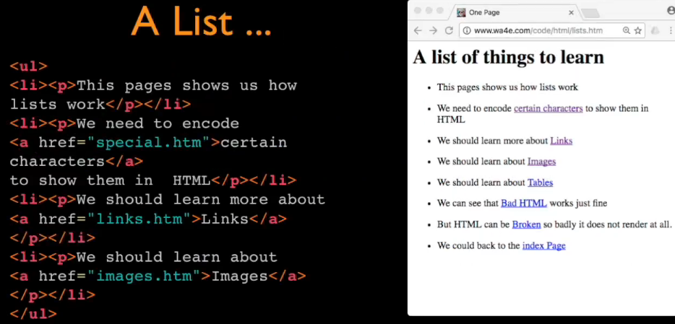

Lists. This example lists within paragraphs for ease of reading. Ordered/unordered (<ol> and <ul>).

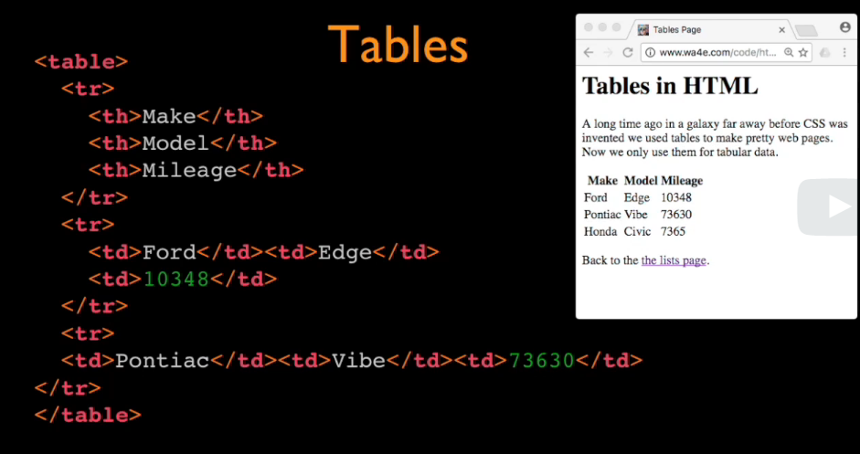

Tables. What a drag. Use CSS.

### HTML - Code Walkthrough (not)

Hello and welcome to Web Applications for Everybody.

In this screencast we are going to play with some of the sample code.

You can either download it and play with it on your own computer where you can look at it in your text editor, or if you just want to browse it, you can browse it here and

take a look at the version that I'm using.

It's really been intended that you look at this in the developer tools.

And you can do things like say inspect element.

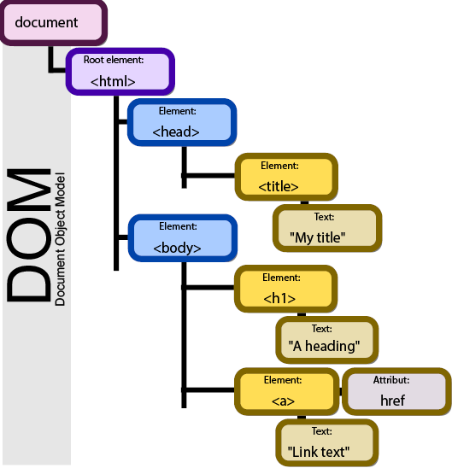

And here we are. This will obviously be a little more valuable even in CSS, but you can see the **Document Object Model (DOM).**

Now the interesting thing here is it shows something I'm always talking about is

the difference between the Document Object Model and the source code.

This is the Document Object Model, it's kind of stylized.

### HTML Assignment Specification

Adding HTML Content to Django

In this assignment we will be adding some HTML content to your Django instance. Most of the content that comes from a site is usually served through a template and a view, but sometimes you just want to have a few static HTML pages on your site.

The specification for this assignment are at: <https://www.dj4e.com/assn/dj4e_html.md>

### Tim Berners Lee - Inventor of HTML and HTTP

Last month I was off in Boston for the fourth annual World Wide Web Conference and I had the opportunity to talk to the inventor of the World Wide Web, Tim Berners-Lee, and I asked him a little bit about where are we going with this Web stuff.

We have just a little bit of footage from Tim telling us where that's going to be.

You haven't seen nothing yet. But you wait until people assume the Web.

When the Web becomes something you can assume, when the infrastructure is all laid down and we have an information space, then it will be time for the next revolution in tune is what happens.

It's hard to imagine a greater revolution than what we've seen.

I mean, I go to the smallest places and everybody's putting up a Web page.

Right. The Web could only take place.

The Web revolution could only take place because the Internet, which had been a quieter, smaller revolution, but that had been the Internet itself quietly being deployed throughout the world, had happened because the Internet was something people could assume, the Web revolution could take place.

The Web is something you can assume, then maybe a cultural revolution, and I say a cultural revolution, unique cultural revolution [inaudible], or maybe we'll find ways of doing things better that we haven't imagined.

Pretty neat, Rich. One of the things that I liked about it was, he just said his idea was the next step is something completely different, a cultural revolution, as compared

to just a little more technology.

### Face to Face Office Hours - New Orleans, LA

So cheers from New Orleans.

### Lecture Resources

**Cascading Style Sheets (CSS)**

The following materials may be helpful to you as you review this week's lectures and content.

* [Downloadable slides for this week's lectures.](https://courses.edx.org/assets/courseware/v1/fa389ead35a2f903a10da039468489cd/asset-v1:MichiganX+dj4e101x+2T2021+type@asset+block/C1-Week4.pptx)
* [CSS Sample Code (Download ZIP)](https://www.dj4e.com/code/css.zip) is the sample code used in the lecture. You can browse the code in your web browser. You can also download the sample code to your computer.

Resources you might find useful / interesting:

* [Web Developer Plugin by Chris Pedrick](https://chrispederick.com/)
* [CSS Cheat Sheet by Leslie Frank](http://www.lesliefranke.com/files/reference/csscheatsheet.html)

### CSS - Cascading Style Sheets (Part 1)

Hello everybody, and welcome to our lecture on Cascading Style Sheets, CSS.

Of course, this follows right on the heels of our HTML lecture, and I'm going to use a bunch of examples from Web Applications for Everybody dot com, and you can just bring these up in your browser.

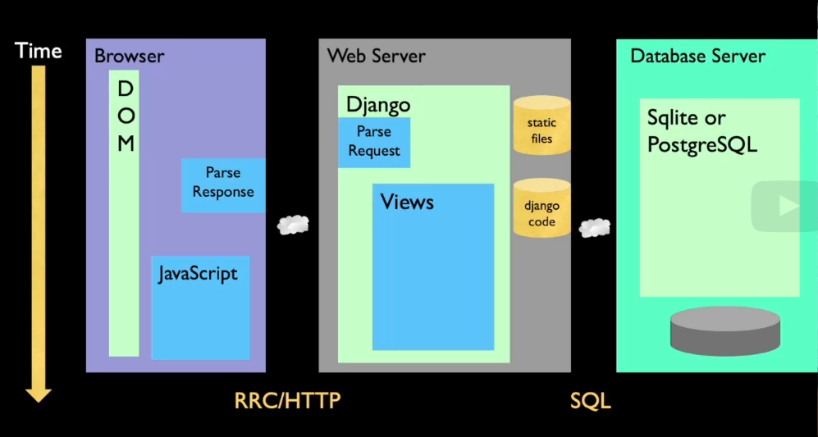

I love to place everything that we talk about in the context of the request-response cycle, because that's the whole Web Applications for Everybody.

You, of course, are out here.

You do a click, it sends an HTTP request, and maybe talks to a database, gets some stuff back, sends some stuff back.

This is the request-response cycle right here, and the thing that comes back is HTML.

And then that is parsed, put into the Document Object Model.

And the thing that you then see, the pixels you see on your screen, are from the Document Object Model.

So that's what we've been doing so far.

And so far, then that HTML, actually, we just talked about this, what the format was when you parsed the response.

What we're going to talk about today is we're going to talk about in addition to that,

we're going to go and pull another file, a CSS file, CSS, and that is going to inform the Document Object Model, and it's going to change how things look out here.

And we'll have some CSS in the HTML, but we'll also have some CSS in separate files

that make separate request-response cycles.

But, we're going to be putting files like our “.htm” files in here and our “.css” files in here.

We're going to be serving them a little bit.

But mostly what we're worried about is sort of the form, how to make the DOM look pretty. And that's sort of what CSS is all about.

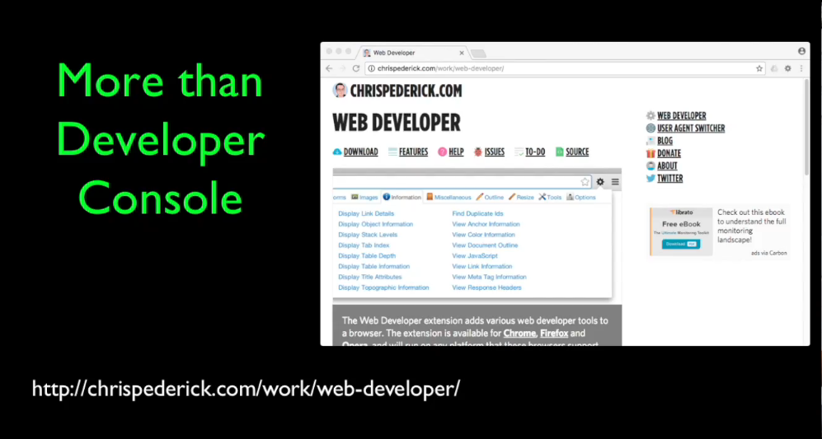

In addition, I would like you to install this thing called Web Developer from Chris Pederick.

Chris Pederick has been doing this a long time before there were even developer consoles in browsers.

And it's funny that the developer consoles don't do what this does.

I don't use all of its features, but it has some wonderful features for CSS, in particular, turning on and off various styles.

It's a great way to sort of dig through CSS issues in addition to the web developer console.

And you can do a lot of fine debugging, but there is some real nice stuff in Web Developer.

It's just a plug-in for your Safari, or your Chrome, or your Mozilla browser, or whatever.

Please install that, I recommend it, and some of the assignments actually require it.

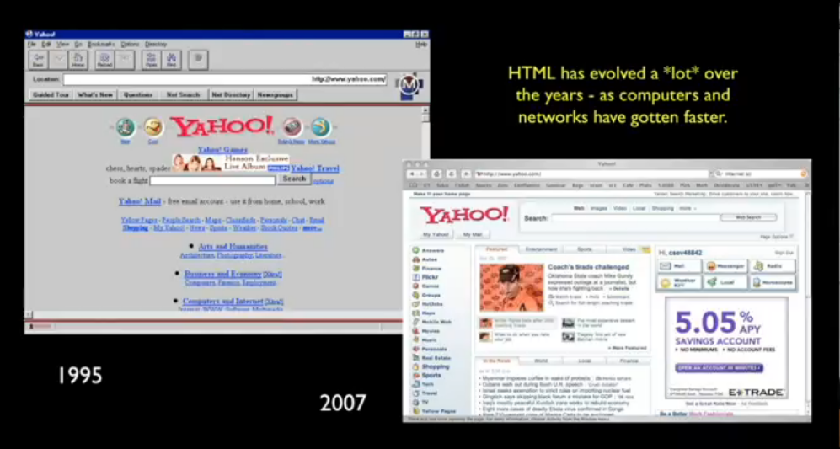

Like I said in the HTML lecture, the HTML started out with we were just amazed in 1995 when we could see a page with a gray background and blue links, and it was long lists of links, and the links turned purple.

And we would click on a link and another page that come up and we're like, "Holy mackerel, this is the future." Right?

And we were so happy.

And our curiosity was piqued, we did interesting things.

But in the 10-15, almost 20 years since all that, it's become a business.

And in business, the look and feel for the average non-nerd user, they don't care that there's a **request-response cycle (RRC).**

They just want to do a thing, talk to their friends, or look up information, or whatever.

And the CSS is in the middle of this time frame.

The ability to precisely lay things out and make pages beautiful became super-important for the web to take its sort of leap into commercialdum.

If you look at the Yahoo web page, for example, this is just a screenshot I took a while back.

They do studies as to how much white space is in between those two pieces.

And they'll add a pixel, and take away a pixel, and they'll see how their revenue goes.

And these user experiences, these visual looks and feels, are highly tuned and highly sort of taken care of.

And CSS needed to be able to precisely have a pixel-perfect layout in every browser.

And CSS is a very, very precise thing.

HTML has become precise, but we don't want to do our markup and layout in HTML.

I showed you tables previously, and in really early versions of HTML, you used tables to create look and feel, and that was never good.

One of the things you can do with the Chris Pederick web developer plug-in is you can show a page without CSS.

And what you should expect when you see a page without CSS is it's sort of beautiful, even without CSS.

It's beautiful in a logic and a structure.

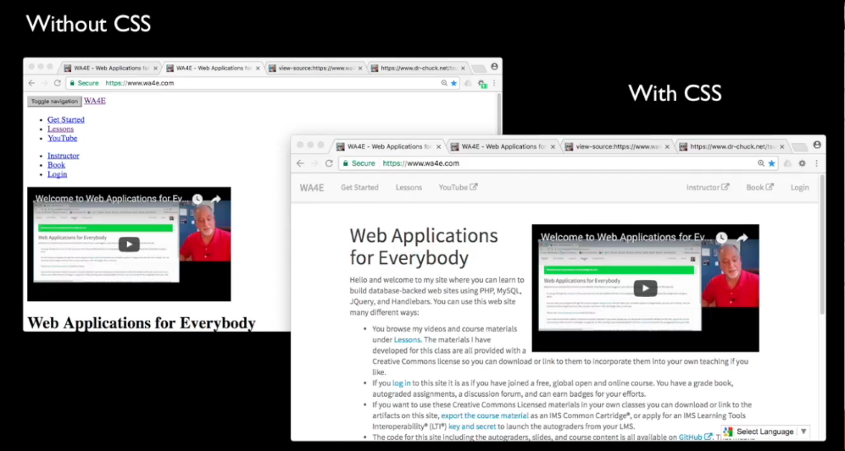

So here is my Web Applications for Everybody website, right?

It's got some cool stuff.

It's got these little things that go over there.

It's got the little border.

The color is gray here, and it's a little lighter gray.

And this wraps around and it looks really awesome, right?

Well, turn CSS off and you should still see a page that you could effectively navigate.

It's like going back in time to a simpler time of, "Okay, I want to see this. This is really a list of links at the end of the day." And there you go.

It's a list of links. And the default is, I've already clicked on Lessons, so Lessons is purple now.

And here's this video, and if you scroll up and down on this, I mean, it's really fun to go to a website and turn CSS off and see how good their HTML developers are and how pretty it is.

And it's supposed to be pretty in a simple way.

And what's nice about this is it really leads to good accessibility, meaning some people do not see the graphics, they hear the page read to them.

And this way, this is how it's read.

And the simpler and more beautiful and elegant your HTML is, the easier it is for a person who has reduced visual ability to understand your site. And that is, I remember the joy of hearing from people who were using the web and Gopher in the early days,

how they all of a sudden could go anywhere and see anything and do anything in a way

that visually impaired people could never do for like hundreds of thousands of years. And it's joyful.

And then what happened was is we ended up with this really nasty markup.

And then they're like, it was like the web was simple and they loved it, and then the web became ugly and nasty, and HTML became nasty.

And they're like the world is horrible because now you go to all these cool websites,

but I can't go to these cool websites because I'm visually impaired.

And now we're back. We're back to that.

We're back to beautiful HTML, simple HTML, and then beautiful web pages and CSS is the, okay, I think I've done enough advertising for CSS, and accessibility, and beautiful HTML.

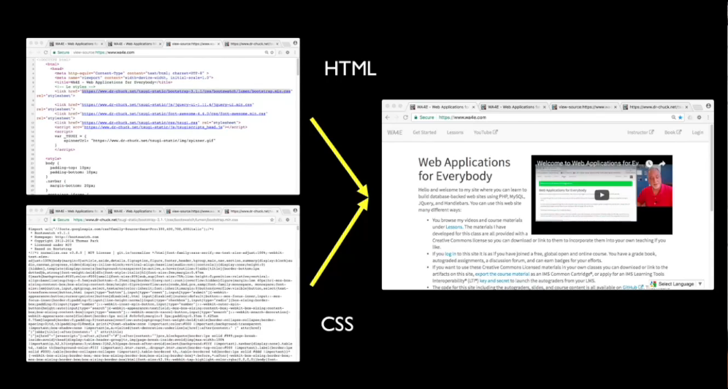

So ultimately, if you look at how this thing is assembled in your browser, there is an HTML page that is pulled down.

And then there is CSS, sort of both inside the document, sometimes there's CSS in the document.

If you look at this, not that it matters, there's a little bit of CSS in that document, and then a whole bunch of other CSS that brings all the beauty to this.

Sometimes it even takes some JavaScript, and whatever.

And we understand that the HTML does not have the beauty in it, the beauty comes from the CSS.

And that is part of what we try to do is learn CSS.

If you're going to be like a coder and you're not going to be a graphic designer, you still need to know enough CSS so that you don't write horrible HTML, so that you know what a really good CSS developer is capable of doing on your behalf.

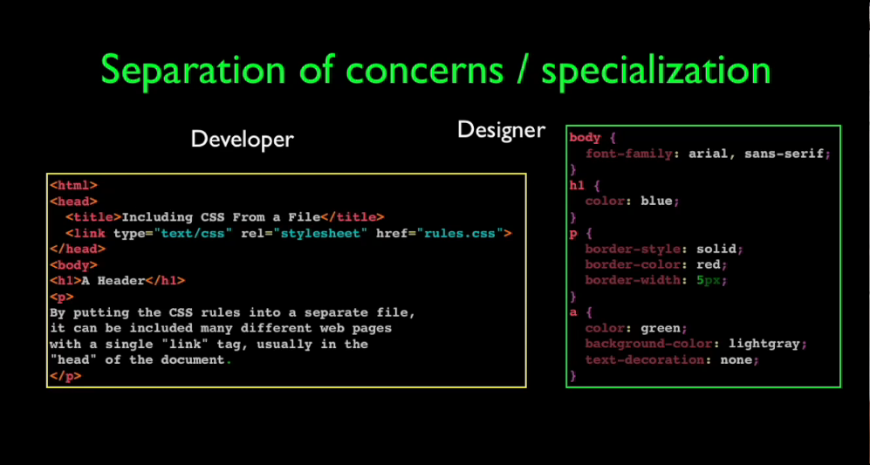

And on large projects, including like Sakai Project, which is an open source learning management system, this allows separation of concerns and you can have people that specialize in the back end and the HTML.

If you think of the developer, usually, there's a back end, and then from the back end,

they generate the HTML, and then the designer will build the CSS.

The designer will often have skill enough to sort of tweak the HTML if the developer built bad HTML.

They kind of meet in the middle at the HTML with a developer mostly being responsible for building the back-end developer.

And then the front-end designer can then tweak the HTML a little, and then tweak the CSS.

And the HTML is where the back-end developer and the front-end developer come together.

But it means that you can have lots of people working and you can develop highly specialized skill sets in larger projects.

I know that my skill set is in this side.

I am not skilled in this side, right?

I can clunk my way through CSS and everything that you'll see is my CSS, and you'll be like, "Whoa, that's not very good."

And if it even looks pretty in mine, I probably used Bootstrap, and I cheated and found a CSS framework and I didn't build it, I just did it.

Now, there are people who are smart enough to build Bootstrap, and they can build such gorgeous websites, and my job is to build beautiful HTML that then they can add CSS to and make it super gorgeous.

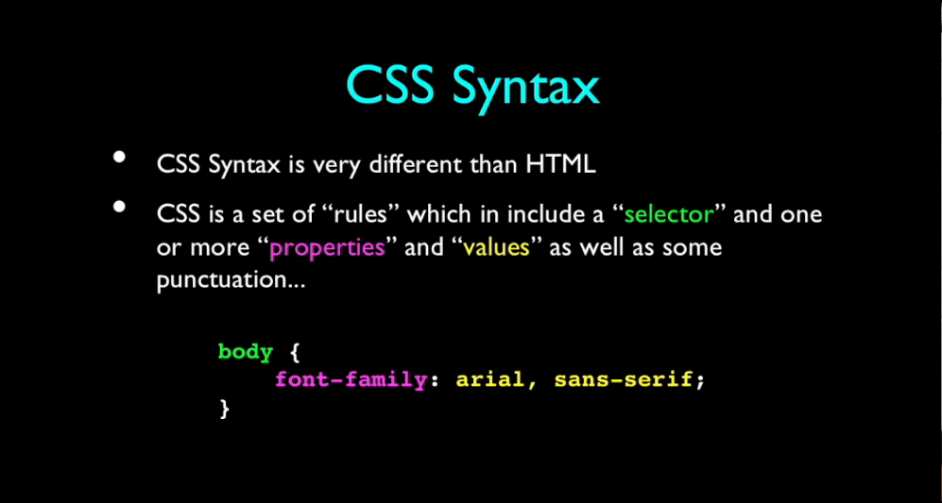

The CSS basic syntax is different than HTML, right?

HTML has got “less thans” and “greater thans”, CSS has curly braces.

I don't really know who invented the first, I should find that out and go videotape that person.

But it has curly braces and semicolons, so it kind of looks like a little bit of C.

And it's really a set of rules and it's not sequential, although the order does matter because what comes later has more importance than what comes earlier in CSS.

But it's not like code that gets run.

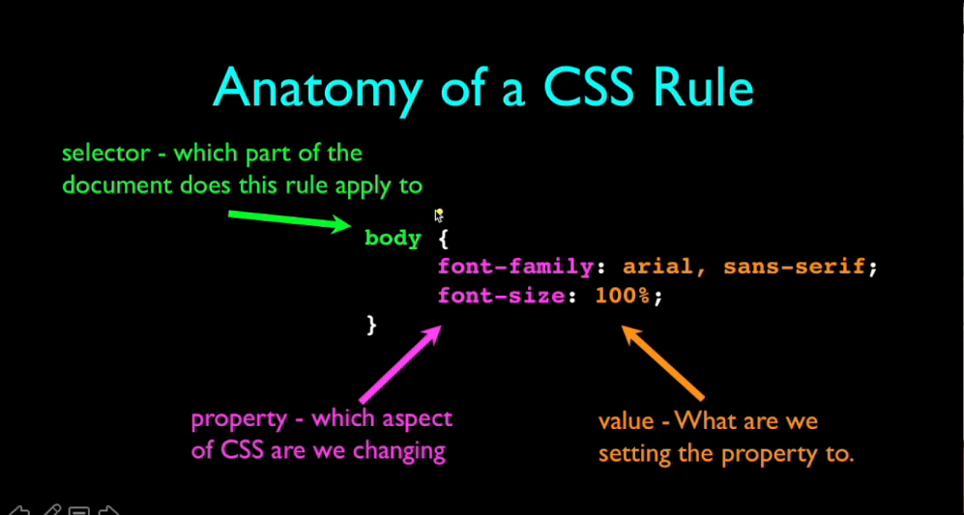

And the anatomy of a CSS rule is that there is some kind of a selector.

And in this case, the simplest selector is the tag that we want to affect, we want to affect the body tag.

Now, there's only one body tag, but you could have a p for a p tag and say, I would like to do this to all p tags.

And it's implicit, kind of like SQL, in that a body tag means for all body tags.

There's an implicit loop for the whole document and we'll see how to reduce that later.

It's not always the whole document.

But for now, a tag there by itself means every tag in this document.

And then there's a series of rules.

And this is really when to apply, this is sort of what aspect, and there's a whole list of aspects that you can have, and then what you want to do, I want to make the font size 100 percent, I want to use Arial and then sans-serif, etc., etc., etc.

And then these end in a semicolon, and you can have a bunch of these, right?

You can have just one, you can have more.

But that's the basic idea is a CSS rule is, go find a part of this document and paint it.

I'd like to think of this as like, go find a thing and then run a paintbrush over top of it,

that is this paintbrush, that is the paintbrush that you go select a piece of the document and then paint it yellow or paint it bold or whatever, that's kind of how I think about it.

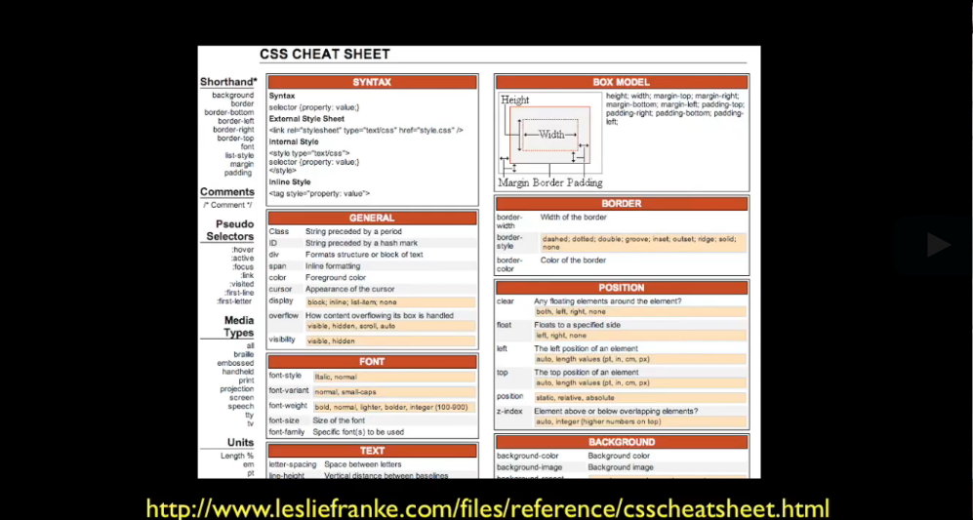

Now, I'll admit I am really a very weak CSS developer and I need a cheat sheet.

And if I'm going to do CSS, having this even a single-page cheat sheet is super helpful for me just because I don't use it all the time.

The attributes like background color and the border dash bottom, for me, they're all very self-explanatory, they're really easy to understand.

Or if you don't understand them, you just Google and you'd go Stack Overflow.

But like for me, I'm like is it border bottom or bottom border.

I just can't remember that stuff.

And I just have to have a cheat sheet whenever I work.

And this is one cheat sheet that I happen to like.

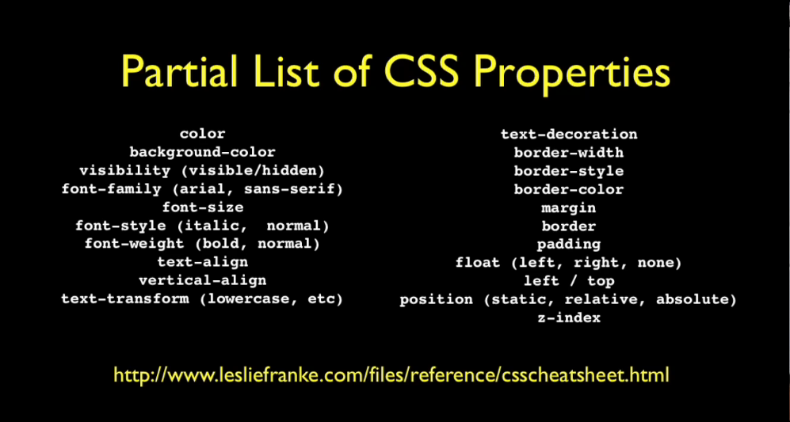

And these are the kind of properties that we're going to be playing with, the background color, how to align it vertically, how to align it horizontally, padding, which is space on the sides, etc., etc., etc.

There's just tons of CSS properties and there's tons of great documentation on each of these CSS properties with little samples all over the place.

And I have my own samples as well that I'll do some recordings and show you, walk you through like line by line on my sample code as well.

But this is the kind of stuff that we're going to play with in CSS.

So up next, we're going to talk about how we connect CSS and HTML together.

### CSS - Cascading Style Sheets (Part 2)

So welcome back.

Now, we're going to talk about how you use CSS within HTML, how you take these CSS rules and apply them to the various parts of HTML.

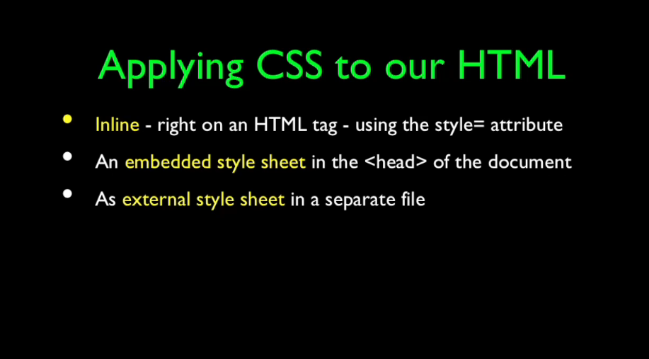

And there are three basic ways that we do this.

One is we take an HTML tag and use the style attribute and just put those little CSS key-value CSS settings right there, very close.

The other thing is you can put it in the background of the HTML document, usually in the head area.

And the other probably most common thing, especially when the styles get large,

is an external style sheet that's a separately loaded file with a separate request-response cycle (RRC).

We'll start with sort of the simplest but sort of least used of these things.

And that is like I said, you can put a style attribute on any tag. And you say any attribute, it's got a double quote and a bunch of stuff and another double quote.

And in there is a series of CSS rules that are basically CSS setting like border style colon, and then the border style setting that you want.

And in here I'm saying I would like a solid border, I would like it red, and I'd like it to be five pixels.

And that effectively determines how that particular thing gets painted, right?

In this particular one, I said font-family monospace for that particular paragraph.

This paragraph is painted with a font-family monospace.

And you can just put these things here.

I put on the body tag, I want an Arial sans-serif font.

The whole body is not Times New Roman, except for the fact that this particular one is monospace.

And this is these two tags are rendering opinions about what the font is supposed to be.

But because this one is closer, the monospace wins here. But the Arial wins everywhere else because none of these other tags render an opinion.

And so that's kind of that cascading bit, meaning the closer it is, the more priority that it has, unless, of course, they put important up here.

And important is something we'll talk about later.

It's you can make the farther away override the local, but it's not something you want to use too much.

If you're using important, that's a trouble.

But don't worry about important right now.

Just imagine cascading means the closer, the higher priority.

The closer to the tag the statement of CSS is, then the higher priority that it is.

Another place that you can put the CSS is right there in the header, right?

Instead of putting it on a tag, we can use a style tag in the header.

And so here we have the header of the document, right?

The head, the body starts down here, and up here we're going to set a set of rules.

And now we're using the thing where we have to say which thing the tag goes to.

Now I can say the body tag, even though there's only one body tag, we want a font-family Arial sans-serif.

And because they're all inheriting from the body tag, then all the paragraphs inherit from this and the headers inherit, etc., etc.

It's like body on down in this particular case.

The header 1, which is this, is blue and paragraphs are supposed to have a solid border, red, 5 pixels, and so border style, border color, etc.

And that means that each of the two paragraphs here are away you go.

And I'm going to dig into the anchor tag, and here's my little anchor tag, and

I'm telling the anchor tag that I would like to have a green font and I would like no underline. The default is to underline them.

If you look at links, they're always underlined.

I'm overriding that.

And then I want the background color of that text to be light gray.

And this is a set of rules.

All that HTML is down here, lower down, and there are no style tags.

There are no style attributes on the tags because we have basically said for all paragraph tags, for all anchor tags, for all h1 tags, and for all body tags.

And we put it up here in the top of the document.

Now, the problem is lots of most websites have multiple pages, and this gets really frustrating after a while.

You really want to pull some of those widely used or repeated things out into a file and include them.

And all we do is take pretty much that same set of CSS rules and we put them into a file.

And in this case, we'll put them in the same file, same directory, same folder, as the HTML.

Although, you can pull these things off of a website, if you want.

HTTP colon slash or whatever, but you put a link in here and tell it it's a CSS, and it's going to be a stylesheet.

And then you give it an <href>, which is then going to pull this file in and sort of expand it as if it were right there in the middle of a style tag.

And it knows it's a CSS and it pulls it in. So that's how you change your HTML.

Now if we take a look at the next example, we see that in this next example, we've got a link, right?

And down here, we've got no style, ignore this little thing, that's how we're putting this little, ignore that page.

But in the real stuff here, we've got this, we got our pre tag, we've moved it in, we've got some things here.

We got all that stuff that we've done, right?

And if you look, here is that rules.css file.

Rules has all that same stuff <h1>, border color, a tag.

All that stuff that we put in the head now is sitting in this rules file.

And we're just pulling it in right here in one fell swoop, and it accomplishes the exact same thing, okay?

And this including in a separate file is by far a superior way to do it than putting it in the head tag.

But sometimes you have to like change two things and you put them in the head tag.

And you use all three of these ultimately, but generally, you tend to start with a large amount of CSS in a file, and then you tweak in the head, and you might tweak on a tag here and there.

And that's kind of how these three things tend to work together.

And the whole cascading thing works out well.

You can put the link first and then style tag second, and then it kind of overrides some of the stuff that are in the link.

And then you can have something on a tag which overrides the stuff that's in the head, unless, of course, it says important.

So as the world went from hacking look and feel in HTML to finely tuning look and feel in CSS, all these tags, paragraph <p>, <h1>, <body>, they all had default styles that had kind of evolved and links and all that stuff that evolved.

And a lot of pages depended on those default styles working.

And they couldn't say welcome to CSS and now all the styles, a paragraph that's unstyled will look terrible.

Not that they look great.

And so we couldn't take the paragraph tag.

Everything had a style, that's the problem.

All the existing tags had something on them.

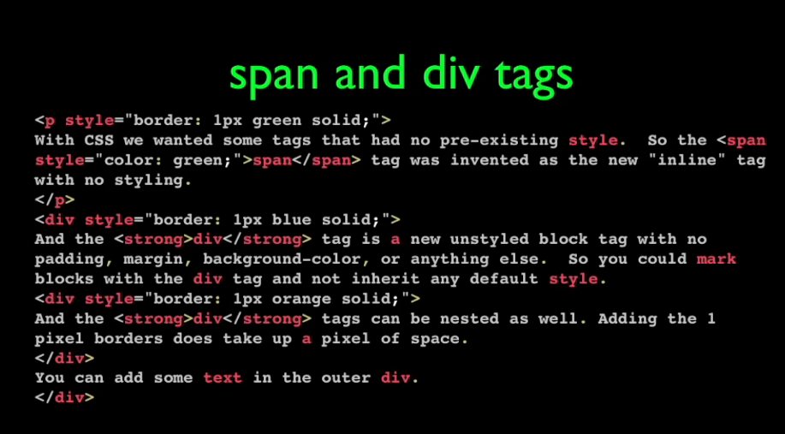

They had to make new tags, and the new tags that they made are the <span> and the <div> tags.

The key to the <span> and the <div> tags is <span> is an inline tag that has no styling

associated with it, no default styling.

It is defined as having no styling.

And the <div> tag is a tag that has no styling associated with it, but it's a block tag.

And we sort of use these to mark text, but without inheriting any styling from some long-ago 1993-94 defaults.

And the <span> tag is span tag here and it's kind of broke over line.

The <span> tag has no styling, except that styling which you add.

In this case, I'm adding it with a style attribute.

And the same thing is true for a <div> tag, right?

The <div> tag, and also <div>’s can be within <div>’s.

This is a nested <div>, right?

There's an outer div an inner <div>, and basically you know that the <div> has no style whatsoever, right?

The <span> has no style whatsoever.

If you just put something in a <span> tag, and you don't sort of render an opinion about what it looks like, the span doesn't change it.

It just inherits from whatever else is there.

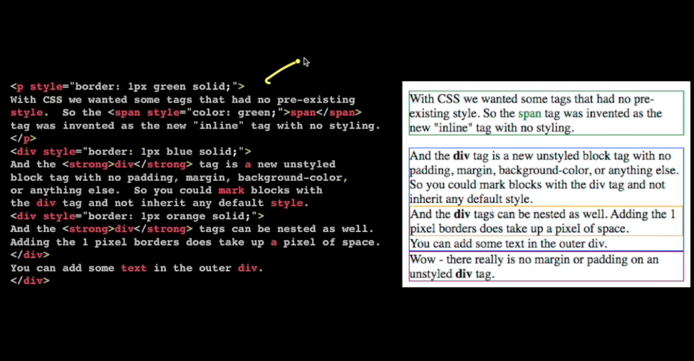

And so if we take a look at this, right?

So here we have a p tag with a green border, 1 pixel border solid.

Now, the interesting thing is you can say, well, did the paragraph tag have styling?

It turns out it does, it has some margin and padding to make it look better, right?

And so, the paragraph tag is not an unstyled tag.

It is expected to create blank space around itself.

And so yeah, so the paragraph tag has a default style, it's supposed to have a default style.

But then if you look at the div tags that we've got here, like this div tag, remember, goes all the way down to here.

This div tag I just put a blue around so you kind of know what's going on, right?

So this blue goes from here to here, but you can see right away that the div tags have no padding, or margin, or a little white space to make them look prettier, and that's okay.

You've got to do that.

You've got to add the padding and the white space.

They just start with nothing.

It's just a block, right?

And the span tag, this one here, changed it green because we put a style color equals green right there.

And okay, so we did that.

And the div tag, and you'll notice interestingly this, because the the divs I'm using end up with a 1 pixel border as their style.

Meaning they started with nothing, you can even see that, if you look really close, it's impossible but you can zoom in.

The blue border takes up space and then the orange borders is on inside of it, and that's 1 pixel wide.

I'm adding to these through the style attribute, I'm adding CSS to them.

But they start with absolutely nothing, and they kind of look ugly when you just like put something in a <div> like right next to each other because they didn't want anything.

And again, they're nested, and there's reasons because we'll use <div>’s to say this is the main body, and then there's <div>’s within the main body.

And then this is the navigation, this is the footer, etc., etc., etc.

And so <div>’s are ways to describe blocks without adding CSS styling by default and as such letting you define all the CSS for these things, so these are cool.

They're like the non-tags, the untags, the tags that don't cause anything to happen but let you cause everything to happen.

They're really important.

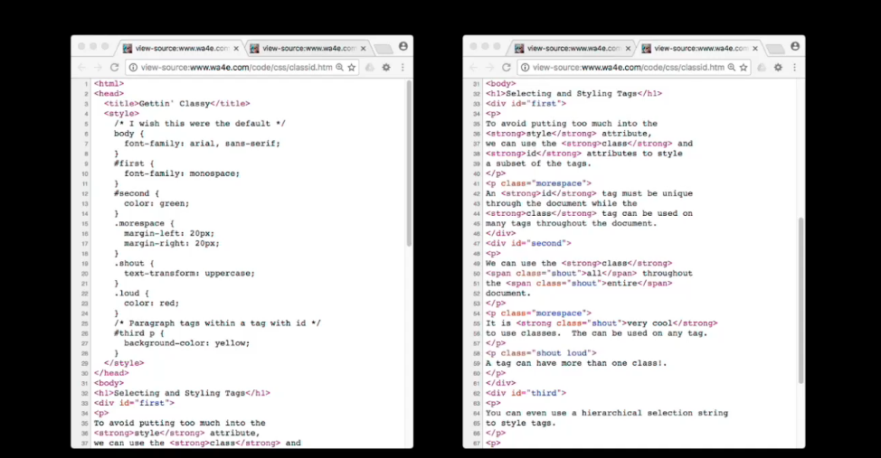

The next thing I want to talk about is making a sort of finer selection of which tags that you want to apply a rule to, write a rule to.

And if we look at this tag right here, this is the body tag, and that basically says I want everything from body to /body then everything inherits.

Unless it's overridden, I want Arial sans-serif to happen, okay?

And I can do that with a paragraph tag, but I want to show you this other thing.

There's a way to mark a tag.

Let's find this one, where's first, first right there.

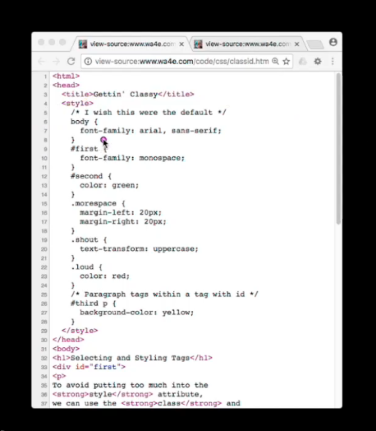

There's this <id> attribute.

And id attribute is an attribute that was added kind of specifically for CSS as well.

And you can only mark one tag per document with an id.

And then there's this class tag, and you can mark as many tags as you want in the document with a class tag.

And the idea is, it's like id tags are for chunks, like main page, like left navigation, top navigation, or something, that's what only going to appear once on the page.

And if you want to sort in effect, what pound sign first means is look through the whole document, find a tag.

Where's div id = first?

Where's that stuff?

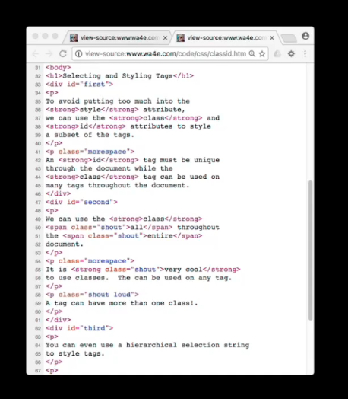

Right there. Find the tag that's got an id of first and then paint it with those rules.

The class can happen more than once, but more space.

Let's see, class is more space here, that's there.

And so that basically says, let's clear and change color here, more space says look through all the document and find all the class.

There's that paragraph. Ooh, do I not I close that paragraph?

Oops, mistake on my HTML here.

Yeah, so that basically says, change the margin left, that means shove this in, and change the margin right and shove it in.

We'll see all these things. And loud. And then you can also see a situation where we can put classes on you can have more than one.

And so this basically will respond both to the shout and to the loud class.

Okay, so let's take a look at what this page looks like.

Here we go, it's a little busy.

If we take a look at first, it grabs this tag here, the div tag is first, right?

And then, if we look at like more space, this more space is affecting this one.

And it's shoving it in both on the left and the right, and that's because it's this paragraph more space, okay?

Shout, let's find the shout ones.

We can see them right here, they're all the loud ones.

That is red, that's shout and loud. Here's one that's shout.

Entire is been shouted and all has been shouted.

You'll notice these guys are lowercase, but shout is a text transform to uppercase.

You can even change the case of things.

And then like in third, for example, where's third at?

This says find the third div, which is right there, and find all the p tags within the third div, this p tag and this p tag.

And then apply a background color yellow to all those, which leads to this right here, okay?

And pound sign means find id and apply, dot means find class and apply.

You can have multiple classes, right, pull in the the definitions from two classes.

Shout space load, go find the whatever in the CSS, and then you can kind of have hierarchical things.

And this is quite useful because you don't have to get special, it saves you from putting classes on all the paragraph tags here.

You don't have to do anything, but you're not affecting the paragraph tags outside here.

You're only affecting the paragraph, I think of this is go find third and the paragraph tags within third.

And then do something to them, otherwise, you'd be making more classes than you need to be.

And this is a very well-liked technique for really fine-tuning your selection, your selector for CSS to touch only the things that you want to touch.

So up next, we'll talk about images and colors and fonts, and a few other things.

### CSS - Cascading Style Sheets (Part 3)

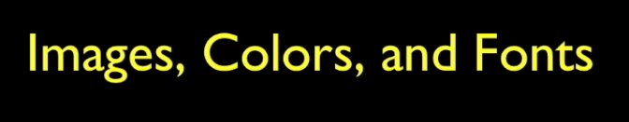

Welcome back. Now, we're going to talk about making our stuff look a little prettier with images and how we can play with images, colors, and fonts.

CSS and images are a lot of fun.

We can fool around with them. We can move them around.

Actually, this for me, years ago, was the thing that in 1994 that made me fall in love with the World Wide Web.

What made me fall in love with the World Wide Web was the ability to take a picture of me, and I love pictures of me, then float it to the right, and then I put a little border around here.

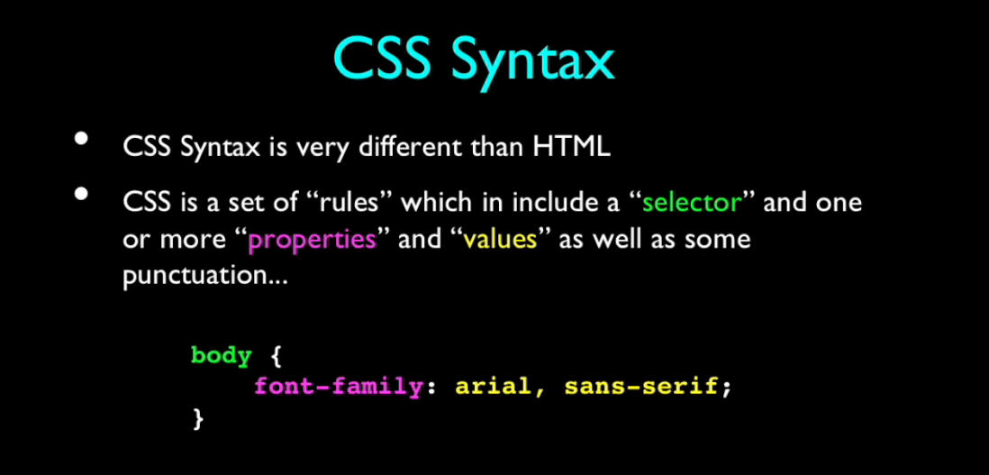

That's what I've done with CSS.

Let's take a look at how I've done that.

If you look inline here, the navigation, which I'll show you when I go through the code walkthrough, how the navigation works.

But at this point, the end of the navigation is right here, and I put this image in.

If you were to watch this inline, the image is right there.

But what I do is, when I say float, and there's other things that we'll see when we start

looking at fixed and absolute positions, you can pull it out of the regular stream.

And this is like pulled out of here, it's as if it didn't exist. And it floats to the right,

then it's vertically aligned.

The next thing you see is this header 1.

I'll pretend that that was an h1 there, but that's okay.

This header at quirks mode, I should run this all through the validator to make sure I'm okay. But okay.

The top box of this CSS and images h1 is right here. And then this floats over, but then it top aligns.

Now you can change this alignment if you like, but it top aligns here.

And then it actually looks at the width, in this case, the width of the picture, but you can also control the width up here in the CSS.

And then it carves out this space and then I do a margin of 1em.

You sometimes wish they would put default formatting on, but then they kind of tend not to put default formatting on, because if they did, then you'd have to turn that off.

I wanted some whitespace and I had to put some whitespace around it.

And I said, "I'd like a margin of 1em," and that puts a little bit of space here, and here, and actually here as well.

You see that this lines up over there and then that talks about what is a 1em.

I could've said five pixels, 5px, and that would have been fine.

But 1em is basically the width of the letter m, roughly.

It is a width that changes with the size and nature of the font.

I think of it as the width of an m and I think that might be a soft definition of it, but I don't think it's a precise definition of it.

But that's what I did.

Float right hoists it and sends it over here and then shoves this over so that it reserves this space the text is wrapped, basically.

And then I held out some space just for prettiness, right?

And so that's like CSS is making it look pretty.

Now, what happens here is, sometimes you want to basically force, after this float has happened, something back to the left margin.

And there's this clear equals all that says, "clear any floats" is what it's really saying.

And it means that even though this, if it wasn't for clear equals all, this next paragraph would have been kind of up in here, and then maybe it would have wrapped if it was long enough.

And when you play with this, you can resize it and see how the wrapping changes.

But no matter what the size is, after the br clear equals all, this is going to format back to the left nav, right?

That clears that hanging wrap.

But you don't have to, you could not do this and then it would wrap and wrap and and it'll get longer it and would continue on.

If you want control over that, you can with the br clear equals all.

And of course, you can have images right inline and this is just from the HTML bit here,

there's nothing fancy CSS here, images kind of are like big characters.

I sized that one so it sort of fit nicely and you can even make this a clickable link.

But that's really just this part, here is just HTML, not CSS.

But I could've if I wanted to change the width and the height of this. That'd be kind of fun.

Make this guy be like the width of an em, and then you'd see it more like a character.

There's a bunch of colors, and the colors have to do with there's the simple thing for us simple folks.

We just put in things like red and green and stuff like that, and especially if you're doing

a developer and you're just trying to get basic stuff working.

I often use colors in my testing, like put the border red, I do that all the time to say where is that that div at anyway?

I'll throw a one-pixel border around it, red border.

Oh, that's where it is.

Although the Chris Pederick plug-in has a thing where it puts one-pixel borders around everything for you automatically, but whatever.

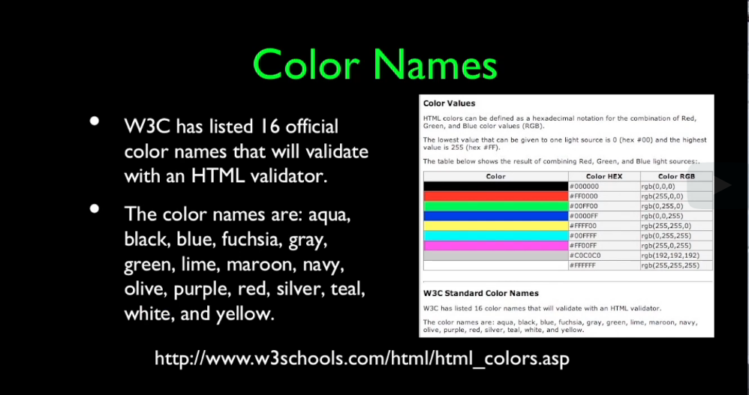

These are not necessarily the most graphically beautiful colors, even though I like them because they're super primary in terms of primary colors and strong.

And you'll see that I kind of use those colors in my slides a lot, because I'm not a graphic artist, of course.

I just like, oh, the greenest I can be is good.

There's 16 official colors and they're here.

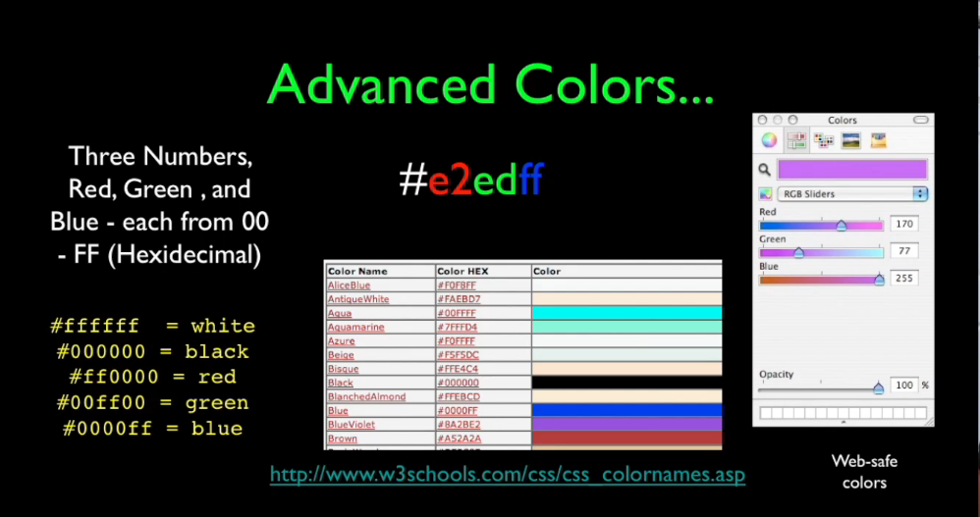

Once you get a little more sophisticated, you can use precise colors from like, I think this is a 32-bit.

Precise colors are the ones that start with pound sign, and these are hexadecimal numbers.

These two numbers are effectively zero through 255, but they're in hex.

So hex is like a, b, c, d, e, f are actually numbers.

Zero through nine, and this is actually 10, 11, 12, 13, this is 15.

And e is bigger than nine, and f is bigger than e.

But basically these are zero through 256.

It's a three-tuple of zero through 256 numbers.

And the more red you put in, the higher this is.

The more green you put in, the higher that is.

And the more blue you put in, the higher that is.

RGB, red, green, blue.

If you're playing with like a slider inside your UI, you might be changing this, but you're just changing these numbers ultimately.

And you can find these things.

White is all f's, if you turn it all on, it's white.

If you turn it all off, it's black.

The absence of color is black. Red, green.

You turn that's max, max, and max, and so you can make sort of a pure red, pure green, and pure blue.

Picking these advanced colors is sort of way beyond my ability as a graphic artist, and people will pick colors, there are sites that help you pick palettes for your pages, etc., etc., etc.

Sometimes these colors can have a transparency and there's a fourth set of two numbers that have to do with how transparent the color might be.

Fonts are also important.

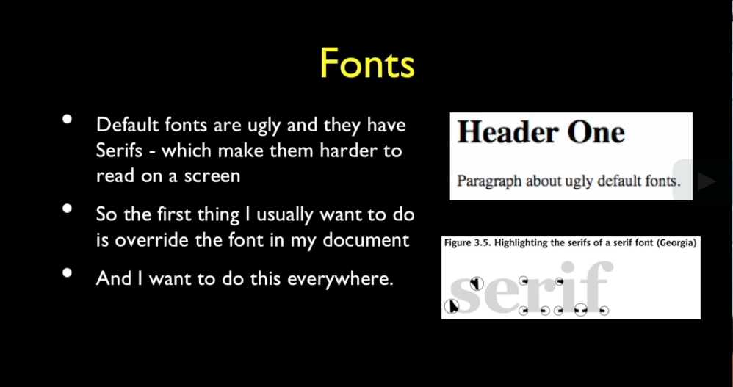

The default font is a Times Roman, because that's what computers had in 1994.

And I think they're ugly, especially on screens.

They're not so bad on print, but they're ugly on screens.

And I tend to want a sans serif font.

And maybe they have changed and structured the default to sans serif.

I just change it to sans serif all the time I want.

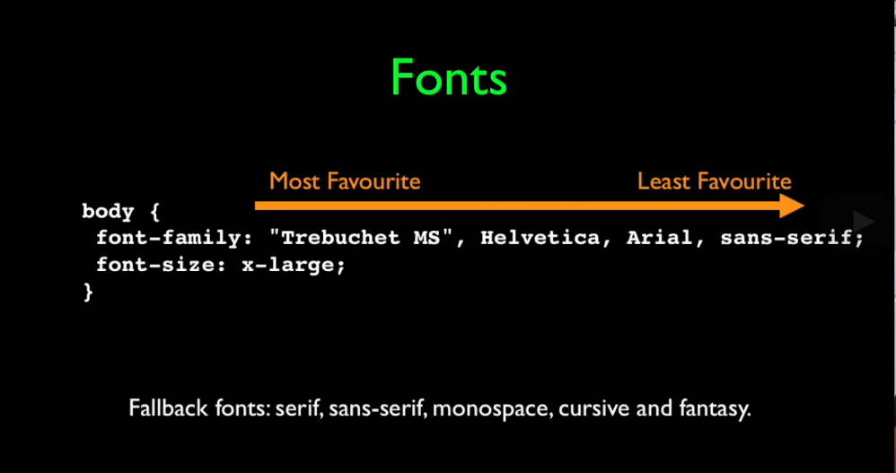

Now if you look at fonts, the font family is kind of a special tag in that you ask it a set of fonts.

And what you're really doing is you're setting a priority.

And the problem is depending on whether you're on Windows or Mac, or which version of Windows or which browser or what fonts they've had installed, fonts might not be there.

And what you basically do is you basically say, okay, I would like this.

I think this is a Microsoft font, and if that font's not there then I would like this font,

and I think that might be also a Microsoft font.

If that font's not there, then there's Arial.

See how much I know about graphic arts?

I have no idea. And I think this might be a Mac font.

If that font doesn't work,

default into the fallback font sans-serif.

And there is always going to be a serif font Times New Roman-like, sans serif Arial-like, Monospace which is Courier-like, Cursive and Fantasy, which are whatever.

So all browsers are supposed to have those fallback fonts, and so you tend to see them here at the very end.

And so when you see me, I usually will say Arial, sans-serif, or something like that,

just to get sans-serif.

Although it's quite common, the more sophisticated the page is, the more likely.

And the other thing that's increasingly the case is people are downloading fonts and having special beautiful web fonts, and then they download them and then they put that font in here, but then they probably still have fallback fonts.

Font family is kind of a weird, a unique, and a glorious thing that leads to some really gorgeous web pages, because so much graphic arts work is going into making web pages beautiful, and we're going way beyond the operating system installed fonts and having

pages that download their own fonts.

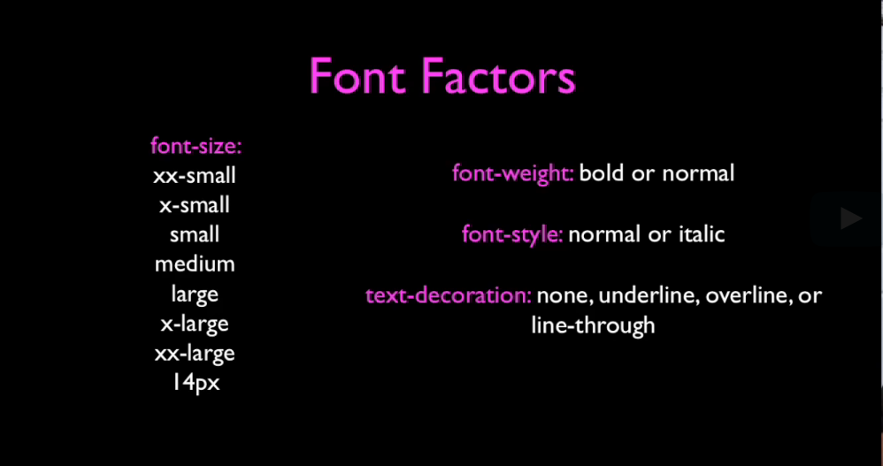

Things that you can do is set the things to bold, italic, text decoration.

Remember, links have underlines and we can turn them on or off.

Font sizes are kind of troublesome in that you can set them to pixels, but then you're in danger if you get to a certain screen size or people start zooming the screen and stuff,

and so you can tend to use these relative ones, but they're not as guaranteed as you might like them to be.

These are a little bit tricky.

Absolute font sizes are a little bit dangerous.

I tend to just go like, "Here's my font, here's the one that's a little larger, here's a little smaller," if I need that.

Most of the time, I'm tending to do things that are like smaller. If I'm like putting like a copyright statement and I don't want to distract from the main page, I'll just make it a little small.

I'll say, "Okay, make this small or extra small," and what if it doesn't turn out to be that much smaller?

It doesn't matter. I'm not an expert in how to use those.

I tend to use them as simply as I possibly can because they're not as predictable as it would be nice if they were.

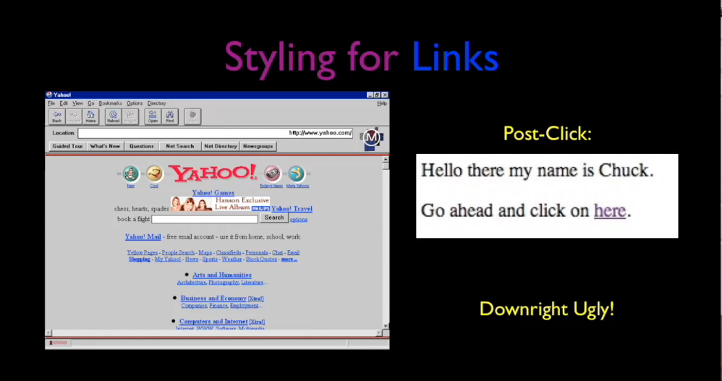

Links were a big part of the early web, and it's called the HyperText Markup Language,

Hypertext Transport Layer, hypertext, hypertext, hypertext.

And links got really special treatment.

They used to be blue before you clicked on them, and purple after you clicked on them.

The blue was to jump out at you and say, "Please click me."

And the purple was to say, "I've been there."

Because a lot of what you did in the early web is you wandered from place to place to places like, "Oh, I've found a new thing. Let me explore this." And so you were always like exploring by clicking links.

Once we got to the point where people assumed the web, these links didn't need to be

blue and garish colors to teach us these things, because people just clicked on everything.

And it became more important to make things pretty.

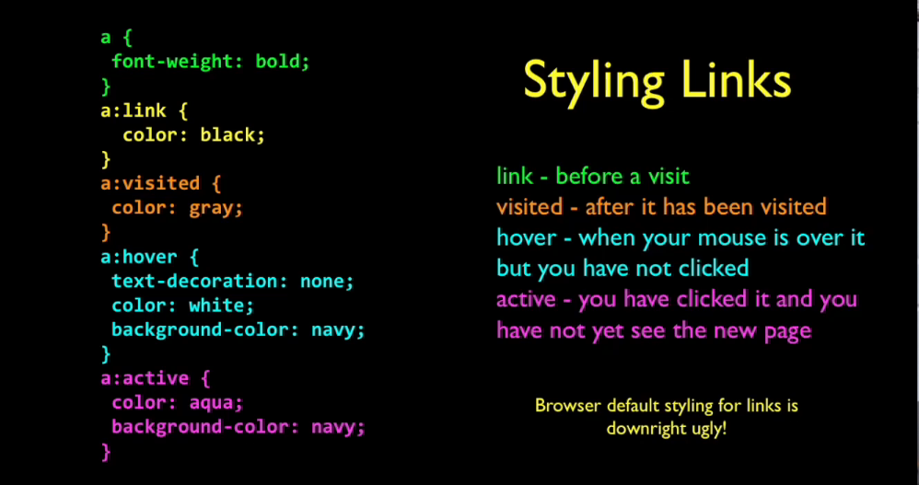

We have a lot of control as to how we style links.

We can say the a tag, we've already colored an a tag with just the a at the top.

You can basically say, an unvisited link is supposed to have the color black, after the visit, it's supposed to be gray, while you're hovering over top of it, it's supposed to have text decoration and none and be white with a background of navy.

And then active is not so heavily used.

It's once you've clicked on the link while the page is loaded.

It's a way to kind of maybe disable it or turn it a color so people think, "Oh, I'd better wait until this next page loads."

And when I do the recording, you'll see this.

It's a lot easier to see this dynamically.

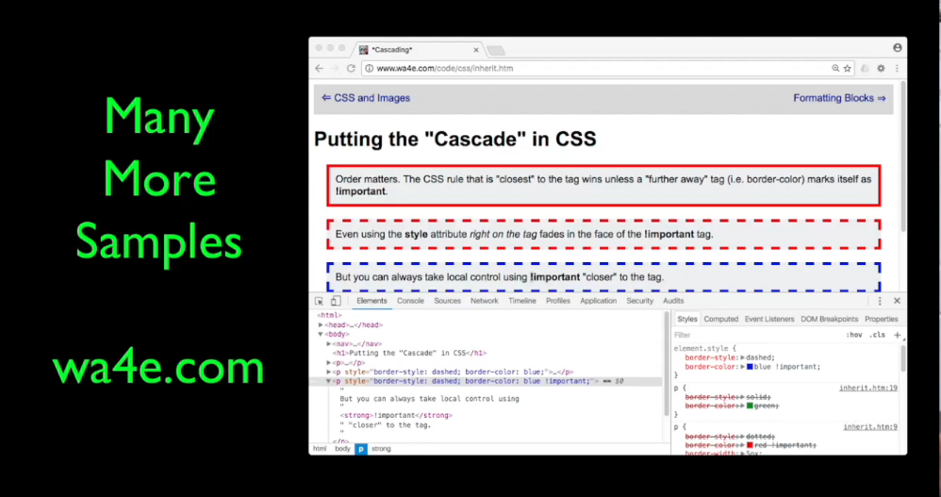

And there's a whole bunch more samples that I have, and I'll record some walkthroughs of every single one of the samples, and so you can take a look at that at Web Applications for Everybody or in the recordings.

This has been a zoom through CSS.

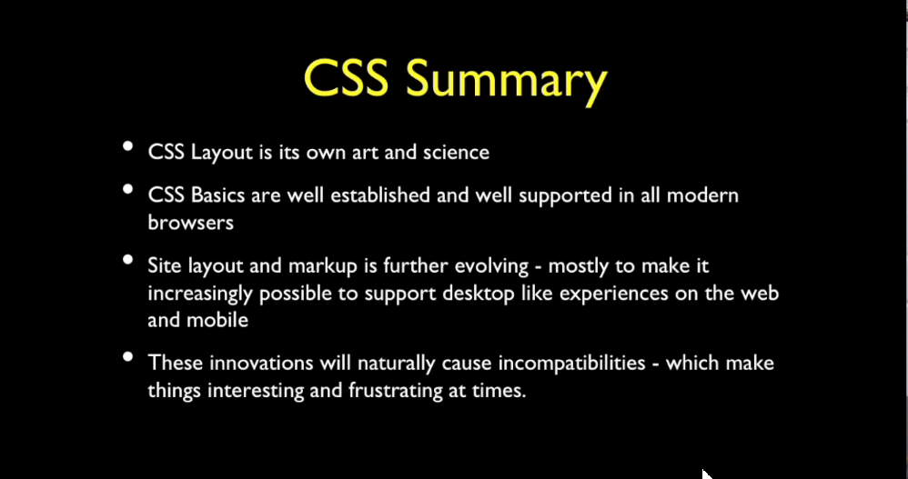

CSS is quite the art and science, and it's evolutionary, and people specialize in this.

They're very good at it.

It's a modern form of graphic arts.

The basics are there, and I think every programmer who does anything on the web should know the basics of HTML.

They keep moving things better with things like nav tags and Bootstrap, etc.

And while there will always be like edgy new things in CSS.

So you sometimes, you'll see CSS with like these Moz, fields, which are for Mozilla, for the Firefox, but people are always pushing that boundary and before you couldn't put rounded corners on things, but then the browsers added extensions to put rounded corners on things, and then everybody kind of agreed on that.

CSS is kind of always going to get better and better and better because for the mobile and desktop, they really want to create as beautiful an experience as possible and use standards wherever possible.

And the basics are there.

You can do so many wonderful things, especially if you pull in something like a Bootstrap that just kind of cleans up the rough edges of HTML, and makes it generally pretty,

and takes a lot of responsibility off of you.

But you can certainly make a lifetime study of CSS if you like.

I hope you found this useful, I will see you on the net.

### WA4E Code Walkthrough: CSS - Part 1

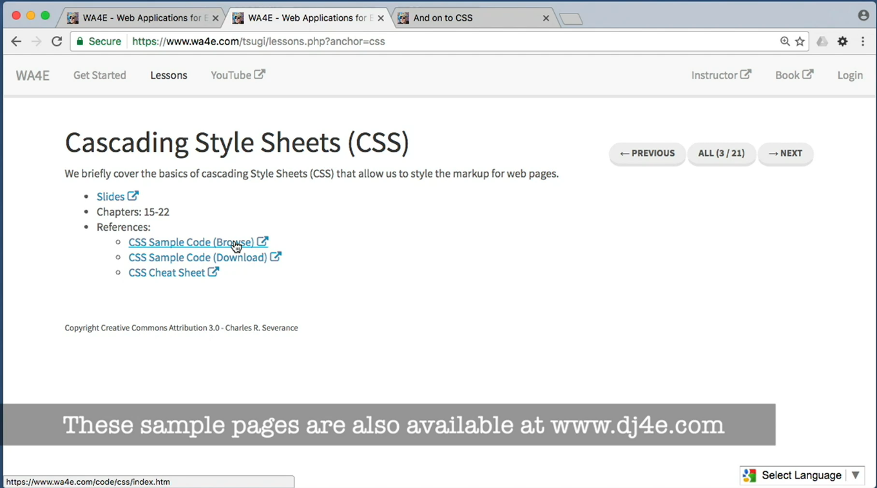

Hello and welcome to Web Applications for Everybody.

We are taking a look today at Cascading Style Sheets.

You can download the source code and unzip and it on your computer if you like or you can browse this code and just play with it in the browser because it's all static content,

it's just as easy to play with it in the browser. And of course, we're going to want to take a look at this in the developer console.

### WA4E Code Walkthrough: CSS - Part 2

### CSS Assignment Specification

Assignment: Cascading Style Sheets

In this assignment you will develop a Cascading Style Sheet (CSS) to control, the look, feel, and layout of some provided HTML content.

The specification for this assignment is at: <https://www.dj4e.com/assn/css/index.php>

### Mitchell Baker - The Mozilla Foundation

I was laid off or fired, depending on how you want to describe it.

And as it turned out, it wasn't really possible to take my place.

And I continued as a volunteer and the Netscape Engineering Organization was very clear whose leadership they were most interested in following.

And so, we had to work out a way in which the management at Netscape AOL remained.

And I worked out sort of a way to work together enough so that they could ship the product they wanted to ship.

But then I continued to lead the project.

And I think that was a surprise, not so much to me, I think.

And I worked as a volunteer in the Mozilla project for a number of years.

Including the years in which we shipped our first product which we called Mozilla

and which we are very proud of technically.

And for its day, many people were surprised at how good it was but it didn't have a good user experience.

But eventually I ended up working on another open source project with Mitch Kapor for a while and that was lucky.

He had started this open project and reached out to talk to Brendan and I about it to learn something.

And the day that he was scheduled to come down and talk with us was the day that I was laid off and so it was an odd sort of timing-

>> Explain it to you?

>> Yeah, that was pre it was pre but.

I worked on that for a while and Mitch was always a supporter of Mozilla even

before Firefox when he didn't like the product but he recognized that we were an important part of the ecosystem.

And that went on until 2003 when AOL decided to stop investing in the client almost completely.

And fortunately they knew that just killing it wasn't good, they knew enough about Mozilla and the name and the brand to think it would be good to do something with it.

And, eventually I ended up working with them and they- some of the people there knew Mitch as well.

And I was working with Mitch and they knew him and so we all spend a chunk of time trying to figure out what was possible.

And my partner Brendan was still at Netscape, very eager to make a move.

And many of the key people we wanted were all so desperate to keep working on Mozilla.

And so we ended up getting a $2 million seed money from AOL.

And Mitch was helpful with that and a few other things, trademark, name Mozilla and

the four giant servers which were so important to us at the time.

And which had taken us almost 18 months to get through the purchase cycle at AOL.

And so, I think we still have those boxes sitting around because they were so

important to us at the time.

And in 2003, the Mozilla Foundation was formed.

### Face to Face Office Hours - IIT TechFest - Mumbai, India

So hello, everybody.

### Lecture Resources

**Basic SQL**

The following materials may be helpful to you as you review this week's lectures and content.

* [Downloadable slides for this week's lectures.](https://courses.edx.org/assets/courseware/v1/9d887acbb3dbd225230324a1c2ad1af0/asset-v1:MichiganX+dj4e101x+2T2021+type@asset+block/C1-Week5.pptx)
* [Sample SQLite Command Line Operations (SQL-01-Basics.txt)](https://www.dj4e.com/lectures/SQL-01-Basics.txt) are the SQL commands used in the lecture(s).
* [Documentation: Command Shell for SQLite](https://www.sqlite.org/cli.html) documents how to use the simple command line tool to access SQLite databases.

If you have your own computer and want to use SQLite on your computer - you can install:

* [SQLite Browser](https://sqlitebrowser.org/) is a desktop application that can be used to open and manipulate SQLite databases on your computer.

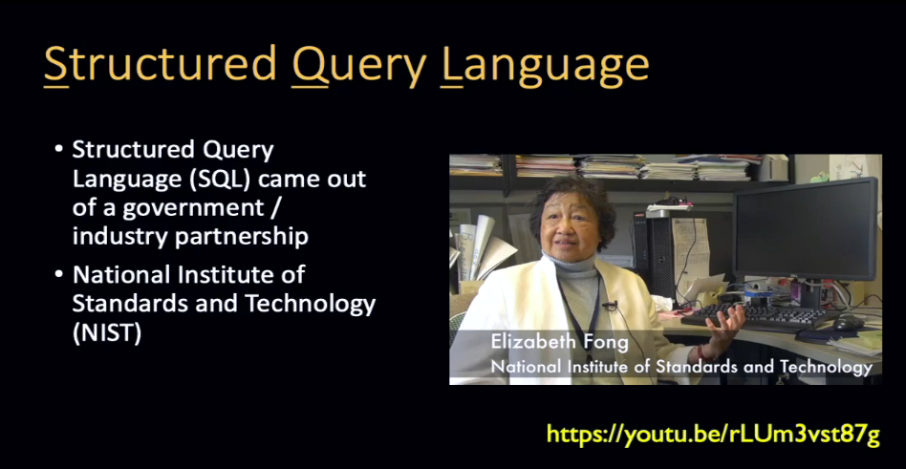

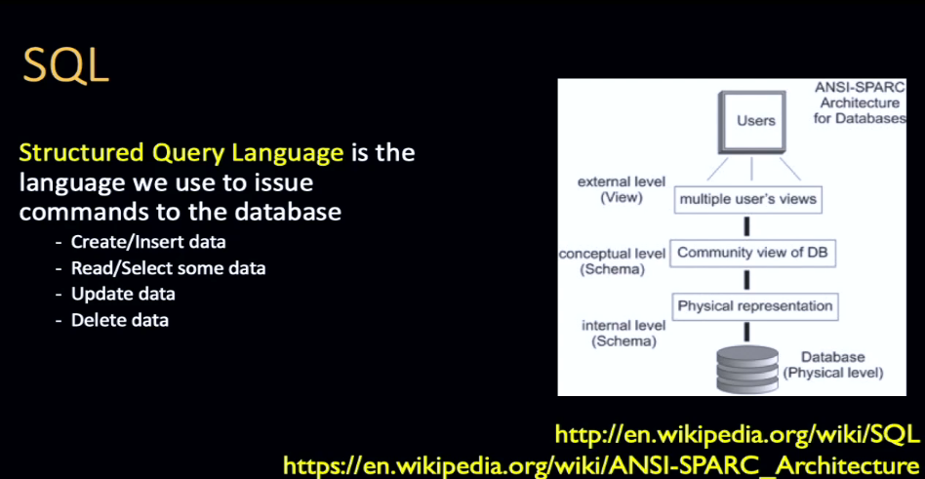

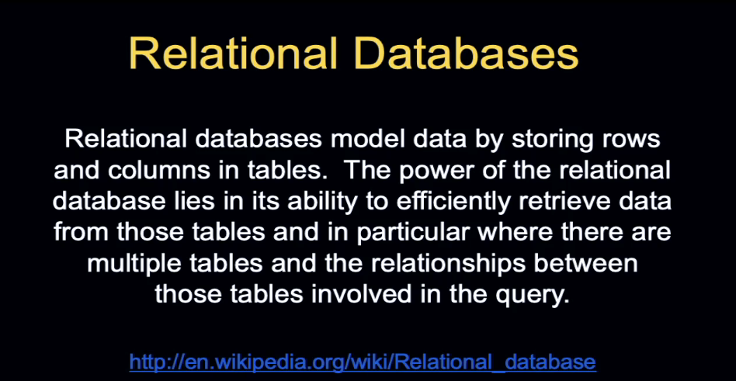

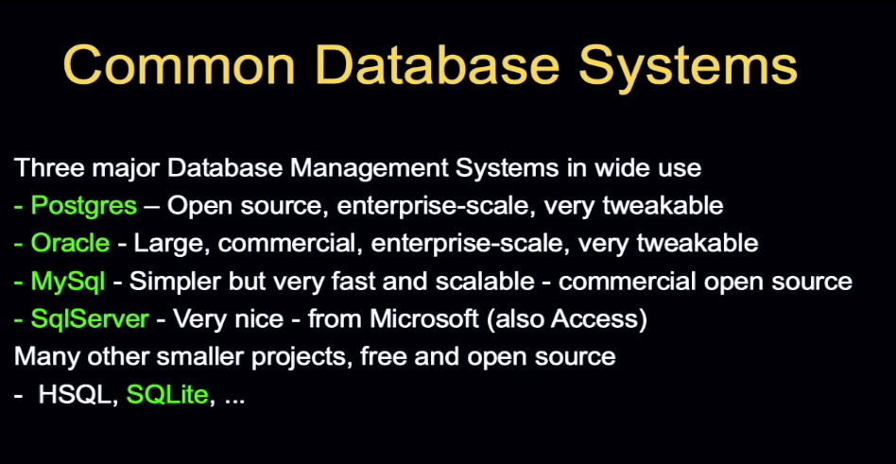

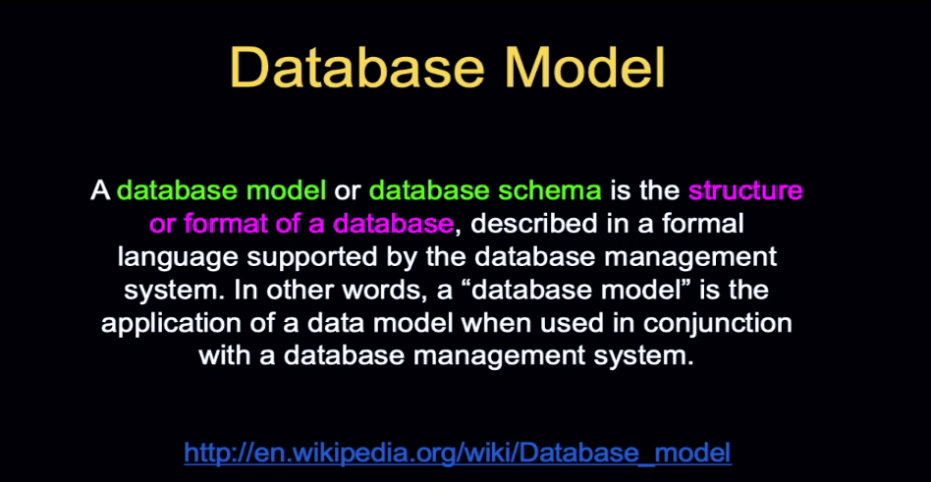

Schema

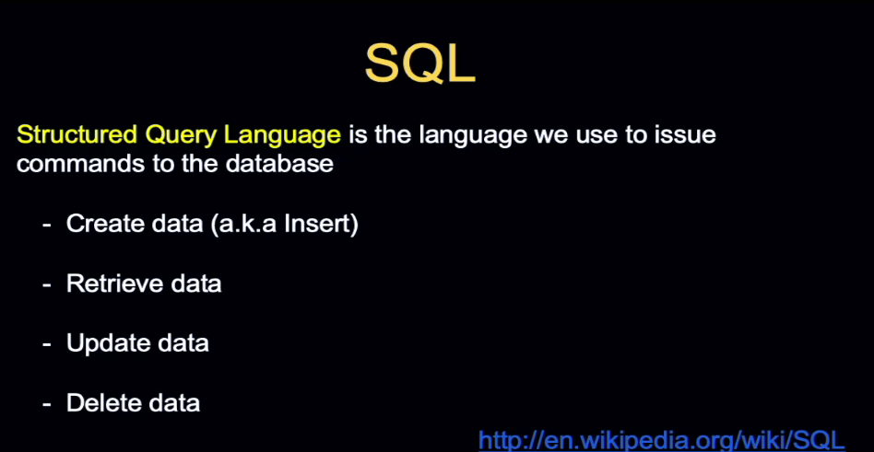

### How Databases Work

<https://www.dj4e.com/lectures/SQL-01-Basics.txt>

<https://www.sqlite.org/cli.html>

<https://sqlitebrowser.org/>

Hello, and welcome to our lecture on SQL.

This is a very, very short introduction to SQL.

SQL. CRUD, create, read, update, and delete data.

### Introduction to Structured Query Language (SQL)

So now we're going to actually play with a little bit of Structured Query Language, SQL.

Now, at this URL you can grab the instructions that I'm using so you can cut and paste it in.

Now, the key thing that you've got to do is you've got to find your way to a shell.

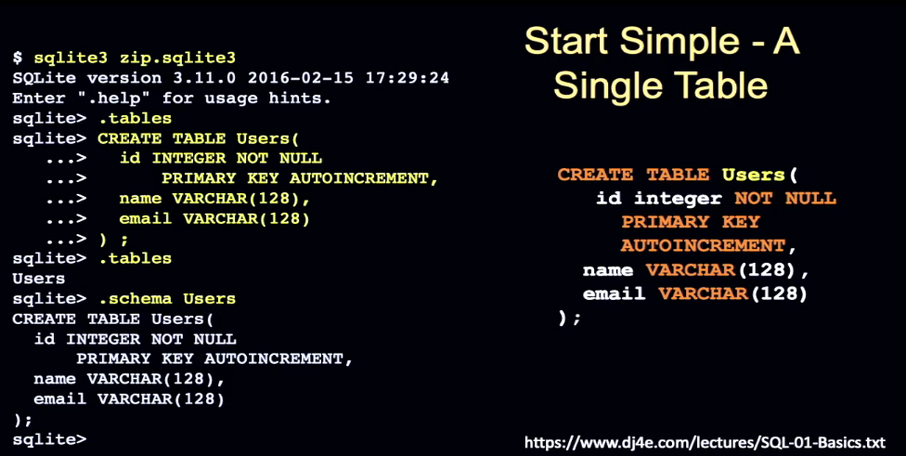

If you're using something like PythonAnywhere, you go ahead and open a command line.

Now if we're using PythonAnywhere, most of what we're doing is running Django applications, but you can really just use PythonAnywhere as a Unix platform.

And get to a dollar sign prompt.

These commands can run on a Mac, I don't know if you can get them working on Windows, but any Linux system, but you can also run them on PythonAnywhere.

There's a command to Linux called sqlite3, and then you give it a filename.

SQLite, as I mentioned, is a very simple database because it does all of its work in one file.

It's not a slouch as a database in terms of its performance and scalability.

What it's not good at is handling hundreds of people hitting it at the same time and

having the database software resolve all those simultaneous accesses.

But if you type sqlite, you end up in a command line where you get this prompt sqlite arrow.

And there's commands you can type, like dot tables says hey, in this database, which is in this case zip.sqlite3, in this database, what tables exist?

And it says there are no tables.

And then you create some tables.

Now, this is our first SQL statement.

And you'll learn something about SQL is that it looks a little different than other programming languages.

And you say CREATE TABLE. That's one statement.

You can create things other than tables.

And then you have a table name.

And then you have some parentheses, right?

And then you have a series of statements about the table that you're working with.

And there's this little language, and there's the name of a column.

These are three columns that we're putting in, id, name, and email.

And we have a type. This is an integer.

VARCHAR means variable length string field.

NOT NULL means it's required.

PRIMARY KEY means that it's an auto-increment,

meaning it's going to be supplied by the database.

It gives us like a handle for every row.

And then a VARCHAR 128 says it's up to 128 characters.

Now, a key to this is that we're making sort of a contract here.

And when we say you've got to do this with 128 characters, you can't put 129 in.

You can put up to 128.

And if you put 129, your database query blows up, and you're like, "Well, that's not very nice."

And the answer is, well, you told it 128 so it could optimize how it's going to store the data on disk.

If you've made this 1,000, it might store it in a different way than if you store 128.

And the key is, you can make any contract you want, but you've got to live by the contract that you make.

And it's not that the database hates you, it's you said I'm going to do 128, and when you do 129, it says you're violating our contract, and so it's up to you.

This whole CREATE TABLE ending in a semicolon, that is a single SQL statement.

And we can type it in.

We can type it in multiple lines, and you can kind of see how SQLite is using this dot dot dot thing to tell you that it's in a continuation.

And then finally, you finish it all and you put a semicolon at the end, and then it does it. And then we can ask using dot tables, we can say, "Is there a table?"

And yes, it says, "Yes, it's Users."

And then there's a command, an SQLite command called dot schema and that says, "Tell me the schema of Users."

Now, that's in case you hadn't just typed in the CREATE statement, it tells you what CREATE statement it would be.

And part of what the database stores in this file sqlite is not only the data for this table called Users that you just created, but it also stores the schema, and so you can say, "Hey, what schema is it?"

If I sent you one of these files, like you might upload to my autograder, for example, I can inquire into that file using SQLite and say what schema? What tables are here?

And I can start looking at the table.

As a matter of fact, that's how I grade these assignments inside of the computer.

And this is just sort of going through some, there's a lot of SQL, but the basics is actually

surprisingly easy to understand.

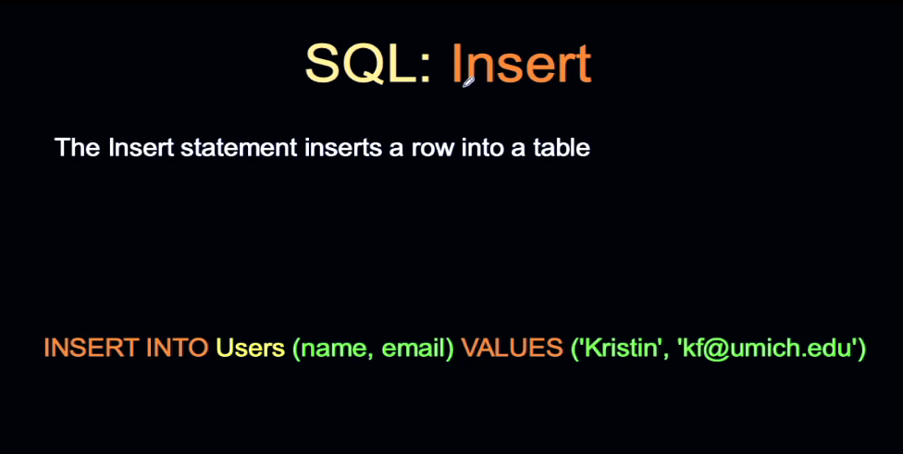

And INSERT INTO, one of the things that SQL does is it tends to use more than one word.

I've met people who have used SQL in their jobs, and they just like type it, and they don't realize how amazing what they're doing is.

They're like, "Well, I just insert, or I delete some stuff, or I select it to read it."

It was designed to be easy because if we go back to the basics of SQL, it was like, "Look,

there's a lot of complexity down there.

We want to hide that complexity.

We want to hand something easy to users."

And I write a lot of very complex SQL, and it's a very sophisticated skill.

But simple SQL is something I think literally everybody should know how to do.

INSERT INTO, then you have a table name, and then you have a parenthesized list of the columns.

Now, these are the columns that you named in your CREATE statement, and then VALUES is a keyword, and then there's a one-to-one correspondence between the values that you're going to put in the columns.

And these happen to be strings, so we have little quotes around them.

They could be integers, they could be dates, they could be all kinds of things,

floating point numbers, etc.

And then this has to meet the schema.

You can't go putting a number into a string field, or a string into a number field,

that would blow up.

You can make all kinds of errors.

You can either have syntax errors, like you forget the word INTO or something, or you can have errors that are bad, that your data is bad, right?

That's the INSERT statement, and that adds a row to the end of a table.

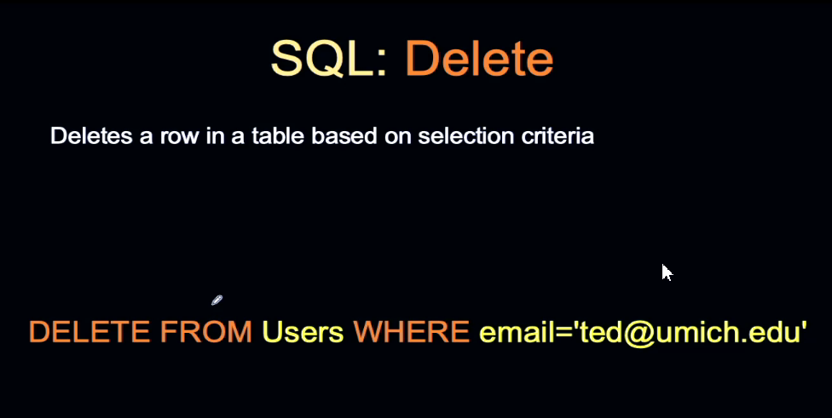

The DELETE statement says DELETE FROM, and then a table name, and then a WHERE clause.

We're going to see WHERE clauses a lot in SQL.

And the key thing is that I sort of mentioned in the beginning that there's kind of no loops in SQL, and that's one of the reasons that we sort of love SQL is you don't have to write loops.

And that's because there's kind of an implied loop at the beginning of these commands.

When you say DELETE FROM Users, that means delete all rows from Users, right?

Delete everything from Users.

If you don't put this WHERE clause on, it actually deletes everything in there because it's like delete all the rows from Users.

You can kind of phrase it that way.

Delete all rows from Users.

Now, the all rows part isn't really there, but that just means that it's really important to have a WHERE clause so that you're not actually deleting all the rows.

It's saying delete all the rows from Users where the email is equal to ted@umich.edu.

And what that is, is an implied loop of all rows on this DELETE statement, and the WHERE clause reduces that down to actually one or a couple of rows depending on those rows where this is like an if statement.

This whole thing is like a loop with an if inside of it, that's how it works.

And this is why a lot of people like it, is because you don't have to write loops.

Because these things sort of like are loops, they have loops built in.

But this would delete one or a couple of rows, depending on whether we had more than one row in this where the email was ted@umich.edu.

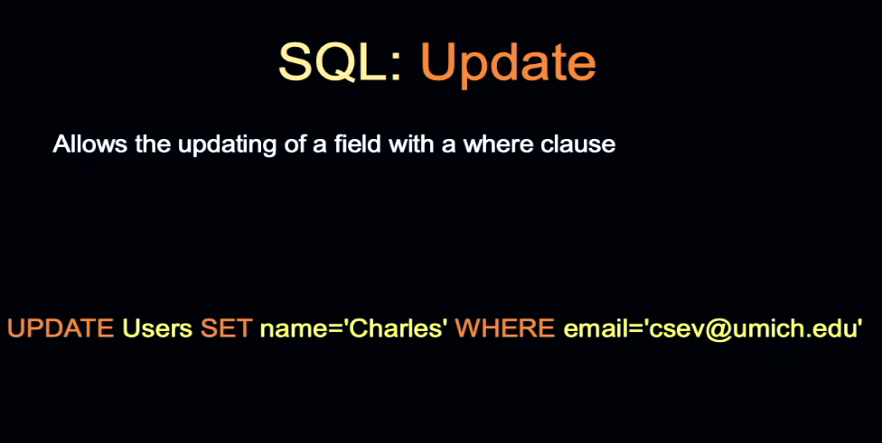

UPDATE is really kind of cool.

You can really zero in.

You can zero into rows and columns.

And again, UPDATE Users, which is the name of the table, SET, and then name equals,

which is the field name and new value.

And you can do all the columns, you can do one of the columns, you can really zone in on this.

And then there's a WHERE clause, because if you don't put a WHERE clause on the update, it implies that this is for all rows.

You don't really want to set the name to be Charles for all the rows, you just want to set the name to be Charles where this is true.

Because, again, you could think of this as like update all rows in Users SET WHERE.

And you've just always got to be thinking that there it's in.

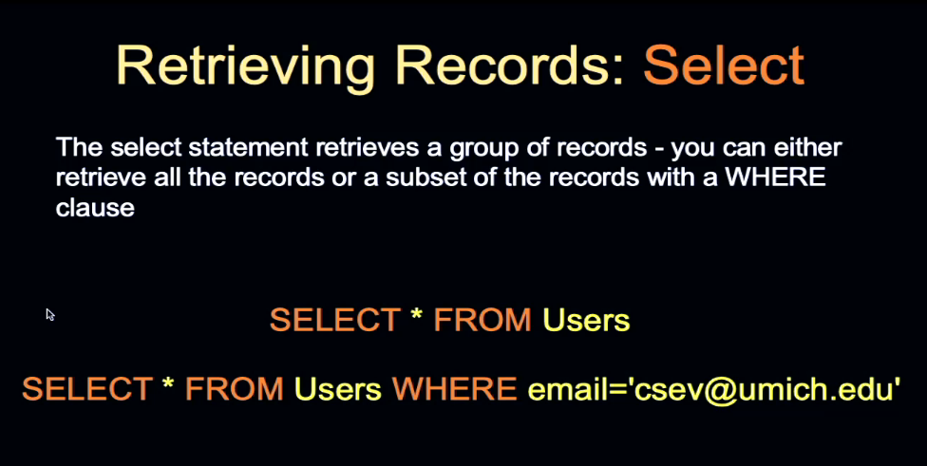

The reading is done with SELECT.

I wish that it would be create, read, update, delete.

But create is insert, read is select, update is update, and delete is delete.

SELECT is the way that we read stuff out.

SELECT basically takes a list of columns, like SELECT name, comma, email, or SELECT star, and FROM, and then a table name.

This SELECT star FROM Users is quite the, almost always the first thing we type.

SELECT star FROM Users, SELECT star FROM books, SELECT star FROM whatever.

You can also put a WHERE clause on a SELECT because this again has this implied all rows kind of a thing going on.

And SELECT all rows FROM Users WHERE email equals csev@umich.edu.

And that reads much better when you kind of add that all rows logic to it.

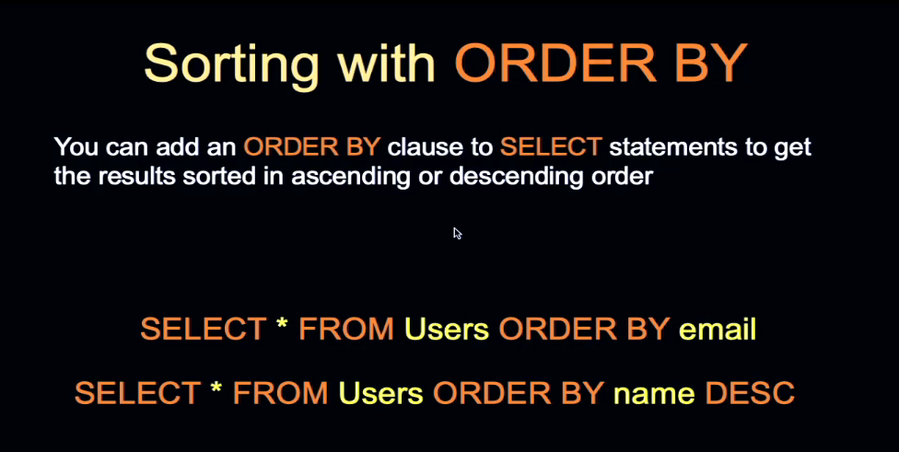

Databases are good at searching.

We can do things like add indexes to the databases

that make searching and ordering even better.

We might say that email, please, while you're maintaining this data, in addition to maintaining the data, maintain an index that has a sense of the order of these records,

so if I want to sort on ascending or descending, then I can get that, and I can get that to be efficient.

ORDER BY is just a thing you throw on the end.

You can add a WHERE clause here as well, and you can have ascending and descending sorts, and it works great.

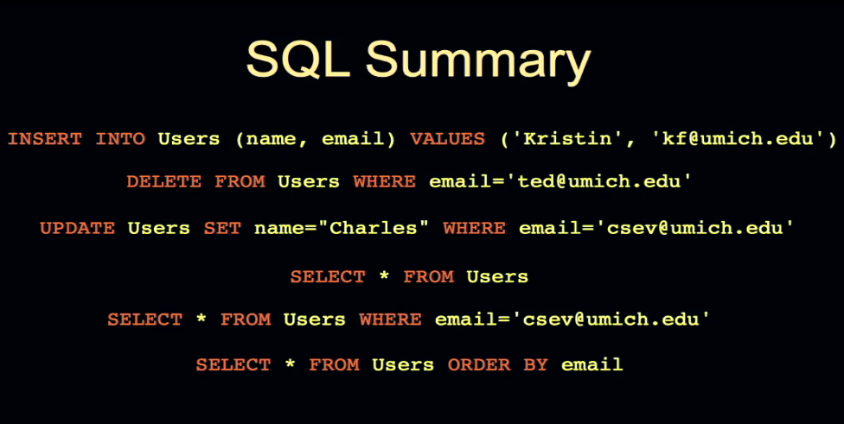

This is sort of the first 60 percent of any SQL is the basic insert, delete, update, and read.

And the beauty is this essence of SQL, the middle part of SQL, is portable across all the databases that I just described, because every one of those databases that's a modern database was invented after the invention of SQL, and so life is pretty good.

Now, there are differences because when they first built SQL in like, I think, '87.

I don't know, I forgot the time.

But when they first built it, they did not realize how powerful they were going to be.

There's a bunch of features that got added by the vendors that were extensions, and some of them are sort of standardized.

There's another round of standardization.

But then there's a whole bunch of features that are a little different.

But because of competition, they have conceptually the same ideas, like a limit clause that limits the number of rows or starts after a certain number of rows, and it's a little different from one database to the other.

But this is just a summary.

You should just know this forever and ever and ever.

And then as you run into a different database, then you'll learn different features for that.

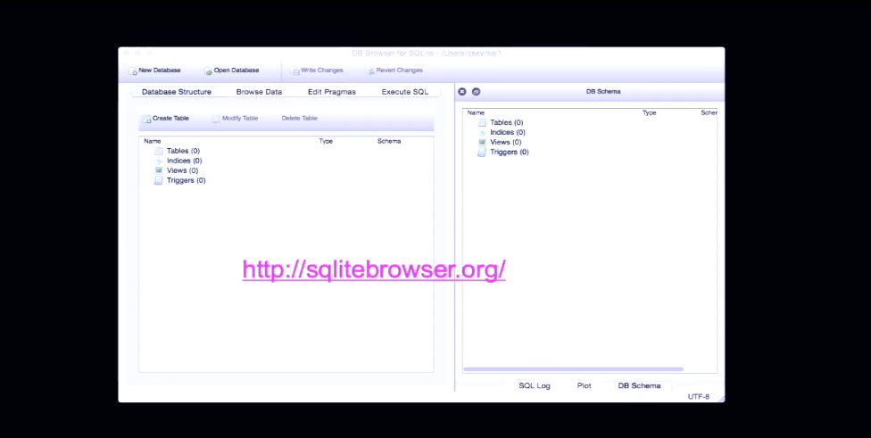

A tool that you might want to install on your laptop if you want to start playing with these SQLite files and not just using the command line is called SQLite browser.

You can download it. It runs on lots of different systems.

You can then open these dot sqlite3 files and you can do stuff to it, including execute the SQL commands right in there.

And a lot of people find this a more interesting and easy way to interact with these files.

And so that kind of sums up our really quick introduction to single-table SQL.

Up next, we'll talk a little bit about multiple-table SQL and relationships.

And then we'll also talk about how we connect this all to Django through an object-relational mapper.

### Walkthrough: Basic SQL (not!)

Hello and welcome to another Django for Everybody walkthrough.

<https://www.sqlitetutorial.net/>

<https://www.tutorialspoint.com/sqlite/sqlite_commands.htm>

<https://sqlite.org/quickstart.html>

<https://sqlite.org/cli.html>

### Liz Fong - Creating the SQL Standards

### Face to Face Office Hours - Kitchener, Ontario

…the end…